

SOFTWARE REQUIREMENT SPECIFICATION
Website UniLap(ULP)

– Hanoi, May 2026 –
Table of Contents
I. Software Requirement Specification 5
1. Overall Requirements 5
1.1 Context Diagram 5
1.2 Main Business Processes 6
1.3 User Requirements 14
View & Update Shopping Cart 17
1.4 System Functionalities 30
1.5 Entity Relationship Diagram 39
2. Use Case Specifications 49
2.1 Authentication & Access 49
2.2 Account Management 58
2.3 E-Commerce Operations 75
2.4 E-Commerce Operations (Customer) 80
2.5 Checkout Order 82
2.6 Product Review 88
2.7 AI System Integration( Customers ) 93
2.8 Warranty Operations 96
2.10 Product Catalog Management (Staff) 102
2.11. Inbound Management 107
2.13. Voucher Configuration 113
2.14. Policy Operations (Admin) 122
2.15 Reporting & Analytics (Admin) 134
2.16 AI System Integration (Admin) 137
2.17 Manage Product Reviews 143
2.18 Product Discovery / E-Commerce Operations 149
2.19. Outbound management 154
3. Functional Requirements 159
3.1 Warranty Management 159
3.2 Admin Dashboard & Advanced Analytics 172
3.3 Store Policies Management 180
3.4 Authentication &Account Management 188
3.5 Product Catalog Management 204
3.6. Inbound Management 211
3.7. Outbound Management 219
3.8 Online Shopping & Order Processing 225
4. Non-Functional Requirements 238
4.1 External Interfaces 238
4.2 Quality Attributes 239
5. Requirement Appendix 243
5.1 Business Rules 243
5.2 System Messages 249
5.3 Validation Rule 251
I. Record of Changes
Date | A*  M, D | In charge | Change Description
25/5 | A | Whole team | Write down demo SRS 1st
26/5 | A/M | Whole team | Completing all SRS to the right projects
5/6 | A/M | Usecase  specific | Completing usecasespecif and screen
11/7 | A/M | Usecase  specific | Fixing usecasespecif and screen
*A - Added M - Modified D - Deleted

I. Software Requirement Specification

1. Overall Requirements

1.1 Context Diagram
The Technology Products E-Commerce Website is a new software system that replaces the current fragmented sales processes on third-party e-commerce platforms and social networks for small and medium-sized laptop retail shops. The context diagram below illustrates the external entities and system interfaces for the initial releases, focusing on core shopping experiences, multi-method checkouts, and basic inventory tracking. The system is expected to evolve over several iterations, ultimately connecting to an intelligent, rule-based Chatbot suggestion system tailored for students, automated e-invoice generation via email, a comprehensive online warranty tracking system, and advanced financial analytics dashboards.
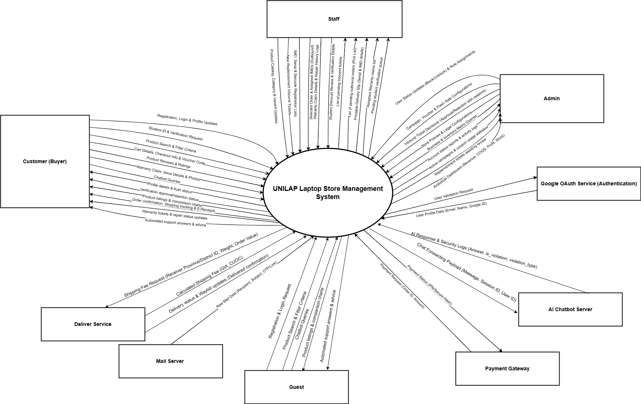

1.2 Main Business Processes

1.2.1 Authentication and Account Management
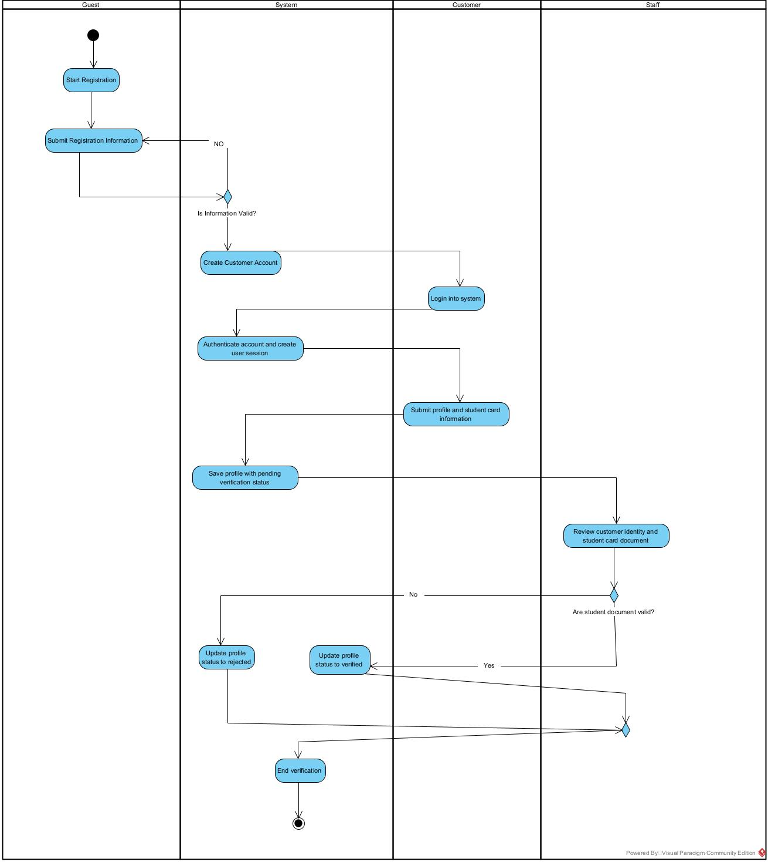

1.2.2. Online Shopping & Order Processing
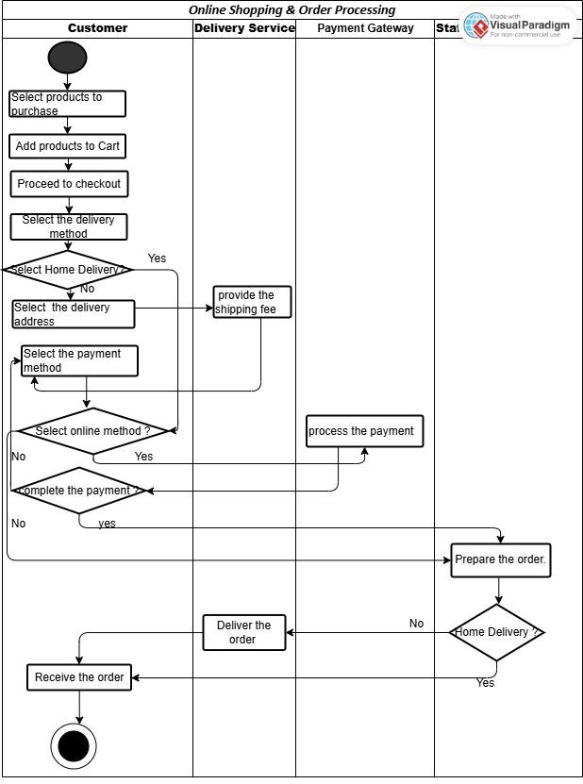

Step 1: Customer selects the products to purchase.
Step 2: Customer adds the selected products to the shopping cart.
Step 3: Customer proceeds to checkout.
Step 4: Customer selects a delivery method.
Step 5: If the customer selects Home Delivery, the customer selects a delivery address.
Step 6: Delivery Service calculates and provides the shipping fee.
Step 7: Customer selects a payment method.
Step 8: If the customer selects an online payment method, Payment Gateway processes the payment.
Step 9: The system verifies whether the payment is successful. If the payment is unsuccessful, the customer selects another payment method or retries the payment.
Step 10: Staff prepares the order.
Step 11: If the customer selects Home Delivery, Delivery Service delivers the order to the customer. Otherwise, Staff hands the order to the customer at the store.
Step 12: Customer receives the order.

1.2.3. Customer Experience & Promotion

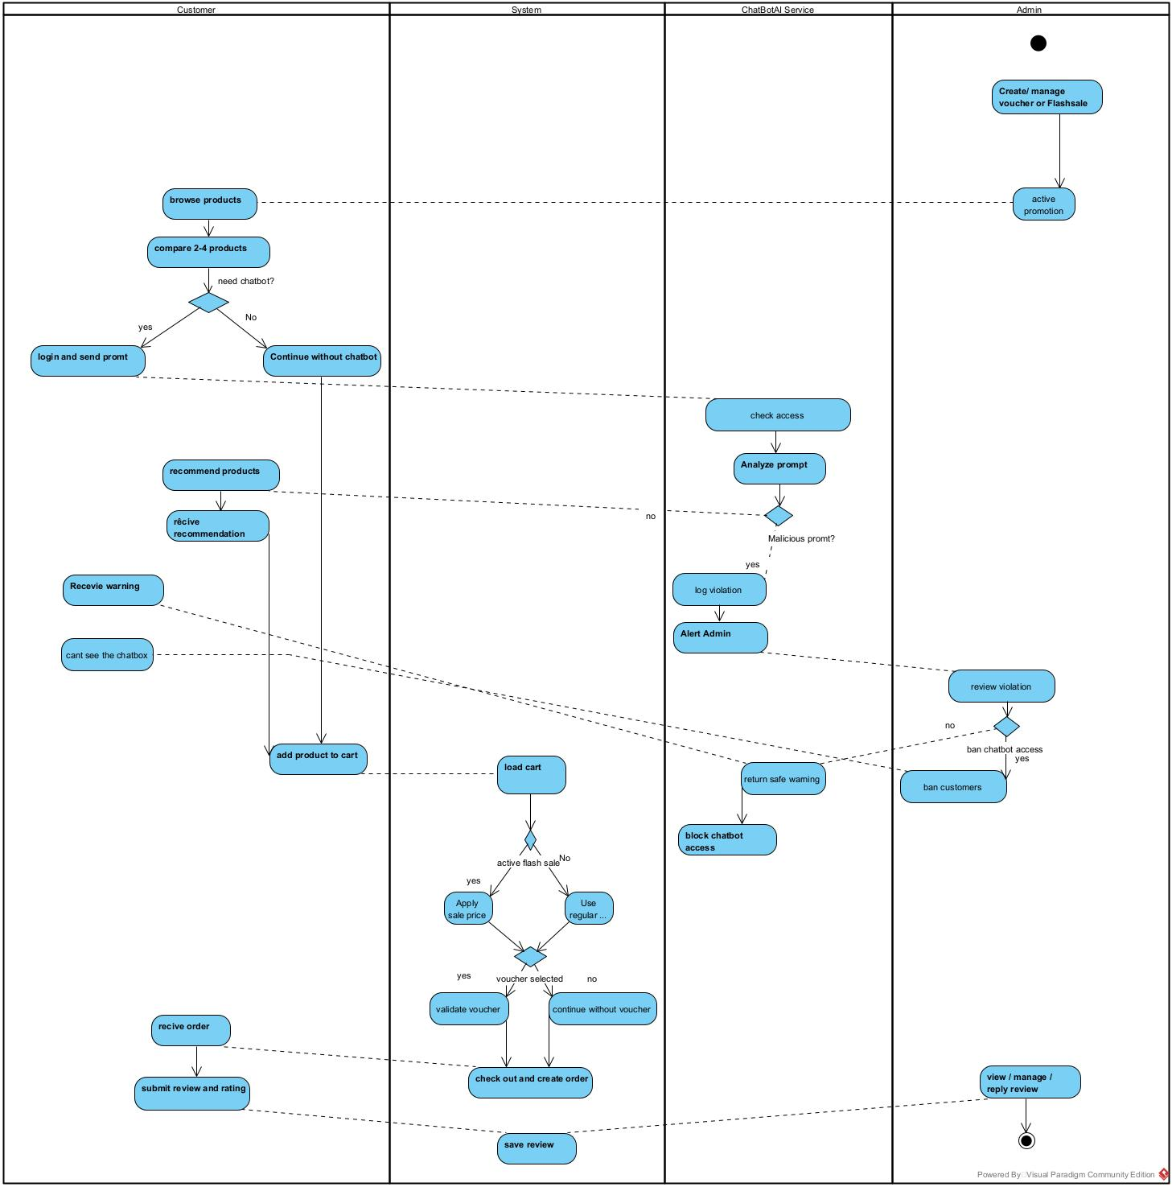

1.2.4. Warehouse Management
1.2.4.1. Inbound Management
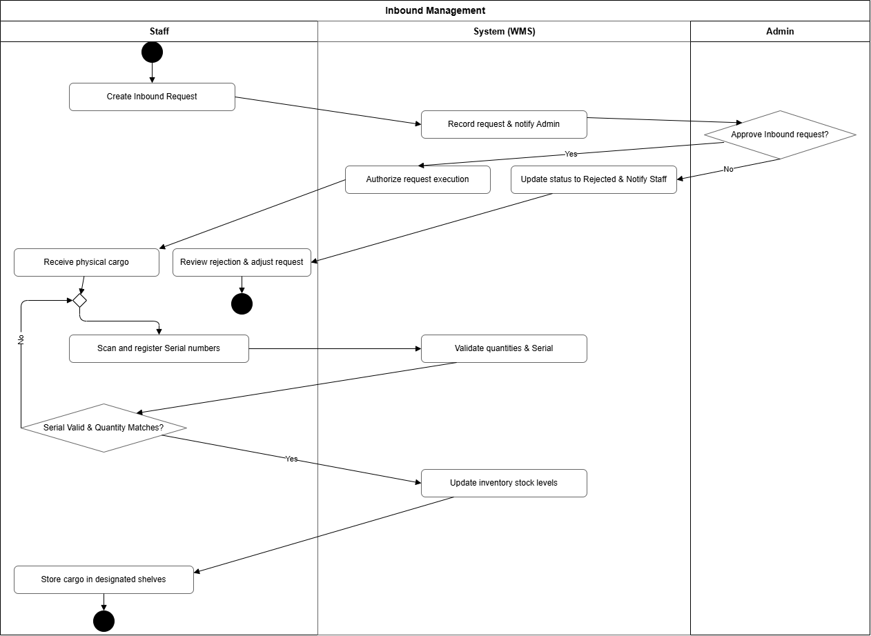
1.2.4.2. Outbound Management
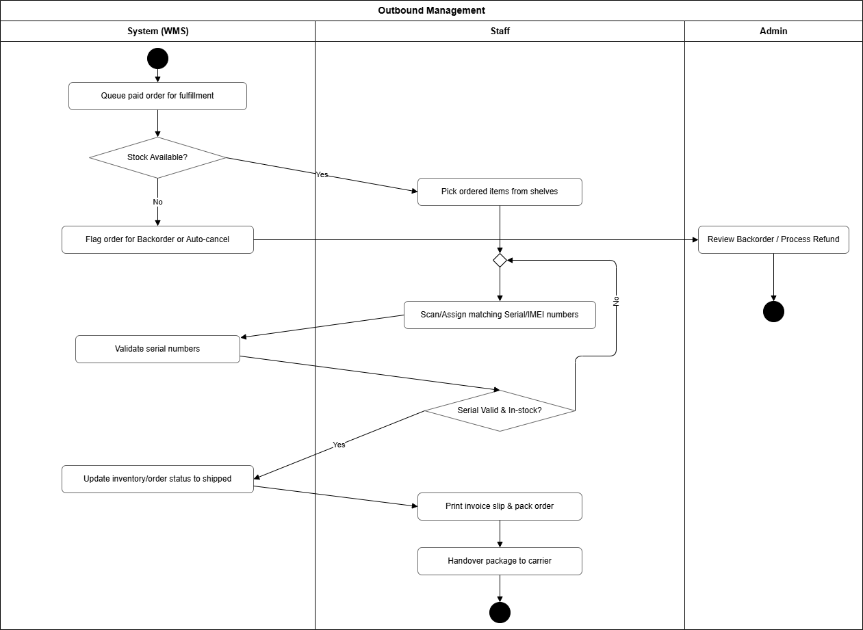

1.2.5. Warranty
- Step 1: Customer submits warranty request.
- Step 2: System registers and queues request.
Nhánh 1: Khách hàng hủy đơn (If Customer Cancels)
- Step 3a: Customer requests cancellation.
- Step 3b: System cancels claim.
Nhánh 2: Quy trình xử lý thông thường (If No Cancellation)
- Step 4: Warranty Staff reviews request.
- Step 5: Admin reassigns claim to another staff (Optional).
- Step 6: Warranty Staff inspects and evaluates product.
Nhánh 2.1: Đồng ý bảo hành (If Approved)
- Step 7: Warranty Staff approves claim.
- Step 8: System records approval.
- Step 9: Warranty Staff repairs or replaces product.
- Step 10: Warranty Staff returns product.
- Step 11: System records completion.
- Step 12: Customer receives product.
Nhánh 2.2: Từ chối bảo hành (If Rejected)
- Step 13: Warranty Staff rejects claim.
- Step 14: System records rejection.
- Step 15: Customer receives rejection notice.

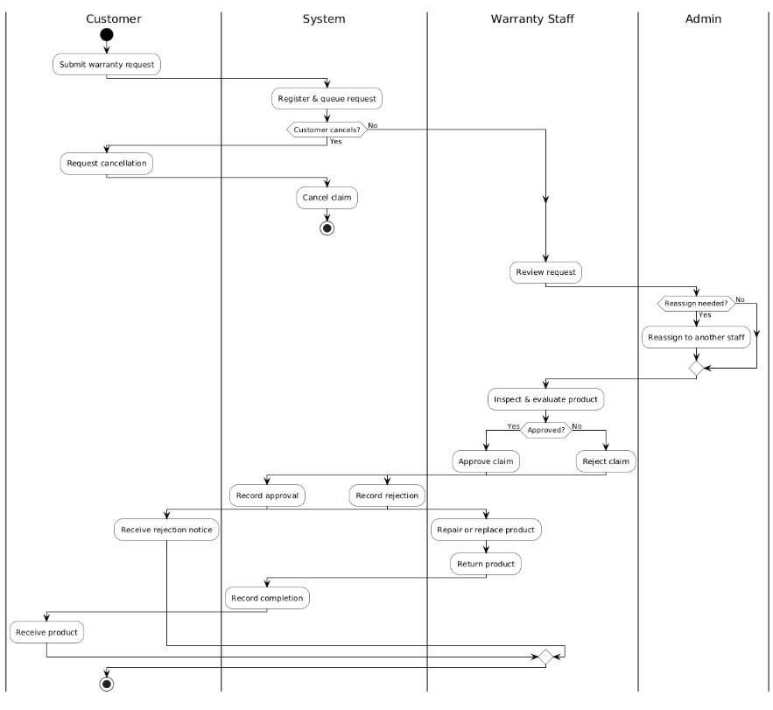

1.3 User Requirements

1.3.1 Actors
# | Actor | Description
1 | USER | Any authenticated account that has successfully logged into the system. Acts as the base role for Customers, Staff, and Administrators to manage common actions (e.g., Login, Logout, Update Profile)
2 | Guest | Unauthenticated public user browsing the storefront. Can search products, read specs
3 | Customer | Authenticated user who has registered an account. Can manage shopping carts, consult the AI assistant ,apply vouchers, place orders, and track shipments.
4 | Staff | Internal operational employee responsible for validating orders, packing hardware items, and monitoring daily inventory balances.
5 | Admin | Supreme administrative manager. Governs user permissions, alters product files, manages vouchers, reviews sales ledger analytics, and mitigates AI chatbot abuse.
6 | AI Chatbot | External system providing automated natural language understanding models to drive custom PC consultation.
7 | Payment Gateway | External system that processes and authorizes online payment transactions (e.g., credit/debit card, e-wallet) on behalf of the platform, and returns transaction status to the system.
8 | Deliver Service | External carrier system responsible for shipping confirmed orders to customers and updating shipment tracking status (e.g., in transit, delivered) back to the platform.

1.3.2 Use Cases (UC)

ID | Feature Group | Actor | Use Case Name | Summary Description
UC01 | Authentication & Access | Guest | Register Account | Allows guests to create a new account by providing personal details.
UC02 | Authentication & Access | User | Login | Authenticates user identity (via credentials or Google) to grant role-based permissions.
UC03 | Authentication & Access | User | Reset Password | Sets a new password via a verification link sent to personal email.
UC04 | Authentication & Access | User | Change Password | Allows logged-in users to update their password after verifying the current password.
UC05 | Account Management | User | Update Profile | Updates personal information such as Full Name, Phone Number, and Profile Picture.
UC06 | Account Management | Use | View Personal Profile | Displays detailed account information and the user's role on the system.
UC07 | Account Management | Admin | View Account List | Allows administrators to view, search, and filter all user accounts.
UC08 | Account Management | Admin | Update Account | Admin locks/unlocks accounts or changes user access roles.
UC09 | Account Management | Admin | Add New Account | Admin proactively creates new accounts for staff or other users.
UC10 | Student Verification | Customer | Submit Student Verification | Customer uploads student ID photo to request promotional verification.
UC11 | Student Verification | Staff, Admin | Verify Student Request | Staff reviews, approves, or rejects student verification requests.
UC12 | E-Commerce Operations | Guest, Customer | Browse Home & Search Product | Views featured products and quickly searches for products from the homepage.
UC13 | E-Commerce Operations | Guest, Customer | Browse Product Catalog | Browses product categories using filters and sorting options.
UC14 | E-Commerce Operations | Guest, Customer | View Product Detail | Views detailed information, specifications, pricing, and inventory status of products.
UC15 | E-Commerce Operations | Guest, Customer | View & Update Shopping Cart | Adds products to cart, adjusts quantities, or removes items.
UC16 | E-Commerce Operations | Customer, Payment Gateway, Delivery Service | Checkout Order | Order process including selecting shipping method, payment, and applying vouchers.
UC17 | E-Commerce Operations | Customer, Delivery Service | Track Order | Tracks order delivery progress or submits cancellation requests within allowable time.
UC18 | E-Commerce Operations | Staff | Manage Order | Staff manages the entire order handling process from confirmation to delivery.
UC19 | Product Review | Customer | Submit Product Review | Verified buyers submit star ratings, comments, and actual product photos.
UC20 | Product Review | Guest, Customer | View Product Reviews | Users view product reviews and average rating scores.
UC21 | Product Review | Staff, Admin | Manage Product Reviews | Staff moderates, hides, or replies to customer reviews.
UC22 | AI System Integration | Customer | Interact with AI Assistant | Chats with AI to receive product recommendations and answers about store policies.
UC23 | Warranty Operations | User | Submit Warranty Request | Allows customers to submit warranty requests for purchased products, and enables staff to manage and process these claims through their lifecycle to resolution.
UC24 | Warranty Operations | Customer | Track Warranty Status | Tracks the warranty claim progress via a timeline.
UC25 | Product Catalog Management | Staff | Create Product Variant | Registers product information and configuration variants (RAM, SSD, Color).
UC26 | Product Catalog Management | Staff | View Product Variant List | Displays list of products and variants along with stock information.
UC27 | Product Catalog Management | Staff | Edit Product Information | Updates technical specifications, pricing, or product images.
UC28 | Product Catalog Management | Staff | Deactivate Product | Temporarily hides or discontinues products and related variants.
UC29 | Stock Inbound | Staff | Create Inbound Ticket | Staff creates stock inbound request tickets awaiting Admin approval.
UC30 | Inbound Management | Admin | Manage Admin’s Inbound Tickets | Admin reviews list of stock inbound request tickets submitted by staff.
UC31 | Inbound Management | Admin | Review Inbound Ticket | Admin approves or rejects stock inbound tickets with notes.
UC32 | Inbound Management | Staff | View Inbound Ticket List | Staff tracks the list and status of request tickets they created.
UC33 | Inbound Management | Staff | Add Product IMEI/Serial | Records specific IMEI/Serial numbers for each device upon physical stock receipt.
UC34 | Reporting & Analytics | Staff | View Operational Reports | Views summary charts of daily revenue and order volume.
UC35 | Voucher Management | Admin | Manage Voucher Campaigns | Manages promotion lifecycle: create, edit, or stop vouchers.
UC36 | Policy Management | Admin | Manage Warranty Policies | Creates and manages warranty terms applicable to products.
UC37 | Policy Management | Admin | Manage Footer Policies | Manages policy article contents displayed in the website footer.
UC38 | Reporting & Analytics | Admin | View Advanced Analytics | Accesses in-depth analytics dashboard on revenue, customers, and products.
UC39 | Reporting & Analytics | Admin | View System Dashboard | Monitors overview of operational metrics and low-stock alerts.
UC40 | AI Governance | Admin | Moderate AI Guardrails | Monitors AI security violations and blocks access for abusive accounts.
UC41 | AI Governance | Admin | Optimize AI Knowledge Base | Trains AI by refining answers based on customer feedback.
UC42 | Product Discovery | Guest, Customer | Compare Products | Selects and compares technical specifications of 2–4 products simultaneously.
UC43 | Outbound Management | Staff | View Pending Orders | Reviews list of paid orders awaiting dispatch.
UC44 | Outbound Management | Staff | Assign Serial & Fulfill | Assigns specific IMEI codes to orders and updates status to delivering.
UC45 | Outbound Management | Staff | Print Invoice Slip | Generates and prints invoice/packing slips to pack with shipments.
UC46 | Outbound Management | Staff | View Outbound History | Reviews history of dispatched orders and sold IMEI numbers.

1.3.2.1 Actor Generalization Architecture
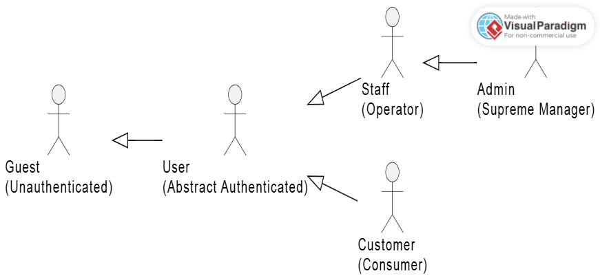The system utilizes the UML Generalization mechanism to establish a structured hierarchical access control system among actors, minimizing redundancy in use case associations.At the foundational layer, the User actor acts as an abstract authenticated entity that inherits from the unauthenticated Guest, ensuring that any logged-in session maintains public browsing capabilities. Moving vertically, the Customer directly inherits from the User, automatically receiving baseline profile-management privileges while extending into consumer-specific features (e.g., cart operations and checkouts).On the operational side, the Staff role inherits from the User to execute back-office operations such as order fulfillment and inventory tracking. Ultimately, the Administrator inherits directly from the Staff. This hierarchical chain implies that the Administrator implicitly possesses all operational capabilities of a Staff member, while explicitly maintaining isolated supreme privileges, including user governance, stock auditing, and AI guardrail moderations.

1.3.2.1 Use Case for Guest

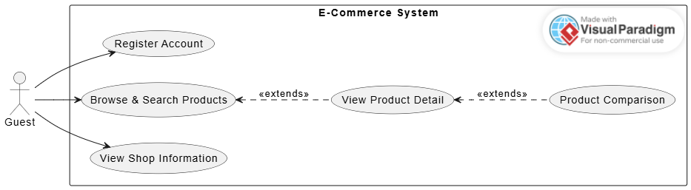
In the E-Commerce system, the Guest is an actor representing unauthenticated users—meaning any individual who accesses the system without an account or before logging in. This use case diagram defines the scope of public interactions available to Guests, which includes viewing informational store content, searching for components, and registering for an account to become an authenticated user.

1.3.2.2 Use Case for Customer
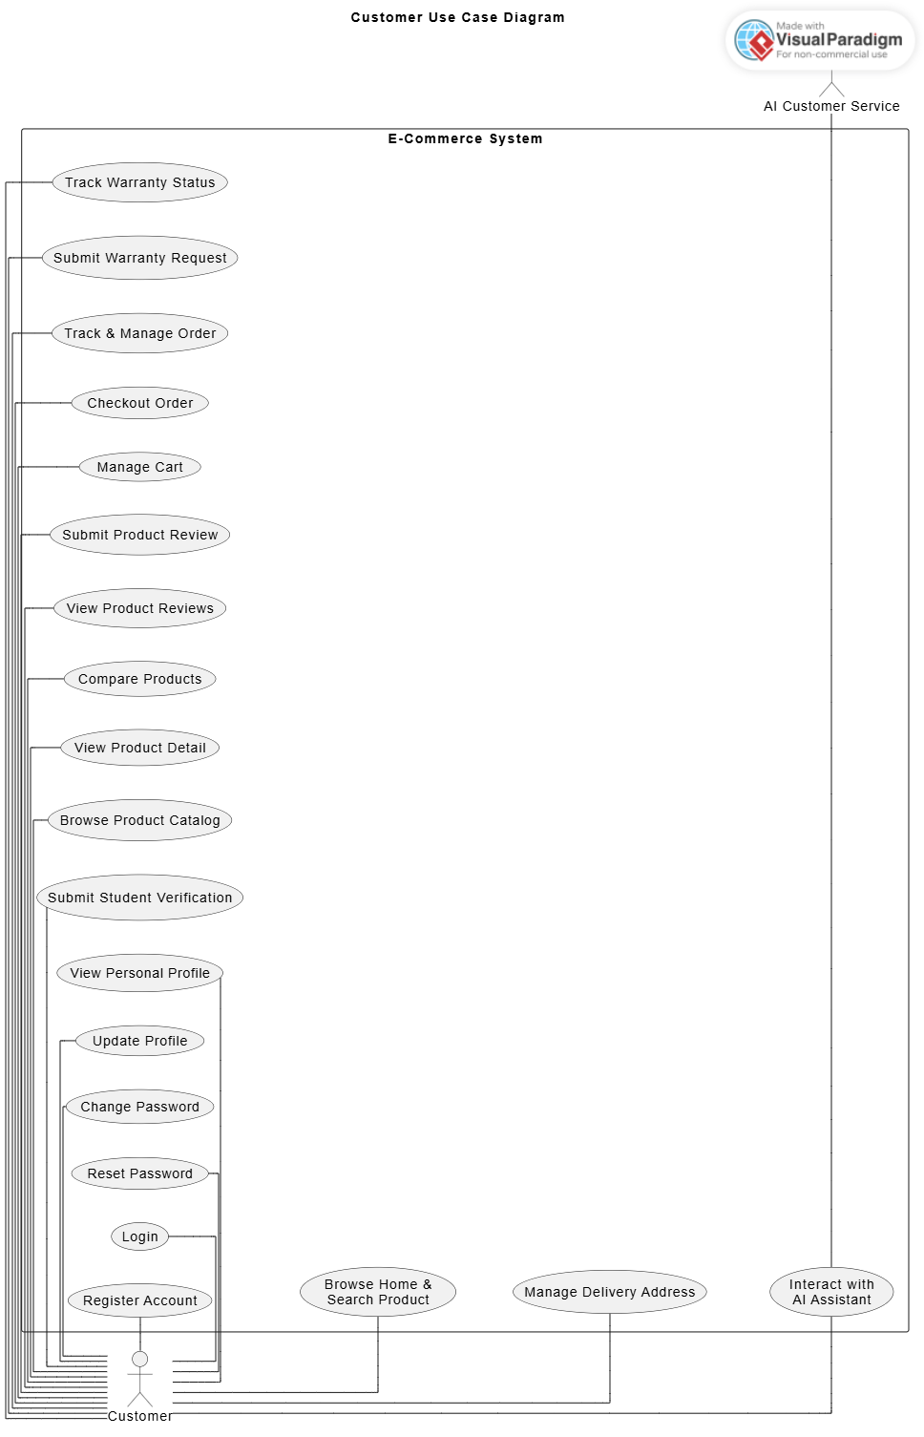
In the E-Commerce system, the Customer is an actor representing authenticated consumers—meaning any individual who has successfully registered a personal account and logged into the system. This use case diagram defines the scope of core post-login interactions available to Customers, which includes managing delivery addresses, controlling shopping carts, tracking orders, and consulting the integrated AI platform. Notably, the <<extend>> relationships in the diagram reflect the optional and situational behaviors of the Customer: transitioning to a complete checkout routine is an extension triggered only when the Customer actively decides to finalize purchase metrics from the active cart interface . Similarly, filing a warranty request extends directly from a historical order verification log , while reviewing tracking metrics serves as an optional monitoring branch triggered only after a specific claim form has been formally submitted , rather than being a mandatory action in every standard consumer interaction session.

1.3.2.3 Use Case for STAFF
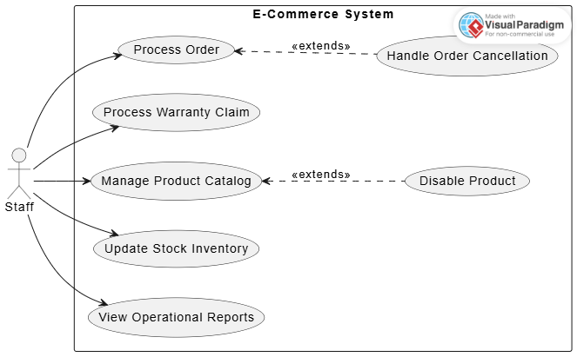
In the E-Commerce system, the Staff is an actor representing internal operational employees—meaning any internal worker responsible for everyday order fulfillment, content maintenance, and inventory auditing. This use case diagram defines the scope of back-office operations available to Staff, which includes validating customer orders, examining media evidence for warranty claims, adjusting physical inventory quantities, and viewing high-level operational statistics. Notably, the two <<extend>> relationships in the diagram reflect the conditional behaviors of the Staff: reviewing and handling a customer's cancellation request is an extension triggered only when an active order in the pending processing queue contains an explicit cancellation flag submitted by a buyer. Similarly, choosing to forcefully hide or disable a component from public view acts as an optional extension triggered from within the active product catalog management wizard when an item becomes discontinued or runs out of stock long-term, rather than being a mandatory action in every standard operational logging session.

1.3.2. 4 Use Case for ADMIN
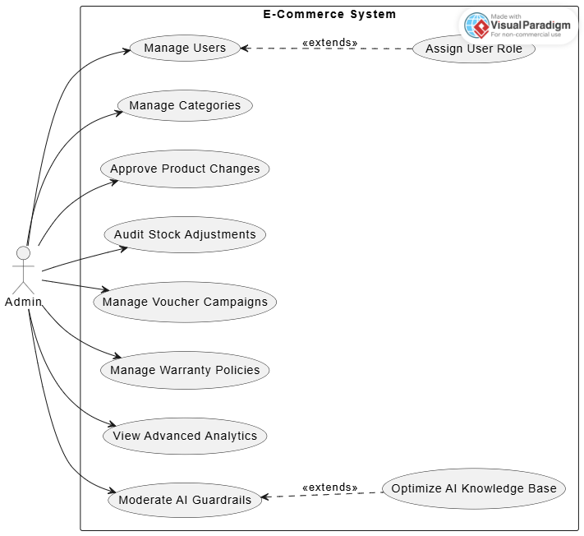
In the E-Commerce system, the Admin is an actor representing supreme administrative managers—meaning any high-level system administrator responsible for overall system governance, operational audit tracking, and security monitoring. This use case diagram defines the scope of high-level system controls available to Admins, which includes browsing user profiles, structuring hardware categories, formally authorizing staff product mutations, tracking stock changes, handling marketing campaigns, reviewing deep business analytics, and managing chatbot frameworks. Notably, the two <<extend>> relationships in the diagram reflect the conditional behaviors of the Admin: altering systemic permissions is an extension triggered only when the Admin actively decides to change user privileges from within a specific account profile inside the global directory. Similarly, inspecting errors or refining underlying vector triages serves as another optional path triggered from the active AI guardrail monitor when inaccurate chatbot responses or user rating drops are detected, rather than being a mandatory action in every standard system governance session.

1.4 System Functionalities

1.4.1 Screens Flow

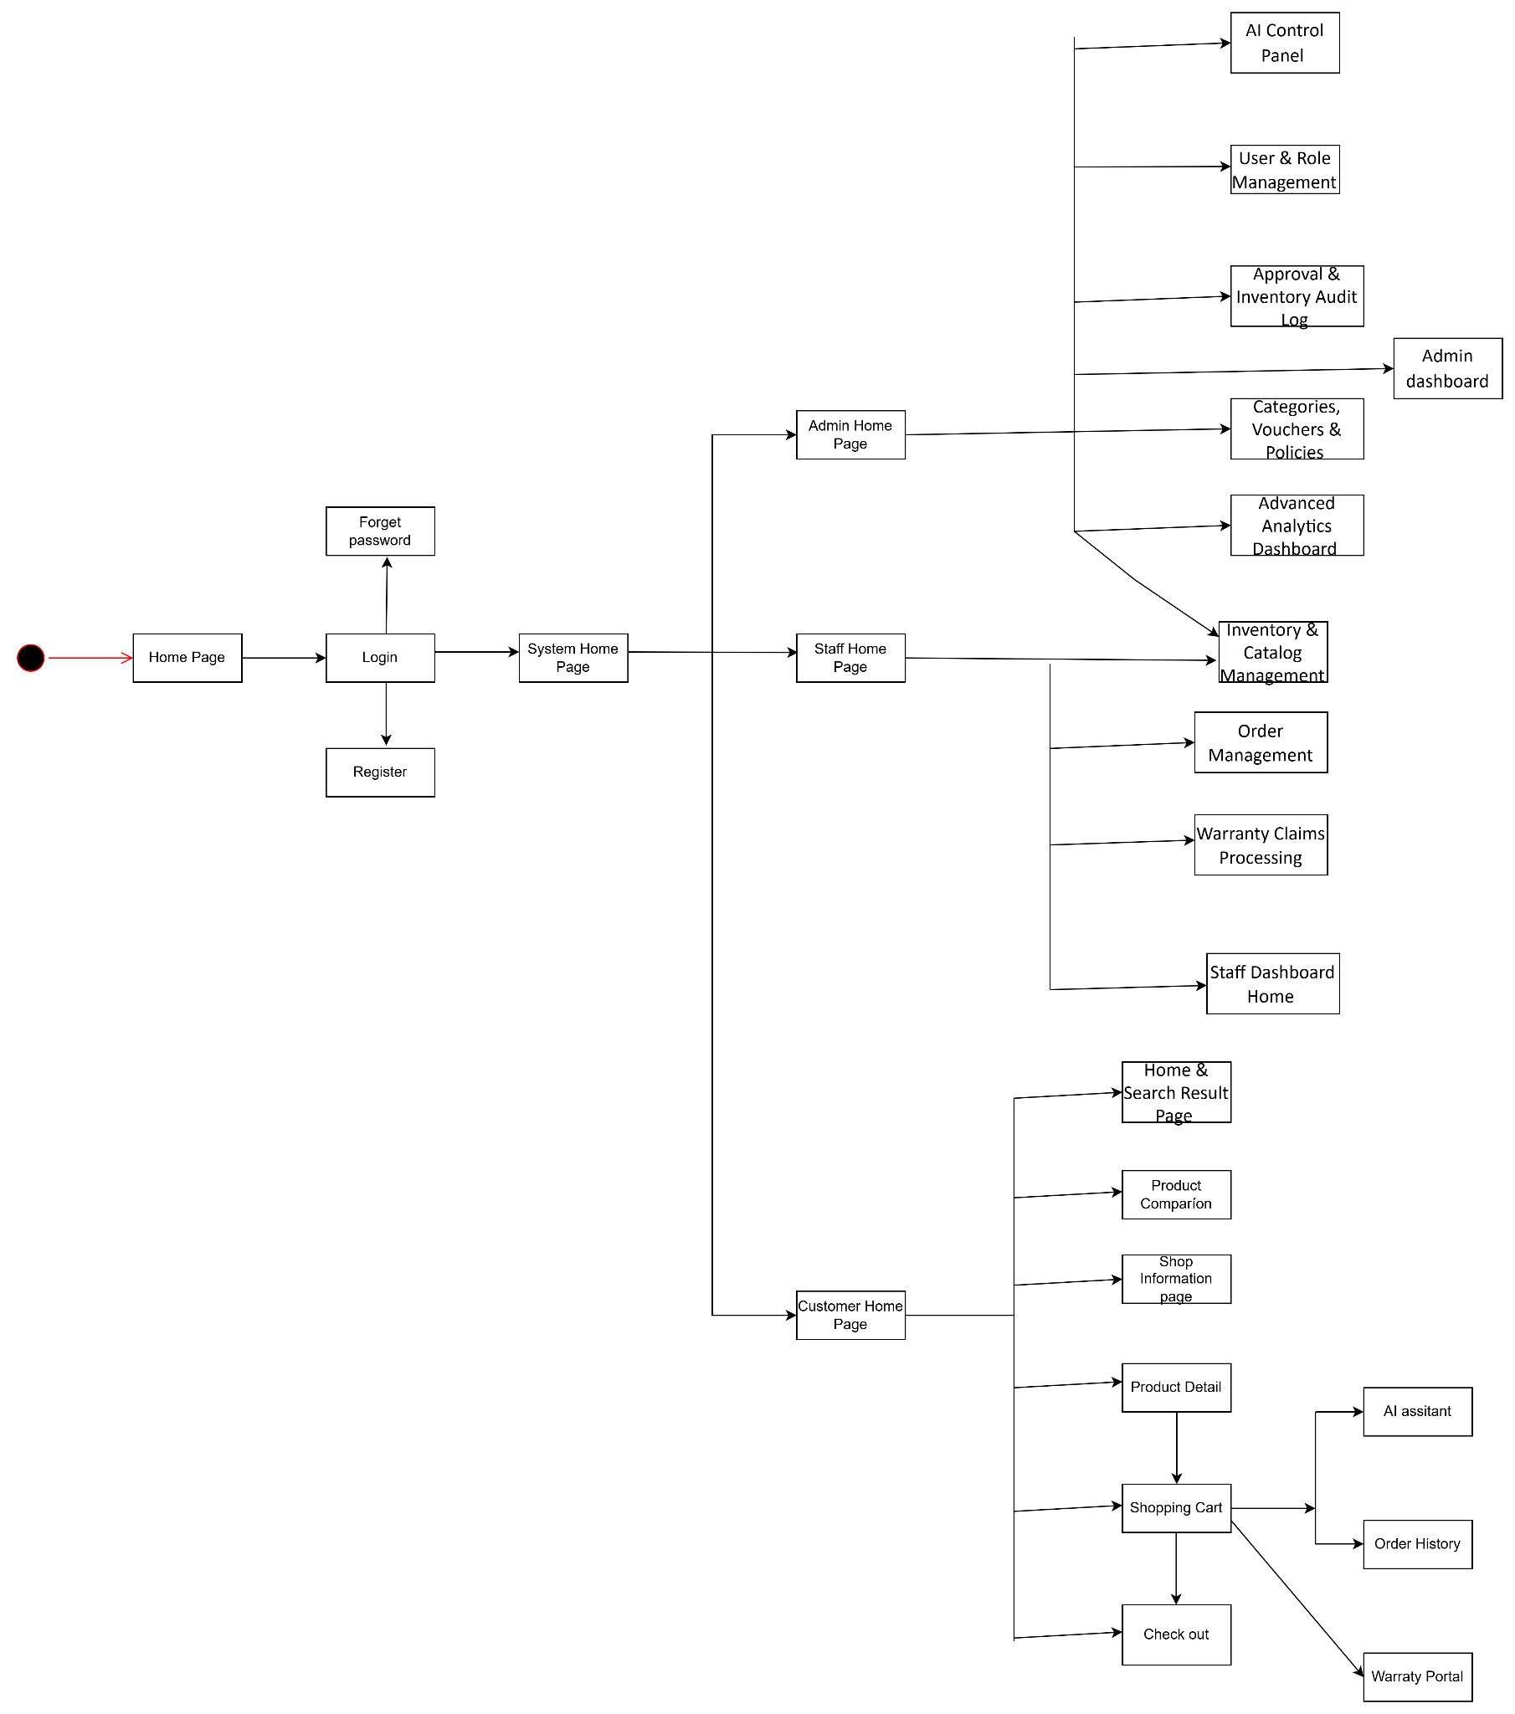

Overview Screen Flow

1.4.1.1 Admin Screen Flow

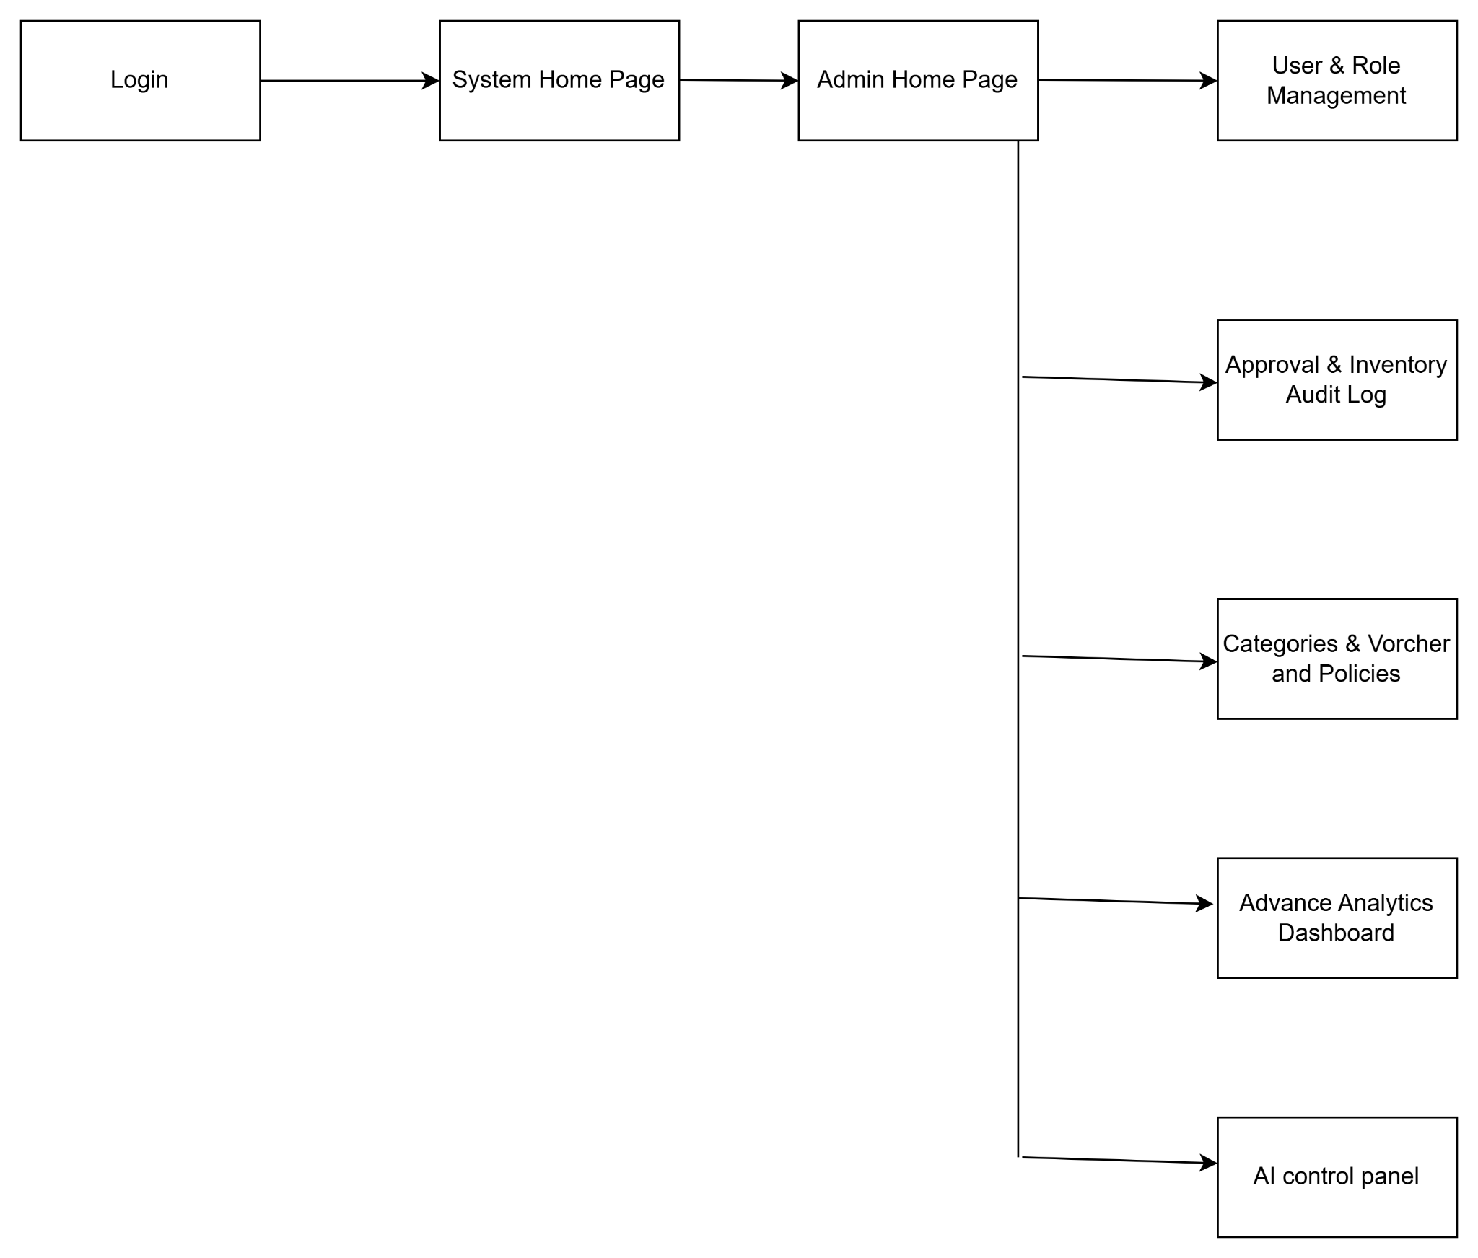
Admin Screen Flow

1.4.1.2 Staff Screen Flow

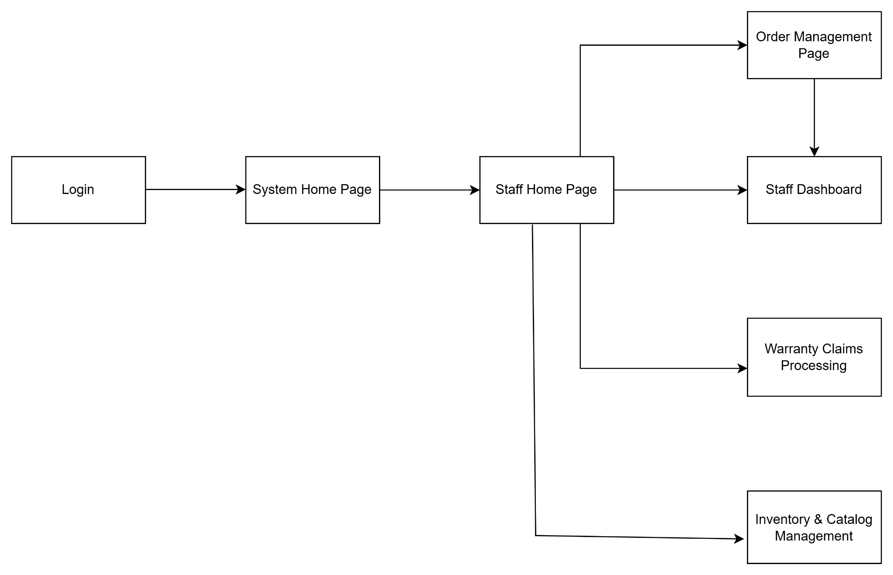
Staff Screen Management

1.4.1.3 Customer Screen Flow
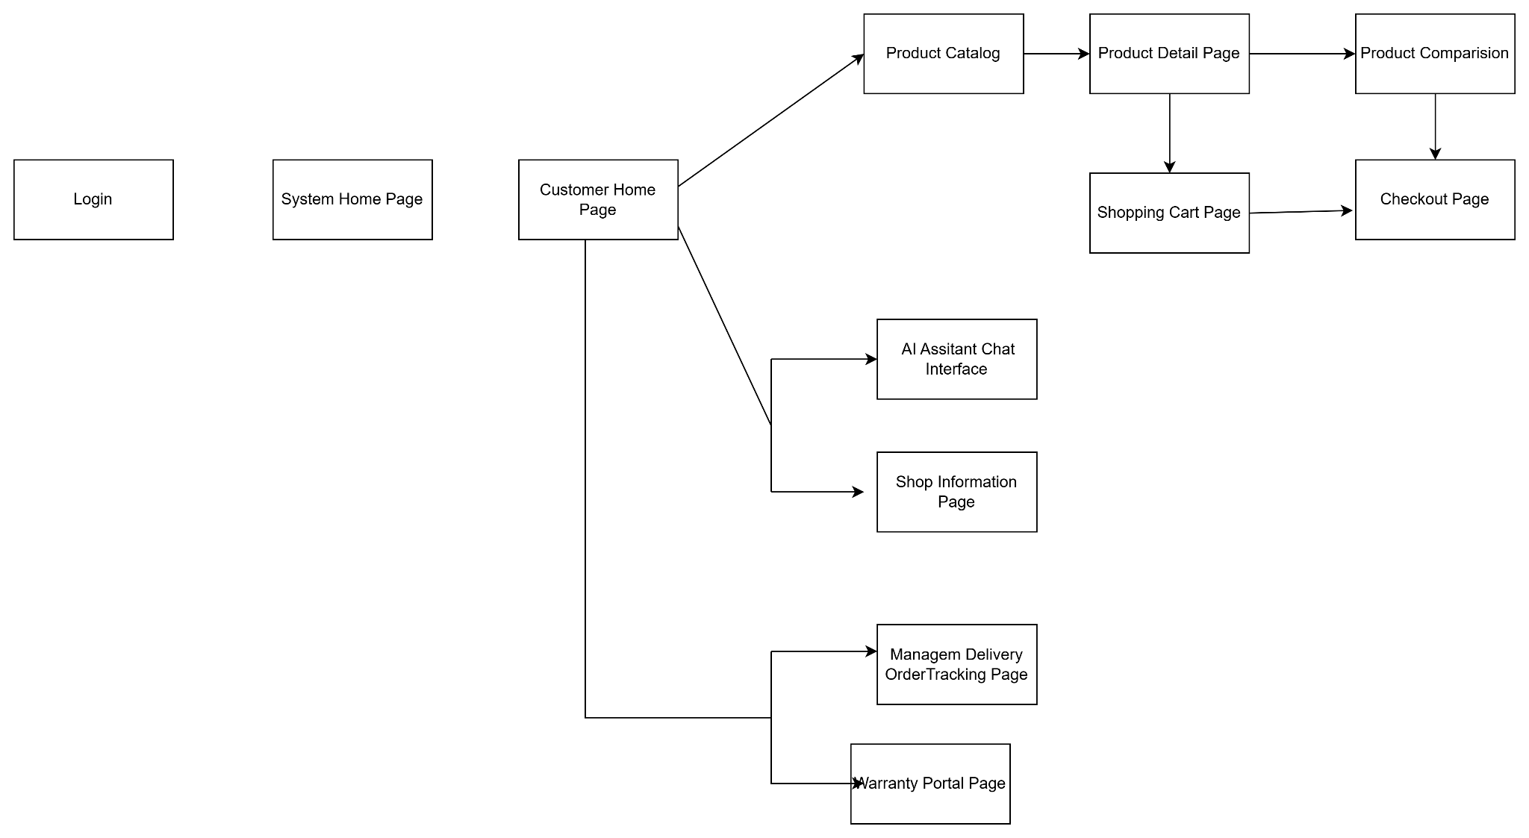
Customer Screen Flow
1.4.1.4 Guest Screen Flow
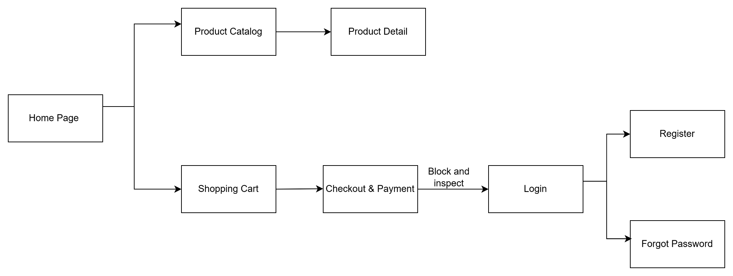
Guest Screen Flow

1.4.2 Screen Authorization

Screen | Guest | Customer | Staff | Administrator
Register Page | X | X
Login |  | X | X | X
Logout |  | X | X | X
Reset Password |  | X | X | X
Change Password |  | X | X | X
Update Profile |  | X | X | X
View Personal Profile |  | X | X | X
View Account List |  |  |  | X
Update Account |  |  |  | X
Add New User Account |  |  |  | X
Verify Student |  | X | X
View System Dashboard |  |  | X | X
Manage Warranty Policy |  |  |  | X
Submit Warranty Request |  | X
Track Warranty Status |  | X
Process Warranty Request |  |  | X | X
View Advanced Analytics |  |  |  | X
Manage Footer Policy |  |  |  | X
Create Product Variant |  |  | X
View Product Variant List |  |  | X
Edit Product Information |  |  | X
Deactivate Product |  |  | X
Manage Product Categories |  |  | X
Create Ticket |  |  | X
Manage Admin Tickets |  |  | X
View Ticket List |  |  |  | X
Review Ticket |  |  |  | X
Add Product IMEI |  |  | X
View Pending Orders |  |  | X
Assign Serial/IMEI and Fulfill Order |  |  | X
Print Invoice Slip |  |  | X
View Outbound History |  |  | X
Manage voucher |  |  |  | X
Manage Sale |  |  |  | X
Compare Products | X | X
Manage Product Reviews |  |  | X | X
AI chatbot |  | X
Moderate AI Guardrails |  |  |  | X
Browse Home Products & Search Products | X | X
Browse & Search Product Catalog | X | X
View Product Detail | X | X
View & Update Shopping Cart |  | X
Checkout Order |  | X
Manage Orders |  |  | X
Track Order |  | X

1.4.3 Non-UI Functions

# | Feature | System Function | Description
1 | Membership & Auth | BcryptCredentialEncryption | Automatically encrypt customer passwords before saving them to the database (users are not able to see this encryption process).
2 | Sales & Order | InventoryLockManager | Automatically and temporarily lock the inventory quantity as soon as a customer places an order, preventing two people from buying the same last item at the same time.
3 | AI Support | ExternalLLMGatewayAPI | Automatically call the API to send data to the OpenAI/Gemini server so the chatbot can process the customer's question and return the result.

1.5 Entity Relationship Diagram
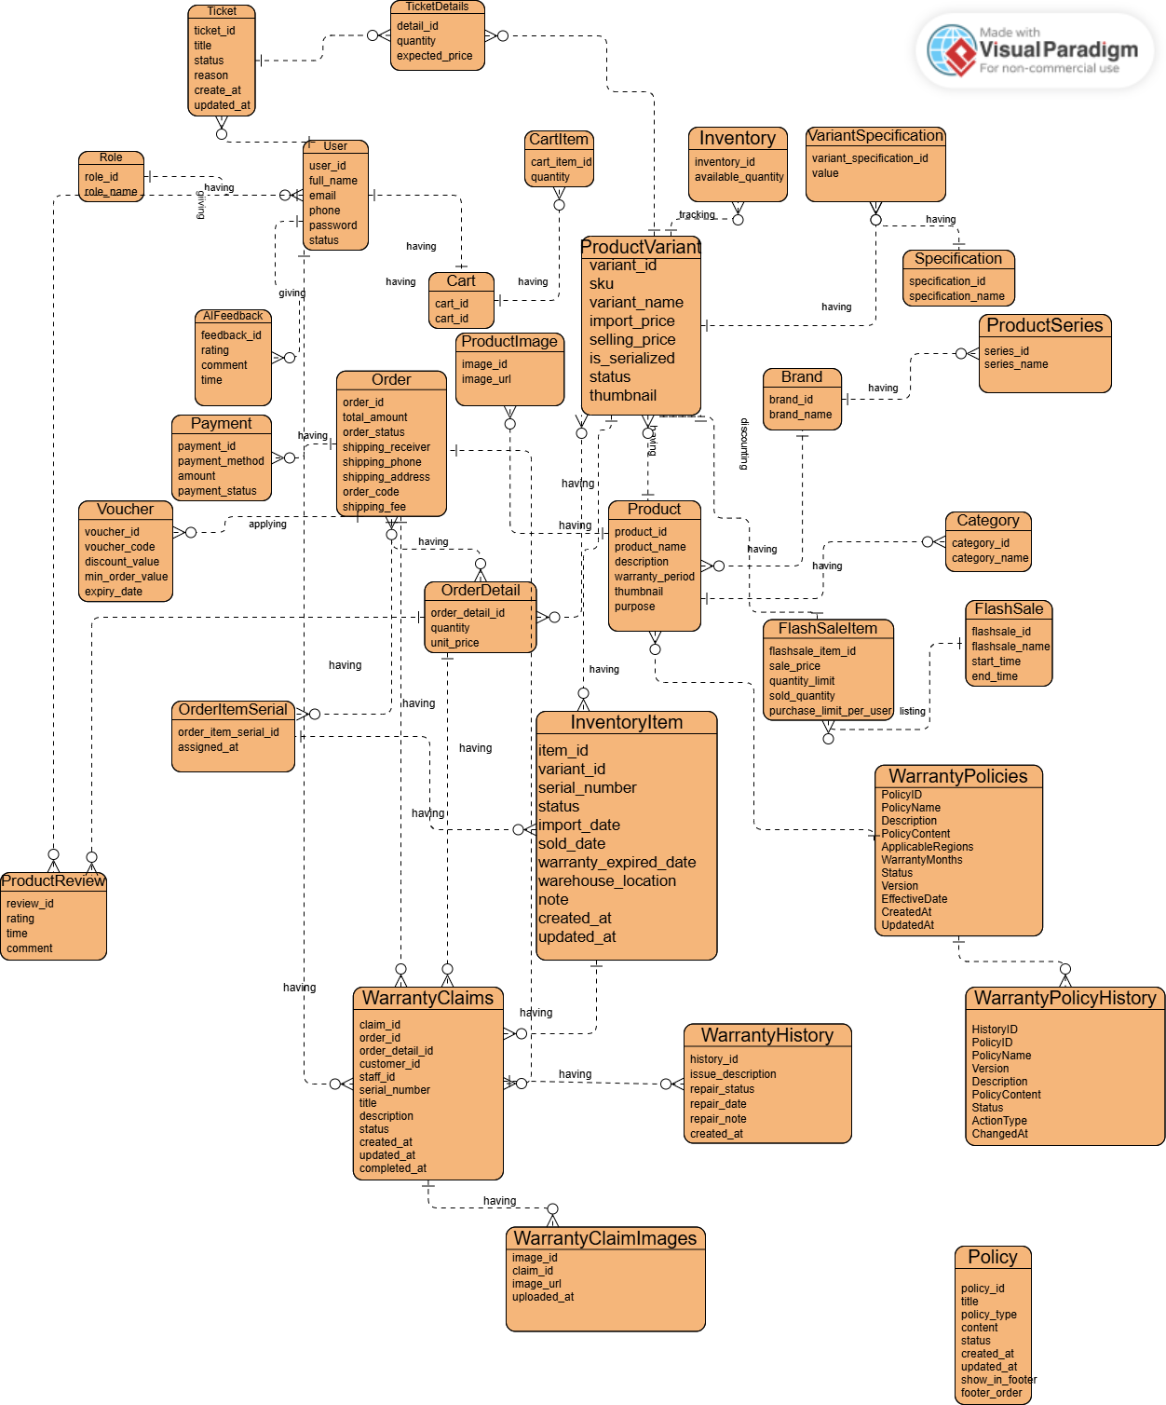
1.5 Logical Entity Relationship Diagram (ERD)
1.Một Role có nhiều User. Một User chỉ thuộc một Role.
2. Một WarrantyClaim có nhiều WarrantyHistory. Một WarrantyHistory chỉ thuộc một WarrantyClaim.
3.Một User có một Cart. Một Cart chỉ thuộc một User.
4.Một Cart có nhiều CartItem. Một CartItem chỉ thuộc một Cart.
5.Một ProductVariant có thể xuất hiện trong nhiều CartItem. Một CartItem chỉ chứa một ProductVariant.
6.Một Product có nhiều ProductVariant. Một ProductVariant chỉ thuộc một Product.
7.Một Product có nhiều Image. Một Image chỉ thuộc một Product.
8.Một Brand có nhiều Product. Một Product chỉ thuộc một Brand.
9.Một Category có nhiều Product. Một Product chỉ thuộc một Category.
10.Một ProductSeries có nhiều Product. Một Product chỉ thuộc một ProductSeries.
11.Một ProductVariant có một Inventory. Một Inventory chỉ quản lý một ProductVariant.
12.Một ProductVariant có nhiều InventoryItem. Một InventoryItem chỉ thuộc một ProductVariant.
13.Một ProductVariant có nhiều VariantSpecification. Một VariantSpecification chỉ thuộc một ProductVariant.
14.Một Specification có nhiều VariantSpecification. Một VariantSpecification chỉ thuộc một Specification.
15.Một FlashSale có nhiều FlashSaleItem. Một FlashSaleItem chỉ thuộc môt FlashSale.
16.Một ProductVariant có thể tham gia nhiều FlashSaleItem. Một FlashSaleItem áp dụng cho nhiều ProductVariant.
17.Một User có nhiều Order. Một Order chỉ thuộc một User.
18.Một Order có nhiều OrderDetail. Một OrderDetail chỉ thuộc một Order.
19.Một ProductVariant có thể xuất hiện trong nhiều OrderDetail. Một OrderDetail chứa nhiều ProductVariant.
20.Một Order có một Payment. Một Payment chỉ thuộc một Order.
21.Một Voucher có thể được áp dụng cho nhiều Order. Một Order áp dụng tối đa một Voucher.
22.Một OrderDetail có nhiều OrderItemSerial. Một OrderItemSerial chỉ thuộc nhiều OrderDetail.
23.Một InventoryItem chỉ được gán cho tối đa một OrderItemSerial. Một OrderItemSerial tham chiếu đến một InventoryItem.
24.Một User có nhiều ProductReview. Một ProductReview chỉ được tạo bởi một User.
25.Một Product có nhiều ProductReview. Một ProductReview chỉ đánh giá một Product.
26.Một User có nhiều AIFeedback. Một AIFeedback chỉ thuộc một User.
27.Một OrderDetail có một Warranty. Một Warranty chỉ thuộc một OrderDetail.
28.Một InventoryItem có một Warranty. Một Warranty áp dụng cho một InventoryItem.
29.Một Warranty có nhiều WarrantyHistory. Một WarrantyHistory chỉ thuộc một Warranty.
30.Một Customer (User) có nhiều WarrantyClaim. Một WarrantyClaim chỉ thuộc một Customer (User).
31. Một Staff (User) xử lý nhiều WarrantyClaim. Một WarrantyClaim chỉ được xử lý bởi một Staff (User).
32. Một OrderDetail có nhiều WarrantyClaim . Một WarrantyClaim chỉ thuộc một OrderDetail.
33. Một WarrantyClaim có nhiều WarrantyClaimImage. Một WarrantyClaimImage chỉ thuộc một WarrantyClaim.

1.5.1 Description of Data Entities
Roles
Function: Stores the list of roles in the system to support user authorization.
Attribute | Description
role_id | Role ID
role_name | Role name (Admin, Staff, Customer)

User
Function: Manages customer and staff account information.
Attribute | Description
user_id | User ID
full_name | Full name
email | Login email
phone | Phone number
password | Encrypted password
status | Account status

Cart
Function: Stores products customers add before placing an order.
Attribute | Description
cart_id | Cart ID

CartItem
Function: Stores the list of products and quantities in the cart.
Attribute | Description
cart_item_id | Cart item ID
quantity | Product quantity

Brand
Function: Manages product brands in the system.
Attribute | Description
brand_id | Brand ID
brand_name | Brand name

Category
Function: Classifies products into groups such as Laptop, Mouse, Keyboard, etc.
Attribute | Description
category_id | Category ID
category_name | Category name

ProductSeries
Function: Manages the product series belonging to each brand.
Attribute | Description
series_id | Series ID
series_name | Series name

Product
Function: Stores general product information.
Attribute | Description
product_id | Product ID
product_name | Product name
description | Product description
warranty_period | Warranty period
thumbnail | Thumbnail image
created_at | Creation date

ProductVariant
Function: Manages product variants.
Attribute | Description
variant_id | Variant ID
sku | SKU code
variant_name | Variant name
import_price | Import price
selling_price | Selling price
is_serialized | Whether serial numbers are tracked
status | Status

Image
Function: Stores illustrative images for products.
Attribute | Description
image_id | Image ID
product_image | Image path

Inventory
Function: Tracks the stock quantity of each product variant.
Attribute | Description
inventory_id | Inventory ID
reserved_quantity | Reserved quantity
available_quantity | Available quantity
tracking_level | Inventory tracking level

InventoryItem
Function: Manages each individual physical product item in the warehouse.
Attribute | Description
idvariant_id | Variant ID
serial_number | Serial number
imei | IMEI code
barcode | Barcode
status | Status
import_date | Import date
sold_date | Sold date
warranty_expired_date | Warranty expiration date
warehouse_location | Warehouse location
note | Note
created_at | Creation date
updated_at | Update date

Specification
Function: Stores the list of technical specification types applicable to products, such as CPU, RAM, Color, Storage capacity, etc.
Attribute | Description
specification_id | Specification ID
specification_name | Technical specification name

VariantSpecificationValue
Function: Stores the specific value of each specification for each Product Variant.
Attribute | Description
variant_specification_id | Link ID
value | Specification value

FlashSale
Function: Manages discount programs within a defined time period.
Attribute | Description
flashsale_id | Program ID
flashsale_name | Program name
start_time | Start time
end_time | End time

FlashSaleItem
Function: Links products to a Flash Sale program and manages the promotional quantity.
Attribute | Description
flashsale_item_id | Flash Sale product ID
sale_price | Promotional selling price
quantity_limit | Quantity limit
sold_quantity | Quantity sold
purchase_limit_per_user | Purchase limit per customer

Voucher
Function: Manages promotional codes applied to orders.
Attribute | Description
voucher_id | Voucher ID
voucher_code | Discount code
discount_value | Discount value
min_order_value | Minimum order value
expiry_date | Expiration date

Order
Function: Stores overview information of orders created in the system.
Attribute | Description
order_id | Order ID
total_amount | Total order value
order_status | Order status
shipping_receiver | Recipient name
shipping_phone | Recipient phone number
shipping_address | Shipping address
order_code | Order code
shipping_fee | Shipping fee

OrderDetail
Function: Stores the list of products belonging to each order.
Attribute | Description
order_detail_id | Order detail ID
quantity | Product quantity
unit_price | Unit price at time of purchase

Payment
Function: Manages customers' payment transactions.
Attribute | Description
payment_id | Payment ID
payment_method | Payment method
amount | Payment amount
payment_status | Payment status

OrderItemSerial
Function: Records the serial number or IMEI of a product delivered to a customer in an order.
Attribute | Description
order_item_serial_id | Record ID
assigned_at | Time the serial was assigned

ProductReview
Function: Stores customer reviews and feedback on purchased products.
Attribute | Description
review_id | Review ID
rating | Rating score
time | Review time
comment | Review content

Feedback
Function: Collects customer feedback about the service and system.
Attribute | Description
feedback_id | Feedback ID
rating | Satisfaction level
comment | Feedback content
time | Time feedback was submitted

Warranty
Function: Manages the warranty period and status of each sold product.
Attribute | Description
warranty_id | Warranty ID
warranty_expired_date | Warranty expiration date
start_date | Warranty start date
warranty_status | Warranty status

WarrantyHistory
Function: Stores the full history of repairs, warranty service, and part replacement of a product during the warranty period.
Attribute | Description
history_id | Warranty history ID
description | Warranty processing content
repair_date | Repair date
repair_note | Technical note
created_at | Record creation date

Ticket
Function: Manages general request tickets (stock-in/stock-out/support) in the system
Attribute | Description
ticket_id | Ticket ID
title | Ticket title
status | Ticket status
reason | Reason/Content of the ticket
created_by | ID of the ticket creator
created_at | Ticket creation date
updated_at | Ticket last update date

TicketDetail
Function: Manages detailed information of items (products/variants) within a specific ticket
Attribute | Description
detail_id | Ticket detail ID
quantity | Product quantity
expected_price | Expected price

2. Use Case Specifications

2.1 Authentication & Access

UC01 – Register Account

UC ID & Name | UC01 - Register
Created By | LUCTV
Date Created | May 26, 2026
Primary Actor | Guest
Secondary Actor | Database System
Trigger | Primary click on the “Đăng kí” tab or link
Description | To allow a Guest to create a new customer account in the system by providing their personal information. Upon successful registration, the Guest is recognized as a Customer and can proceed to sign in to access member-only services.
Preconditions | The Guest does not have an existing account associated with the email address or phone number they intend to use.
Postconditions | A new Customer account is created and activated. The user is guided to the Login page.
Normal Flow | - User navigates to Register page  - User enter:full name,email,phone, password and confirm password  - User clicks the Register button  - System validates the inputs  - System checks for duplicate email or phone in the database  - System hash the password  - System insert the user record into database  - System redirects the user to Login page with successful message
Alternative Flow | None
Exception Flow | - Exception Flow 1: Missing required fields  - System displays error message: "Please fill in all required fields!"  - Exception Flow 2: Invalid Name format (contains numbers/special characters)  - System displays error message:"Full name must only contain letters and spaces!  - Exception Flow 3: Name exceeds maximum length (over 100 characters)  - System displays error message:"Full name must not exceed 100 characters!"  - Exception Flow 4: Passwords mismatch  - System displays error message: "Passwords do not match!"  - Exception Flow 5: Invalid Email format  - System displays error message: "Invalid email address!"  - Exception Flow 6: Invalid Phone format (must be 10 digits starting with 03/05/07/08/09)  - System displays error message:"Invalid phone number!"  - Exception Flow 7: Password is too short (less than 6 characters)  - System displays error message: "Password must be at least 6 characters long!"  - Exception Flow 8: Email already in use  - System displays error message: "This email is already registered!"  - Exception Flow 9: Phone number already in use  - System displays error message: "This phone number is already registered!"
Business Rule | - BR1-Identity Uniquesness  - BR2-Default Account Status and Access Level  - BR3-Credential Protection  - BR4-Input Contraints & Formats
Priority | Must Have

UC02 – Login

UC ID & Name | UC02 - Login
Created By | LUCTV
Date Created | May 26, 2026
Primary Actor | Customer, Staff , Admin
Secondary Actor | Google OAuth Service(For Google Login)
Trigger | The user wants to access secured features or their personal account on the system.
Description | Verify the user's identity (via standard credentials or a Google account) to grant access to the appropriate features based on their specific role.
Preconditions | The user has an active account on the system (or a functional Google account).
Postconditions | The user is successfully logged in and directed to the appropriate interface for their role.
Normal Flow | • User opens the Login page.  • User enters their registered Email and Password.  • User submits the credentials.  • System recognizes the user's role and redirects them to their designated dashboard.
Alternative Flow | Quick Login via Google:  1. User selects the "Continue with Google" option.  2. User approves sharing their basic profile info on the Google authentication screen.  3. System checks the user's status:  - If new user: System automatically sets up a new profile under the Customer role.  - If existing user: System recognizes the existing profile.  4. System logs the user in and redirects them to the Home Page.
Exception Flow | • Incorrect Credentials: System informs the user of an invalid email or password combination and asks them to check their inputs.  • Restricted Account: System denies access, showing a message that the account is locked or disabled, and provides guidance to contact support.  • Linked Google Account Locked: Even if Google authentication succeeds, the system blocks the user if their internal profile status is locked.
Business Rule | BR1 - Credential Verification: Users must provide the exact matching  BR2 - Account Status Check:  BR3 - Role-Based Redirection:  BR4 - Credential Persistence (Remember Me)  BR5 - Automatic Registration via Google  BR6 - Google Login Authorization  BR7 - Mandatory Input Fields
Priority | Must Have

UC03 –Reset Password

UC ID & Name | UC03 - Reset Password
Created By | LUCTV
Date Created | June 18, 2026
Primary Actor | Customer, Staff, Admin
Secondary Actor | None
Trigger | The user clicks the secure recovery link received in their personal email inbox.
Description | To enable a user to set up a brand new password for their account using a validated email link, ensuring the recovery process is straightforward for the user while protecting their account credentials.
Preconditions | The user's password has been successfully updated in the system. The reset link is marked as used and cannot be reused. The user is redirected to the Login page with a success
Postconditions | The user's account password is safely updated. The security link is immediately deactivated to prevent reuse, and the user is guided to the Login screen to access their account with the new credentials.
Normal Flow | - User navigates to the Login page and clicks the "Forgot Password?" link  - System displays the Forgot Password page with an email input form  - User enters their registered email address and clicks the "Request Reset Link" button  - System validates that the email format is valid  - System verifies that the email exists in the system  - System generates a password reset link, sends it to the user's email, and displays a success message confirming the request was sent, hiding the email form  - User opens their email inbox and clicks the "Reset Password" button in the email  - System validates that the reset link is still valid (not expired, not yet used) and displays the Reset Password page with New Password and Confirm Password fields  - User enters a new password and confirms it, then clicks the "Save New Password" button  - System validates the password (minimum length, matches confirmation) and confirms the link is still valid  - System updates the user's password and marks the reset link as used  - System redirects the user to the Login page with a successful password reset message
Alternative Flow | None
Exception Flow | - Exception Flow 1: Empty email field  - System displays error message: "Vui lòng nhập địa chỉ email!"  - User is returned to the email input form  - Exception Flow 2: Invalid email format  - System displays error message: "Định dạng email không hợp lệ!"  - User is returned to the email input form  - Exception Flow 3: Email does not exist in the system  - System displays error message: "Email không tồn tại trong hệ thống!"  - User is returned to the email input form  - Exception Flow 4: Email sending failure (SMTP/network error)  - System displays error message: "Gửi email thất bại. Vui lòng kiểm tra lại kết nối mạng hoặc thử lại sau!"  - User is returned to the email input form  - Exception Flow 5: Token is invalid, expired (>15 minutes), or already used  - System displays error message: "Liên kết khôi phục mật khẩu không hợp lệ hoặc đã hết hạn!"  - The password form is hidden. Only the "Back to Login" link is shown  - Exception Flow 6: Password is less than 6 characters  - System displays error message: "Mật khẩu phải chứa ít nhất 6 ký tự!"  - User is returned to the password input form  - Exception Flow 7: Confirm password does not match  - System displays error message: "Xác nhận mật khẩu không khớp!"  - User is returned to the password input form
Business Rule | - BR1-Token Uniqueness and Security  - BR2-Token Expiration Policy  - BR3-Single-Use Token Enforcement  - BR4-Credential Protection  - BR5-Input Constraints & Formats  - BR6-Password Confirmation Agreement
Priority | Must Have

UC04 –Change Password

UC ID & Name | UC04- Change Password
Created By | LUCTV
Date Created | May 26, 2026
Primary Actor | Customer, Staff , Admin
Secondary Actor | None
Trigger | The user interacts with the "Đổi mật khẩu" (Change Password) card inside their personal Profile interface and submits the form.
Description | To allow any authenticated user (Customer, Staff, or Admin) to actively update their account password for better account protection by verifying their current credentials and defining a new secure one.
Preconditions | The user (Customer, Staff, or Admin) must be successfully signed into the system with an active, authenticated active session.
Postconditions | The account security records are successfully updated. The user’s active session remains continuous under the updated credentials, and a confirmation message is delivered.
Normal Flow | • Step 1 (User Action): The user navigates to their personal Profile page layout.  • Step 2 (User Action): The user locates the dedicated "Đổi Mật Khẩu" entry card.  • Step 3 (User Action): The user fills out three required entry slots: their Current Password, New Password, and Confirm New Password.  • Step 4 (User Action): The user clicks the "Đổi Mật Khẩu" button to request the change.  • Step 5: The system checks that all three inputs contain data and validates that the provided current password accurately matches the user's active identity.  • Step 6: The system validates that the new password is safe (at least 6 characters long), matches the confirmation input exactly, and is not identical to the current active password.  • Step 7: The system securely updates the account credentials in the background and applies the change to the user's active login session status without disrupting their stay on the site.  • Step 8: The interface displays a clear success notification on the screen: "Đổi mật khẩu thành công!"
Alternative Flow | None
Exception Flow | • Exception Flow 1: Blank Input Fields  - Condition: The user fails to fill out one or more of the three password entry slots before hitting submit.  - System Response: The interface stops the update and warns: "Vui lòng điền đầy đủ tất cả các trường mật khẩu!"  • Exception Flow 2: Incorrect Existing Password  - Condition: The text entered in the "Current Password" slot does not match the user's real password.  - System Response: The system rejects the change and prompts: "Mật khẩu hiện tại không đúng!"  • Exception Flow 3: Short Length Selection  - Condition: The user proposes a new password that contains fewer than 6 characters.  - System Response: The interface flags the entry and warns: "Mật khẩu  mới phải có ít nhất 6 ký tự!"  • Exception Flow 4: Mismatched Confirmation Entry  - Condition: The text typed in the confirmation slot does not exactly match the chosen new password text.  - System Response: The interface prompts the user with: "Xác nhận mật khẩu không khớp!"  • Exception Flow 5: Reusing Identical Credentials  - Condition: The user tries to set a new password that is exactly identical to the password they are currently using.  - System Response: The interface blocks the submission and displays: "Mật khẩu mới không được trùng với mật khẩu hiện tại!"  • Exception Flow 6: Internal Data Update Glitch  - Condition: A temporary backend storage error or operational failure disrupts the update transaction midway.  - System Response: The system preserves the user's current view state safely and displays: "Đổi mật khẩu thất bại. Vui lòng thử lại!"
Business Rule | • BR1 - Verification Pre-Requisite  • BR2 - Rotation Security Enforcements  • BR3 - Complexity Threshold  • BR4 - Integrity Confirmation  • BR5 - Credential Data Protection
Priority | Must Have

2.2 Account Management

UC05 –Update Profile

UC ID & Name | UC05-Update Profile
Created By | LUCTV
Date Created | May 26, 2026
Primary Actor | Customer, Staff , Admin
Secondary Actor | None
Trigger | The user modifies their contact identity details or changes their avatar display inside the Profile layout and submits the changes.
Description | To enable a logged-in user (Customer, Staff, or Admin) to keep their personal account profile details fresh and accurate by modifying their Full Name, Phone Number, or choosing a personalized profile photo.
Preconditions | The user (Customer, Staff, or Admin) must be logged into the system and currently view their account configuration section.
Postconditions | The user's profile identity values are successfully saved. Any newly selected avatar file is stored on the hosting space, and the changes instantly mirror across all visual menus on the application interface.
Normal Flow | • Step 1 (User Action): The user goes to their personal Profile dashboard space.  • Step 2 (User Action): The user alters their identity text fields, specifically Full Name (Họ và Tên) or Phone Number (Số Điện Thoại).  • Step 3 (User Action): Optionally, the user clicks on their profile photo frame to upload a new image from their device, immediately seeing a live preview of the image update on the screen.  • Step 4 (User Action): The user clicks the "Lưu Thay Đổi" (Save Changes) button to apply their updates.  • Step 5: The system verifies that the Full Name text field is not left empty and ensures that any uploaded avatar is a valid image type file format.  • Step 6: The system processes the new image safely, updates the user's permanent profile records, and ensures the active identity profile updates in real-time across the active user session workspace.  • Step 7: The interface refreshes the top navbars or side panels to match the new details and pops up a clear confirmation message: "Cập nhật thông tin cá nhân thành công!"
Alternative Flow | None
Exception Flow | • Exception Flow 1: Name Field Left Empty  - Condition: The user clears out their full name or places only spaces into the input field and attempts to save.  - System Response: The interface blocks the submission and displays: "Họ tên không được để trống!"  • Exception Flow 2: Non-Image Document Format Uploaded  - Condition: The user selects a file format that is not a standard image (e.g., a PDF, text file, or zip file) to use as an avatar.  - System Response: The interface stops the processing flow and displays: "Định dạng file không hợp lệ! Vui lòng tải lên file ảnh."  • Exception Flow 3: Server Media Saving Failure  - Condition: The file transfer process encounters an unexpected interruption or directory write issue while saving the picture file.  - System Response: The application halts safely and provides a descriptive warning: "Lỗi tải ảnh đại diện: [error message]"  • Exception Flow 4: Profile Records Write Error  - Condition: A temporary transactional storage timeout or database failure prevents the new text data from being updated.  - System Response: The system safeguards the current view state inputs and warns the user with: "Cập nhật thông tin thất bại. Vui lòng thử lại!"
Business Rule | • BR1 - Mandatory Identity Requirement  • BR2 - Avatar Document Standard  • BR3 - File Volume Envelope Constrain  • BR4 - Seamless Visual Interface Sync
Priority | Must Have

UC06 –View Personal Profile

UC ID & Name | UC06-View Personal Profile
Created By | LUCTV
Date Created | May 26, 2026
Primary Actor | Customer,Staff,Admin
Secondary Actor | None
Trigger | The user chooses their profile option from the top navigation header dropdown menu or directly navigates to their profile screen area.
Description | To allow any signed-in user (Customer, Staff, or Admin) to review their complete account profile records—including personal contact information, avatar display, and active system responsibilities—on a dedicated summary screen.
Preconditions | The user (Customer, Staff, or Admin) must be successfully signed into the system with an active, recognized login state.
Postconditions | 1The system presents the user's latest account details, displays an accurate role title, and offers a tailored navigation back-step option corresponding to their access level.
Normal Flow | • Step 1 (User Action): The user clicks the profile link from the account dropdown or opens the profile workspace directly.  • Step 2: The system screens the request to confirm the user is signed in and automatically fetches their latest profile summary from the records.  • Step 3: The system loads the Profile Information layout screen, rendering the following specific details for the user:  - The user's active profile picture avatar (or a generic placeholder if they haven’t added one).  - Their Full Name and Phone Number loaded inside editable text boxes.  - Their registered Email Address displayed clearly inside a locked, read-only field.  - A distinct system role label badge that clearly identifies their account clearance tier.  • Step 4: The interface dynamically positions a "Quay lại" (Back) navigation link that targets their respective workspace destination seamlessly:  - If the actor is an Admin: The button points directly back to their main administration dashboard workspace (/admin/dashboard).  - If the actor is a member of Staff: The button points directly back to their internal operational inventory workspace (/staff/inventory).  - If the actor is a standard Customer: The button points directly back to the public store homepage layout (/HomeServlet).
Alternative Flow | None
Exception Flow | • Exception Flow 1: Unauthenticated Guest Attempt  - Condition: An unauthenticated visitor (Guest) tries to access the profile link or types the path directly without logging in.  - System Response: The application completely blocks the attempt, intercepts the view, and redirects them to the Login page displaying a restrictive prompt: "Vui lòng đăng nhập để tiếp tục!"  • Exception Flow 2: Live Records Retrieval Timeout/Failure  - Condition: The system experiences a momentary database connection error or retrieval glitch when opening the profile page.  - System Response: To prevent screen crashing or blank spaces, the interface safely falls back to using the user data saved from their initial login session to populate the screen fields seamlessly.
Business Rule | • BR1 - Access Enforcement  • BR2 - Real-Time Information Delivery  • BR3 - Smart Role-Based Routing  • BR4 - Role Badge Standardization
Priority | Must Have

UC07 –View Account List

UC ID & Name | UC07-View Account List
Created By | LUCTV
Date Created | May 26, 2026
Primary Actor | Admin
Secondary Actor | None
Trigger | The Admin clicks the "Manage Users" (Quản lý tài khoản) tab or link on the Admin Dashboard panel.
Description | To allow the Administrator to seamlessly browse, search, filter, and page through the global directory of all registered system user accounts (including Customers, Staff, and fellow Admins).
Preconditions | The Admin is logged in with a valid session and has Admin-level privileges.
Postconditions | The list of user accounts matching the search/filter criteria is displayed to the Admin. No data is modified.
Normal Flow | - Admin navigates to the "Quản lý tài khoản" page from the sidebar menu  - System verifies the Admin's session and confirms the user has Admin privileges  - System displays the first page of user accounts (10 records per page)  - System displays the account list in a table with columns: User ID, Full Name, Email, Phone, Role, Status, and Actions  - Admin can enter a keyword (name or email) in the search box, select a Role filter (Admin / Staff / Customer / Student / B2B) and a Status filter (Active / Inactive), then click "Tìm kiếm" to filter results  - System filters the account list based on the applied search keyword and filters, and displays the matching results with updated pagination  - Admin clicks the "Chi tiết" button on a specific account row  - System opens the User Detail Modal popup displaying full account information: User ID, Full Name (with Avatar), Email, Phone, Role Badge, Status Badge, Registration Date (dd/MM/yyyy HH:mm:ss), and Last Login (dd/MM/yyyy HH:mm:ss)
Alternative Flow | - Alternative Flow 1: Admin clears all filters  - Admin clicks the "Xóa lọc" button (appears only when filters are active)  - System reloads the page with no search keyword and no filters applied, showing the full account list from page 1  - Alternative Flow 2: Admin closes the detail modal  - Admin clicks the "Đóng" button or the "×" close icon on the User Detail Modal  - System closes the modal and returns to the account list view
Exception Flow | - Exception Flow 1: Unauthorized access (not logged in or not Admin)  - System redirects the user to the Login page with error message: "Bạn không có quyền truy cập trang quản lý tài khoản!"  - Exception Flow 2: No accounts match the search/filter criteria  - System displays an empty table with the message: "Không tìm thấy tài khoản nào phù hợp với từ khóa."  - Pagination is hidden
Business Rule | - BR1-Role-Based Access Control  - BR2-Pagination Policy  - BR3-Search Behavior  - BR4-Filter Combination Multiple  - BR5-Account Detail Display
Priority | Must Have

UC08 –Update Account

UC ID & Name | UC08-Update Account
Created By | LUCTV
Date Created | May 26, 2026
Primary Actor | Admin
Secondary Actor | Database System
Trigger | Admin clicks the "Khóa" / "Mở khóa" button, or changes the Role dropdown, of a user account on the Manage User Accounts page
Description | To allow an Admin to update user account properties, including changing the account status (lock to inactive, or unlock to active) and updating the account role (Admin, Staff, Customer, Student). The system prevents the Admin from performing these operations on their own account and checks for active orders before locking an account.
Preconditions | 1. The Admin is logged in with a valid session and has Admin-level privileges.  2. The Admin is on the Manage User Accounts page (View Account List).
Postconditions | The target account's status or role is updated. The Admin is redirected back to the account list page with a success message.
Normal Flow | Scenario A — Change Account Status (Lock)  - Admin views the account list and identifies the account to lock  - Admin clicks the "Khóa" button on the target account row  - System verifies the target account is not the Admin's own account  - System checks whether the target user has any active (unfinished) orders  - System displays a confirmation dialog: "Bạn có chắc chắn muốn KHÓA tài khoản {email}?"  - Admin confirms the action  - System updates the account status to "Đã khóa"  - System redirects the Admin back to the account list with success message: "Tài khoản đã được khóa thành công."  Scenario B — Change Account Role  - Admin views the account list and identifies the account to update  - Admin clicks on the Role dropdown in the target account row (currently showing the account's role)  - System verifies the target account is not the Admin's own account  - Admin selects a new role from the dropdown (Admin / Staff / Customer / Student / B2B)  - System displays a confirmation dialog: "Bạn có chắc chắn muốn ĐỔI QUYỀN tài khoản {email} thành {new role}?"  - Admin confirms the action  - System updates the role of the target account  - System redirects the Admin back to the account list with success message: "Phân quyền đã được cập nhật thành công."
Alternative Flow | Alternative Flow 1: Admin unlocks a locked account  - Admin clicks the "Mở khóa" button on an inactive account row  - System displays a confirmation dialog: "Bạn có chắc chắn muốn MỞ KHÓA tài khoản {email}?"  - Admin confirms the action  - System updates the account status to "Đang hoạt động"  - System redirects with success message: "Tài khoản đã được mở khóa thành công."  Alternative Flow 2: Admin cancels the action  - Admin clicks "Hủy" on the confirmation dialog  - System cancels the operation. No changes are made. The Admin remains on the account list page
Exception Flow | Exception Flow 1: Admin attempts to lock/unlock their own account  - System displays error message: "Bạn không thể khóa tài khoản của chính mình."  - No changes are made  Exception Flow 2: Admin attempts to change their own role  - The Role dropdown is disabled for the Admin's own account row (client-side prevention)  - If the request is still submitted, the system rejects it server-side and displays error message: "Bạn không thể thay đổi quyền của chính mình."  - No changes are made  Exception Flow 3: Admin attempts to lock an account with active orders  - System checks the active orders count before showing the confirmation dialog  - If the user has active orders, system displays an alert: "Không thể khóa tài khoản này vì người dùng đang có {count} đơn hàng chưa hoàn tất!"  - No changes are made  Exception Flow 4: Invalid role value  - The selected role value is not one of the accepted roles  - System displays error message: "Phân quyền không tồn tại!"  - No changes are made  Exception Flow 5: Update failure  - System fails to update the account status or role due to a system error  - System displays error message: "Khóa tài khoản thất bại. Vui lòng thử lại!" or "Cập nhật phân quyền thất bại. Vui lòng thử lại!"  - No changes are made
Business Rule | BR1 – Self-Modification Prevention  BR2 – Active Order Check Before Locking  BR3 – Valid Role Constraint  BR4 – Status Values  BR5 – Context Preservation on Redirect  BR6 – Data Storage
Priority | Must Have

UC09 –Add New Account

UC ID & Name | UC09-Add New Account
Created By | LUCTV
Date Created | May 26, 2026
Primary Actor | Admin
Secondary Actor | None
Trigger | The Admin clicks the "Add Account" (Thêm tài khoản) button, fills out the account registration form, and submits it.
Description | To allow the Administrator to manually onboard and provision a brand new user profile into the system by specifying their identity, contact details, system operational level (Admin, Staff, or Customer), and password.
Preconditions | The user must be logged into the system with active, verified Administrator privileges and currently viewing the User Management console screen.
Postconditions | A brand new, distinct user account is successfully saved into the system directory. The Admin's active filters, search keywords, and page positions are fully retained upon returning to the directory grid, accompanied by a creation success notification.
Normal Flow | • Step 1 (User Action): The Admin opens the User Management workspace directory layout.  • Step 2 (User Action): The Admin clicks the "Thêm tài khoản" (Add Account) action button.  • Step 3: The system opens the Account Creation form interface (via an overlay window or dedicated section), presenting entry slots for: Full Name (Họ và Tên), Email, Phone Number (Số Điện Thoại - optional), Password (Mật Khẩu), and a system role dropdown menu.  • Step 4 (User Action): The Admin fills in the required account details and assigns a specific operational level tier (Admin, Staff, or Customer).  • Step 5 (User Action): The Admin clicks the "Thêm mới" (Add New) button to confirm creation.  • Step 6: The system checks the registration form entries to ensure all mandatory info is filled out correctly, verifying that the chosen Email and Phone Number have not been taken by any existing profile.  • Step 7: The system establishes the profile with a default active accessibility state, updates the central user directory, and seamlessly returns the Admin to the main User Management grid layout.  • Step 8: The interface preserves the Admin's precise workspace state (retaining search phrases, filters, and page index locations) and updates the top of the grid to show a clear success banner: "Tài khoản mới đã được tạo thành công."
Alternative Flow | None
Exception Flow | • Exception Flow 1: Unauthenticated Guest Attempt  - Condition: An unauthenticated visitor (Guest) tries to access the profile link or types the path directly without logging in.  - System Response: The application completely blocks the attempt, intercepts the view, and redirects them to the Login page displaying a restrictive prompt: "Vui lòng đăng nhập để tiếp tục!"  • Exception Flow 2: Live Records Retrieval Timeout/Failure  - Condition: The system experiences a momentary database connection error or retrieval glitch when opening the profile page.  - System Response: To prevent screen crashing or blank spaces, the interface safely falls back to using the user data saved from their initial login session to populate the screen fields seamlessly.
Business Rule | • Exception Flow 1: Blank Mandatory Inputs  • Exception Flow 2: Forbidden Symbols in Name Field  • Exception Flow 3: Malformed Email Entry  • Exception Flow 4: Broken Phone Prefix or Format  • Exception Flow 5: Weak Password Length  • Exception Flow 6: Improper/Invalid System Tier Assignment  • Exception Flow 7: Email Duplicate Conflict  • Exception Flow 8: Phone Duplicate Conflict  • Exception Flow 9: Server Storage & Data Insert Corruptions  • Exception Flow 10: Unauthorized or Guest Tampering Attempt
Priority | Must Have

UC10-Verify Student

UC ID & Name | UC10- Verify Student
Created By | LUCTV
Date Created | May 26, 2026
Primary Actor | Admin
Secondary Actor | Database System
Trigger | Staff clicks on the "Xác Minh Sinh Viên" menu item in the Staff sidebar
Description | As a Customer, I want to submit a request to verify my student status by uploading a photo of my student ID, so that my account can be upgraded to student status. As a Staff member, I want to review pending student verification requests and either approve or reject them, so that only genuine students receive the student benefits.
Preconditions | 1The Customer is logged into the system  2.The Customer does not already have a verification request awaiting review  3.The Staff member is logged into the system with the appropriate permissions.  4.There is at least one verification request available for the Staff to review.
Postconditions | 1 A new verification request is created and awaits Staff review.  2 The verification request is marked as either approved or rejected.  3 If approved, the Customer's account is upgraded to student status.  4 The Staff member sees confirmation that the action was completed.
Normal Flow | Scenario A – Submit Request (Customer)  A1. The Customer goes to their profile page.  A2 .The Customer opens the student verification section.  A3. The Customer uploads a photo of their student ID.  A4. The system checks that the uploaded file is a valid image.  A5. The system creates a new verification request for review.A6The system confirms that the request has been submitted successfully.  Scenario B – Approve Request (Staff)  B1. The Staff member opens the student verification page.  B2. The system shows the list of pending requests, including each uploaded ID image and submission date.  B3. The Staff member reviews a request and chooses to approve it.  B4. The Staff member may add an optional note.  B5. The Staff member confirms the approval.  B6. The system marks the request as approved and upgrades the Customer's account to student status.  B7. The system confirms the approval was successful.  Scenario C - Reject Request  C1. The Staff member reviews a request and chooses to reject it.  C2. The Staff member enters a reason for rejection.  C3. The Staff member confirms the rejection.  C4. The system marks the request as rejected.  C5. The system confirms the rejection was successful.
Alternative Flow | Alternative Flow 1: No verification requests exist  - System displays the verification list page with an empty list  - No actions are available. Staff can only view the empty state
Exception Flow | Exception Flow 1: Unauthorized access (not logged in or not Staff)  - System redirects the user to the Login page with error message: "Bạn không có quyền truy cập trang này!" or "Bạn không có quyền thực hiện hành động này!"  Exception Flow 2: Invalid or missing request data  - The submitted request is missing required information (e.g., which action or which verification request)  - System redirects back to the verification list with error message: "Yêu cầu không hợp lệ!"  Exception Flow 3: Staff attempts to reject without entering a reason  - The rejection reason field is left empty  - System redirects back to the verification list with error message: "Vui lòng nhập lý do từ chối!"No changes are made.
Business Rule | BR1 – Role-Based Access Control  BR2 – Mandatory Rejection Reason  BR3 – Optional Approval Note  BR4 – Status Values  BR5 – Role Upgrade on Approval
Priority | Must Have

2.3 E-Commerce Operations

UC12 – Browse Home Products & Search Products
UC12 – Browse Home Products & Search Products
Created By | MinhCT
Date Created | 2026-06-02
Primary Actor | Guest / Customer
Secondary Actor | None
Trigger | The user accesses the UniLap homepage.
Description | As a guest (not logged in) or a customer, the user wants to view featured products on the homepage (Best-selling Products / New Products), quickly filter each section by product group (Laptop / Mouse / Keyboard), search for products by keyword, and browse by category, in order to quickly find a suitable product and open the product list or product detail page.
Preconditions | PRE-1. The system is operating.  PRE-2. Product data already exists in the database.
Main Flow | 1.0 Product discovery & search  1. The user accesses the UniLap homepage.  2. The user views featured products under two sections, “Best-selling Products” and “New Products”.  3. The user quickly filters each section by product group (Laptop / Mouse / Keyboard).  4. The user searches for a product by entering a keyword in the search bar.  5. The user browses products by category in the main menu (Laptop / Keyboard / Mouse / Accessories).  6. The user opens the product list page or a product’s detail page to view more.  7. The user adds the product to the cart or selects “Buy Now” on the product card.
Product List Page | Displays the heading “Product List” plus the result count (e.g. “9 matching products”).  Brand filter tabs (vary by category, e.g. Laptop: Acer / Apple / ASUS / Dell / HP / Lenovo / MSI).  Filter sidebar (varies by category): Laptop (Use case, CPU, RAM, SSD, GPU, Display, Price range); Keyboard (Use case, Connection type, Switch, Price range); Mouse (Use case, Connection type, DPI, Price range); a “Clear all filters” button.  Sort dropdown (“Sort by: Most popular”).  Each card: brand, name, spec tags (CPU/RAM/GPU...), price, “Add to cart” button.  Pagination (1, 2, >).
Postconditions | POST-1. The user can view products by section, category tab, brand, and applied filters.  POST-2. The system navigates to the product list or detail page based on the user’s action.
Exception Flows | EF1: The search keyword matches no product → display “No matching products found.”  EF2: The search bar is submitted empty → requires BA confirmation of the expected behavior (stay on page / show suggestions).  EF3: The filter returns no products → display an empty state and allow “Clear all filters.”  EF4: Database connection lost → display an error message / retry.
Business Rules | BR-49, BR-50, BR-51, BR-52, BR-53

UC13 – Browse & Search Product Catalog
UC ID & Name: UC13 – Browse & Search Product Catalog
Created By | MinhCT
Date Created | 2026-06-02
Primary Actor | Guest / Customer
Secondary Actor | None
Trigger | The user accesses the UniLap homepage.
Description | As a guest (not logged in) or a customer, the user wants to view featured products on the homepage (Best-selling Products / New Products), quickly filter each section by product group (Laptop / Mouse / Keyboard), search for products by keyword, and browse by category, in order to quickly find a suitable product and open the product list or product detail page.
Preconditions | PRE-1. The system is operating.  PRE-2. Product data already exists in the database.
Main Flow | 1.0 Product discovery & search  1. The user accesses the UniLap homepage.  2. The user views featured products under two sections, “Best-selling Products” and “New Products”.  3. The user quickly filters each section by product group (Laptop / Mouse / Keyboard).  4. The user searches for a product by entering a keyword in the search bar.  5. The user browses products by category in the main menu (Laptop / Keyboard / Mouse / Accessories).  6. The user opens the product list page or a product’s detail page to view more.  7. The user adds the product to the cart or selects “Buy Now” on the product card.
Postconditions | POST-1. The user can view products by section, category tab, brand, and applied filters.  POST-2. The system navigates to the product list or detail page based on the user’s action.
Exception Flows | EF1: The search keyword matches no product → display “No matching products found.”  EF2: The search bar is submitted empty → requires BA confirmation of the expected behavior (stay on page / show suggestions).  EF3: The filter returns no products → display an empty state and allow “Clear all filters.”  EF4: Database connection lost → display an error message / retry.
Business Rules | BR-49, BR-50, BR-51, BR-52, BR-53

UC14 – View Product Detail
UC14 – View Product Detail
Created By | MinhCT
Date Created | 2026-06-17
Primary Actor | Guest / Customer
Secondary Actor | None
Trigger | The user clicks on a product from the homepage, the product list page (Laptop / Keyboard / Mouse / Accessories), or from search results.
Description | As a customer or a casual visitor, the user wants to view complete information about a product — images, name & brand, selling price and promotions, versions (color, CPU, RAM, SSD), stock availability, specifications, and similar products — to have enough basis to compare, evaluate, and decide whether to add it to the cart or buy it now.
Preconditions | PRE-1. The system is operating.  PRE-2. The selected product exists and is in ACTIVE status.  PRE-3. The product has at least one valid variant (ProductVariant).
Postconditions | POST-1. The detail page fully displays the product’s information based on the currently selected version.  POST-2. The currently selected version is added to the cart or proceeds to checkout (when the user takes that action).
Main Flow | 1.0 Product detail lookup  1. The user selects a product they want to learn about.  2. The user views the image, name, brand, and product code.  3. The user views the selling price, original price, and promotion level (if any).  4. The user views the product’s key specifications (CPU, GPU, display, refresh rate).  5. The user selects the desired version (color, chip/CPU, RAM, SSD) and sees the corresponding stock status.  6. The user views the Description and detailed Specifications tabs.  7. The user refers to similar products.  8. The user adds the product to the cart or chooses to buy it now.
Alternative Flows | 1.1 Change version attribute (Color / Chip / RAM / SSD): The user selects a different value for an attribute → the system determines the matching ProductVariant and updates the price, SKU, stock status, and image in real time without reloading the page; when changing the Color, the gallery switches to that color’s image set.  1.2 Switch content tab: The user switches between Description / Specifications → the system displays the selected tab’s content.  1.3 View similar products: The user clicks a card under “Similar Products” → opens that product’s detail page.  1.4 Buy while not logged in (Guest): A guest clicks “Buy Now” → the system may require login/registration (behavior to be confirmed by BA).
Exception Flows | EF1: The product has been disabled/deleted → display “Product unavailable” and redirect to the category page.  EF2: The selected version is out of stock (Inventory.available_quantity = 0) → display “Out of stock” and disable the “Add to cart” / “Buy now” buttons.  EF3: The selected attribute combination (Color + Chip + RAM + SSD) has no matching variant → disable/hide the invalid option or display “This configuration is unavailable.”  EF4: An image fails to load → display a placeholder image.  EF5: The Flash Sale has expired → display the original price and hide the discount badge.  EF6: There are no similar products → hide the suggestion section.
Priority | High

2.4 E-Commerce Operations (Customer)

UC15 – View & Update Shopping Cart
UC15 – View & Update Shopping Cart
Created By | MinhCT
Date Created | 2026-06-17
Primary Actor | Guest / Customer
Secondary Actor | None
Trigger | The user clicks “Add to cart” / “Buy now” on the product detail page, or opens the Cart page.
Description | As a customer, the user wants to review the products selected in the cart (name, version, unit price, quantity, line total), change the quantity or remove products, and see the estimated total, in order to actively manage the cart before proceeding to checkout.
Preconditions | PRE-1. The system is operating.  PRE-2. The product / version exists and is in ACTIVE status.
Postconditions | POST-1. The cart (session) correctly reflects the list of variants and quantities.  POST-2. The total quantity and total amount are calculated correctly.
Main Flow | 1.0 View & update cart  1. The user adds a product (selected version) to the cart.  2. The user reviews the list of products in the cart: image, name, version, unit price, quantity, and line total.  3. The user changes the quantity of a product in the cart.  4. The user removes a product they no longer want to buy.  5. The user sees the estimated total after each change.  6. The user proceeds to checkout once satisfied with the cart.
Alternative Flows | 1.1 Buy now: The user clicks “Buy now” → the system adds the variant to the cart and goes straight to the checkout page.  1.2 Update quantity: The user enters a new quantity → the system updates it; if the quantity is ≤ 0, the product is automatically removed from the cart.  1.3 Remove product: The user clicks “Remove” → the system removes the variant from the cart.  1.4 Continue shopping: When the cart is empty, the system displays a “Continue shopping” link back to the homepage.
Exception Flows | EF1: The variant is out of stock (available_quantity = 0) → the system does not add it and displays “Out of stock.”  EF2: The requested quantity exceeds stock → the system caps the quantity to the current available stock.  EF3: The cart is empty → the system displays “Your cart is empty” along with a continue-shopping link.
Priority | High

2.5 Checkout Order

UC16 – Checkout Order
UC16 – Checkout Order
Created By | MinhCT
Date Created | 2026-06-17
Primary Actor | Customer
Secondary Actor | Payment Getway , Deliver Service
Trigger | The user clicks “Proceed to checkout” from the cart, or “Buy now” from the product detail page.
Description | As a logged-in customer, the user wants to complete the purchase — choosing a delivery method (home delivery or in-store pickup), providing recipient information, applying a discount code / voucher if available, and choosing a payment method — in order to successfully order the products in the cart and receive an order confirmation.
Preconditions | PRE-1. The system is operating.  PRE-2. The cart contains at least one product.  PRE-3. The user is logged in (session user).
Postconditions | POST-1. An [Order] row and its [OrderDetail] rows are created.  POST-2. Inventory.available_quantity is deducted according to the ordered quantity.  POST-3. The cart is cleared; the order code / success page is displayed.  POST-4. The amount to be paid = product subtotal − discount + shipping fee (if any), saved in [Order].
Normal Flow | 1. The user proceeds to checkout from the cart.  2. The user logs in (if not already logged in) in order to place the order.  3. The user chooses the delivery method: home delivery or in-store pickup.  4. If home delivery, the user enters recipient information (full name, phone number, delivery address); if in-store pickup, no address is required.  5. The user applies a discount code / voucher if available.  6. The user reviews the total summary: product subtotal → discount → shipping fee → amount to be paid.  7. The user selects a payment method (e.g. COD).  8. The user confirms the order.  9. The user receives an order-success notification along with the order code.
Alternative Flows | 1.1 Not logged in: The system redirects to the login page; after logging in, it returns to the checkout page.  1.2 Payment method:The user selects COD or Online/Bank Transfer. COD is accepted immediately, while Online/Bank Transfer requires successful payment confirmation.  1.3 Invalid information:The user submits incomplete or invalid information. The system highlights the invalid fields and allows the user to correct and resubmit.  1.4 Delivery method:The user selects either Home Delivery (delivery address required) or In-store Pickup (delivery address not required).
Exception Flow | EF1: The cart is empty → redirect to the cart page.  EF2: Required information is missing or invalid (delivery information, phone number, payment method, or delivery address). → Display an error message and do not create the order.  EF3: Online payment fails. → The order is not created or confirmed.  EF4: The voucher is invalid or expired. → The voucher is not applied, but the customer may continue placing the order.
Priority | High
Frequency of Use | Medium–High; occurs every time a customer completes a purchase.
Business Rules | BR-54, BR-55, BR-56, BR-57, BR-58, BR-59

UC17 – Track Order
UC17 – Track Order
Created By | MinhCT
Date Created | 2026-06-02
Primary Actor | Customer
Secondary Actor | None
Trigger | Customer navigates to the Order History or Order Detail page.
Description | View order details, monitor real-time shipping progress, or cancel an order if it is within the allowed cancellation timeframe.
Preconditions | 1. Customer is logged in.  2. Customer has at least one existing order.
Postconditions | 1. Order details and current status are displayed.  2. If cancellation is requested: order status is updated and a cancellation request is logged for Staff review.
Normal Flow | 1.Customer navigates to the Order History page.  2.Customer views the list of their orders.  3.Customer selects an order to view its details.  4.Customer reviews the order information and delivery progress.  5.If the order is eligible for cancellation, the customer selects Cancel Order.  6.Customer submits the cancellation request.  7.The cancellation request is recorded for Staff review.  8.Customer receives confirmation that the cancellation request has been submitted.
Exception Flow | EF1: Order has already been shipped or is in a non-cancellable state – System disables the Cancel button and informs Customer the order can no longer be cancelled.  EF2: Order not found – System displays an error message.
Priority | High

UC18 – Manage Order
Code & Name | UC18 – Manage Orders
Created By | MinhCT
Date Created | 2026-06-12
Primary Actor | Staff
Secondary Actor | Delivery Service
Trigger | The staff opens the “Order Management” page in the staff area (/staf).
Description | Staff manages the complete order fulfillment process, including reviewing orders, confirming orders, sending warehouse release requests, generating shipping tracking numbers, updating order status throughout the fulfillment process, monitoring delivery progress, handling customer cancellation requests, and sending electronic invoices after successful delivery.
Preconditions | PRE-1. The system is operating.  PRE-2. The user is logged in with staff rights.  PRE-3. Order data exists in the system.
Postconditions | POST-1. The order list is displayed correctly according to the applied filter / keyword / sort.  POST-2. The selected order’s details are fully displayed (customer, delivery address, products, total amount, status).
Main Flow | 1.Staff opens the Order Management page.  2.Staff views and searches the list of orders.  3.Staff selects an order to view its details.  4.Staff confirms the order.  5.Staff submits a warehouse release request.  6.Staff creates a shipping tracking number after the warehouse releases the order.  7.Staff updates the order status according to the fulfillment process (Confirmed → Shipping → Delivered).  8.Staff monitors the delivery progress until the shipping carrier confirms successful delivery.  9.Staff generates and sends the electronic invoice to the customer.
Alternative Flows | 1.1 Filter & search: The staff filters by status or searches by order code / customer name / phone number → the system updates the corresponding list.  1.2 Sort & paginate: The staff sorts by order date / total amount and changes pages → the system displays the correct result set.
Exception Flows | EF1: The user is not logged in or lacks staff rights → AuthorizationFilter blocks access and redirects to the login page.  EF2: No order matches the filter / keyword → display an empty list.  EF3: Database read error → display an error message / retry.
Priority | High
Usage Frequency | High; used daily by staff to monitor orders.
Business Rules | BR-60, BR-61, BR-62

2.6 Product Review

UC19 - Submit Product Review
UC ID & Name | UC23 - Submit Product Review
Created By | MINHBQ
Date Created | June 2, 2026
Primary Actor | Customer
Secondary Actor | None
Trigger | Customer opens a completed order detail or eligible product page and selects Submit Review.
Description | Allow customers who have purchased and received a product to submit ratings, written comments, and optional images. The system verifies purchase eligibility, prevents duplicate reviews, and saves the review according to moderation rules.
Preconditions | 1. Customer is logged in.  2. Customer has purchased the product.  3. The related order is delivered, completed, or received.  4. Customer has not reviewed the same product in the same order.
Postconditions | 1. Product review is saved successfully.  2. Review status is set to pending approval or visible based on moderation policy.  3. Product rating information may be updated after approval.
Normal Flow | 1. Customer opens the completed order detail or product detail page.  2. System checks whether the product is eligible for review.  3. System displays the review form.  4. Customer selects a star rating.  5. Customer enters review content.  6. Customer optionally uploads review images.  7. Customer submits the review.  8. System validates rating, content, and image format.  9. System saves the review.  10. System displays a successful submission message.
Alternative Flow | AF1: Submit review without images  1. Customer leaves the image upload field empty.  2. System validates rating and review content only.  3. System saves the review successfully.
Exception Flow | EF1: Customer is not eligible  1. System detects that the customer has not purchased or received the product.  2. System blocks the review submission.  3. System displays an eligibility error message.  EF2: Duplicate review  1. System detects that the customer already reviewed the same product in the same order.  2. System prevents duplicate submission.  3. System displays a duplicate review message.  EF3: Invalid review data  1. Customer submits missing rating, empty content, or invalid image format.  2. System displays validation errors.  3. Customer corrects the form before resubmitting.  EF4: System cannot save review  1. System encounters a database or server error.  2. System displays an error message.  3. Customer may try again later.
Priority | Medium
Business Rules | BR-07, BR-31

UC20 - View Product Reviews
UC ID & Name | UC24 - View Product Reviews
Created By | MINHBQ
Date Created | June 2, 2026
Primary Actor | Guest, Customer
Secondary Actor | None
Trigger | Guest or Customer opens a product detail page and scrolls to the review section.
Description | Allow guests and customers to view product ratings and customer reviews on the product detail page, including average score, review count, comments, images, reviewer information, and review time before making purchase decisions.
Preconditions | 1. Product detail page is accessible.  2. Product exists and is visible to public users.  3. Review data is available or the system can display an empty review state.
Postconditions | 1. Product review list is displayed.  2. Average rating and total review count are shown.  3. User can use review information to support purchase decisions.
Normal Flow | 1. Guest or Customer opens a product detail page.  2. System loads product information.  3. System retrieves approved reviews for the product.  4. System calculates average rating and total review count.  5. System displays review summary.  6. System displays review list with rating, comment, image, reviewer, and review time.  7. User reads reviews before deciding to purchase.
Alternative Flow | AF1: Product has no reviews  1. System finds no approved reviews for the product.  2. System displays a message indicating that no reviews are available.  3. Product detail page remains accessible.
Business Rules | BR-29, BR-30
Exception Flow | EF1: Product not found  1. System cannot find the selected product.  2. System displays a product not found message.  3. User may return to product browsing.  EF2: System cannot load reviews  1. System encounters a database or server error while loading reviews.  2. System keeps the product detail page visible.  3. System displays a review loading error message.  EF3: Review image cannot be loaded  1. System detects an unavailable review image.  2. System hides the broken image or displays a placeholder.  3. Remaining review content is still displayed.
Priority | Medium
Business Rules | BR-29, BR-32, BR-33

UC21 - Manage Product Reviews
UC ID & Name | UC25 - Manage Product Reviews
Created By | MINHBQ
Date Created | June 2, 2026
Primary Actor | Staff, Admin
Secondary Actor | None
Trigger | Staff or Admin opens the Product Review Management page from the administration area.
Description | Allow staff and administrators to search, filter, approve, hide, or delete product reviews. The system supports moderation by checking review content, rating details, approval status, and reviewer information to maintain reliable feedback.
Preconditions | 1. Staff or Admin is logged in.  2. Staff or Admin has permission to access Product Review Management.  3. Product review data exists or the system can display an empty list.
Postconditions | 1. Selected review status is updated successfully.  2. Approved reviews become visible to users.  3. Hidden or deleted reviews are not displayed on the public product detail page.  4. Review moderation history may be recorded.
Normal Flow | 1. Staff or Admin opens the Product Review Management page.  2. System displays review list with product, customer, rating, content, and status.  3. Staff or Admin searches or filters reviews.  4. System returns matching review results.  5. Staff or Admin selects a review.  6. Staff or Admin chooses approve, hide, or delete.  7. System validates permission and selected action.  8. System updates the review status.  9. System displays a successful moderation message.
Alternative Flow | AF1: Search returns no results  1. Staff or Admin enters filter conditions.  2. System finds no matching reviews.  3. System displays an empty result message.  AF2: Staff or Admin cancels moderation  1. Staff or Admin opens a review action.  2. Staff or Admin cancels the action before confirmation.  3. System keeps the review unchanged.
Exception Flow | EF1: Access denied  1. System detects that the current account has no review management permission.  2. System blocks access to the page.  3. System displays an access denied message.  EF2: Review not found  1. System cannot find the selected review.  2. System displays a review not found message.  3. Staff or Admin may refresh the review list.  EF3: Invalid moderation action  1. System receives an invalid or unsupported action.  2. System rejects the request.  3. System displays an invalid action message.  EF4: System cannot update review  1. System encounters a database or server error.  2. System displays an error message.  3. Staff or Admin may try again later.
Priority | High
Business Rules | BR-29, BR-32, BR-33

2.7 AI System Integration( Customers )

UC22– Interact with AI Assistant

ID and Name | UC26 – Interact with AI Assistant
Created By | MinhBQ
Date Created | 2026-06-07 (Updated: 2026-07-12)
Primary Actor | Customer
Secondary Actors | None
Description | This use case enables a Customer to open the full-screen AI chat interface, send questions about products and store policies to the UniLap AI assistant, receive intelligent responses with product recommendations, clear the conversation history, and optionally submit a star rating and comment to evaluate the quality of the AI's responses.
Trigger | Customer navigates to the AI chat page or clicks the chatbot widget on the storefront.
Preconditions | • PRE-1. The Customer is authenticated and holds an active session.  • PRE-2. The AI assistant backend service is operational and reachable.
Postconditions | • POST-1. The AI assistant's response is displayed in the conversation panel.  • POST-2. The conversation history is retained for the duration of the session.  • POST-3. If a rating is submitted, the feedback is recorded in the system for Admin review.
Normal Flow | 26.0 Interact with AI Assistant  1. Customer navigates to the AI chat page.  2. System verifies that the Customer is authenticated; if not, redirects to the login page.  3. System loads and displays the full-screen chat interface, including the conversation panel, a text input area, and a sidebar with suggested questions.  4. Customer types a question into the input field and submits it.  5. System displays the Customer's message in the conversation panel and shows a loading indicator.  6. System forwards the message to the AI assistant, which processes the query and generates a response.  7. System displays the AI's response in the conversation panel. If the response includes product recommendations, the relevant product cards are also displayed.  8. Customer reads the response and may continue the conversation by repeating Steps 4–7. Flow ends when the Customer leaves the page.
Alternative Flows | 26.1 Customer Uses a Suggested Question (triggered at Step 4 when Customer selects from the suggestion list)  1. Customer clicks one of the pre-defined suggestion buttons in the sidebar (e.g., "Laptop Gaming dưới 25tr", "Chính sách bảo hành").  2. System auto-fills the selected question into the input field and submits it on the Customer's behalf.  3. Flow resumes at Step 5 of the Normal Flow.  26.2 Customer Clears Conversation History (triggered at any point while on the chat page)  1. Customer clicks the "Xóa lịch sử chat" button in the sidebar.  2. System clears all messages from the current conversation panel and resets the session history.  3. System displays the empty initial chat state. Flow ends.  26.3 Customer Submits a Feedback Rating (triggered after the AI delivers a response in Step 7)  1. System presents a rating prompt below the AI's response, allowing the Customer to select a star rating (1–5) and optionally enter a comment.  2. Customer selects a star rating and optionally enters a comment, then confirms submission.  3. System records the rating, comment, and the associated question-and-answer pair.  4. System confirms to the Customer that the feedback has been received. Flow ends.
Exceptions | 26.0.E1 Prohibited or Harmful Message Detected (triggered at Step 6)  1. System detects that the Customer's message contains a prompt injection attempt, jailbreak pattern, or other prohibited content.  2. System does not forward the message to the AI model. Instead, it displays a refusal message in the conversation panel informing the Customer that the request cannot be processed.  3. The violation event is logged by the system for Admin review. Flow ends at this step; the Customer may send a different message.  26.0.E2 AI Backend Unavailable (triggered at Step 6)  1. System is unable to reach the AI assistant backend.  2. System displays an error message in the conversation panel informing the Customer that the assistant is temporarily unavailable.  3. No response is generated. The Customer may retry or return later. Flow ends.  26.0.E3 Customer Not Authenticated (triggered at Step 2)  1. System detects that the Customer does not hold a valid session.  2. System redirects the Customer to the login page. No chat session is initiated. Flow ends.
Priority | High
Frequency of Use | High — available at all times to logged-in Customers seeking product advice or store policy information.
Business Rules | BR-15, BR-16, BR-17, BR-42, BR-43
Other Information | None
Assumptions | • The AI assistant is aware of the store's current product catalog and policy content through its knowledge base.  • Conversation history is maintained per session and is cleared when the Customer explicitly requests it or the session expires.

2.8 Warranty Operations

UC23 – Handle Warranty Request

UC23.1 Submit Warranty Request
ID and Name | Submit Warranty Request
Created By | DuyLD
Date Created | 2026-06-07 (Updated: 2026-07-16)
Primary Actor | Customer
Secondary Actors | None
Description | This use case allows a Customer to submit a warranty request for a purchased product with a registered serial number.
Trigger | Customer navigates to the Warranty Center to submit a request.
Preconditions | PRE-1. The actor is authenticated.  PRE-2. The Customer has at least one completed order containing a product with a registered serial number.
Postconditions | POST-1. A new warranty claim is created with the status Pending.  POST-2. The creation event is recorded in the warranty history log.
Normal Flow | 1. Customer navigates to the Warranty Center.  2. System retrieves and lists all products purchased by the Customer from completed orders.  3. Customer selects a product from the list, or enters the serial number directly.  4. System verifies the product's eligibility for warranty (Exception 23.E1, Exception 23.E2).  5. System displays the product's warranty status and active policy information.  6. Customer enters a title for the defect and describes the issue in detail.  7. Customer optionally uploads up to five supporting images.  8. Customer confirms and submits the request (Alternative Flow 23.1).  9. System validates all provided details (serial number, title, description, and image format/count/size).  10. System creates a new warranty claim record with Pending status.  11. System records the creation event in the history log.  12. System saves any uploaded images, linking them with the claim.  13. System displays a confirmation message. Flow ends.
Alternative Flows | 23.1 Customer Revises Information Before Confirmation (triggered at Step 8)  1. Customer chooses to revise the provided information.  2. System allows Customer to update the defect title, description, or images.  3. Flow resumes at Step 8.
Exceptions | 23.E1 Product Not Eligible (triggered at Step 4 or Step 9)  1. System detects that the serial number does not exist, does not belong to the Customer's completed orders, or is outside its active warranty period.  2. System displays a message stating the specific ineligibility reason.  3. The submission is blocked. Flow ends.  23.E2 Duplicate Active Warranty Request (triggered at Step 4 or Step 9)  1. System detects that an active warranty request (Pending, Processing, or Approved) already exists for this serial number.  2. System displays a message: "An active warranty request is already in progress for this product."  3. The submission is blocked. Flow ends.
Priority | High

UC23.2 Process Warranty Claim
ID and Name | Process Warranty Claim
Created By | DuyLD
Date Created | 2026-06-07 (Updated: 2026-07-16)
Primary Actor | Staff/Admin
Secondary Actors | Customer
Description | This use case allows a Staff/Admin member to process and resolve a submitted warranty claim through its lifecycle (accepting, processing, approving, completing, rejecting, cancelling, or reassigning).
Trigger | Staff/Admin navigates to the Warranty Console to process a request.
Preconditions | PRE-1. The actor is authenticated.  PRE-2. The Staff/Admin has warranty processing permissions.  PRE-3. A warranty claim exists (created via UC27) with status Pending, Processing, or Approved.
Postconditions | POST-1. The claim status reflects the Staff/Admin decision: Processing, Approved, Rejected, Completed, or Cancelled.  POST-2. Each status transition is recorded in the warranty history log.
Normal Flow | 1. Staff/Admin requests to view the warranty claims processing queue in the Warranty Console.  2. System displays all claims with search, filter, and pagination options.  3. Staff/Admin selects the submitted claim to review.  4. System displays the claim details, uploaded evidence images, and audit history.  5. Staff/Admin reviews the claim details and evidence.  6. Staff/Admin confirms to accept the claim for processing.  7. System assigns the claim to the current Staff/Admin, verifies that the claim status is still Pending (Exception 28.E1), applies an Optimistic Lock, updates the claim status to Processing, and records the transition in the audit history log.  8. Staff/Admin inspects the physical device and provides a resolution decision and notes (Alternative Flows: 28.1 Approve, 28.2 Reject, 28.3 Cancel, 28.4 Take Over/Reassign).  9. System updates the claim status and records the final transition and notes in the history log. The processing details are synchronized to the Customer's page. Flow ends.
Alternative Flows | 28.1 Staff/Admin Approves Claim (triggered at Step 8)  1. Staff/Admin (currently assigned to the claim) provides approval remarks and confirms the approval decision.  2. System checks ownership (Exception 28.E2), updates the claim status from Processing to Approved, and records the transition in the audit history log.  3. Staff/Admin confirms completion of physical warranty service (repair or replacement).  4. System checks ownership (Exception 28.E2), updates the claim status from Approved to Completed, records the completion time, and records the final transition in the audit history log. Flow ends.  28.2 Staff/Admin Rejects Claim (triggered at Step 8)  1. Staff/Admin (currently assigned to the claim) provides rejection remarks and confirms the rejection decision.  2. System checks ownership (Exception 28.E2), updates the claim status from Processing to Rejected, and records the transition in the audit history log. Flow ends.  28.3 Staff/Admin Cancels Claim (triggered at Step 8, or directly when status is Pending)  1. Staff/Admin provides cancellation remarks and confirms the cancellation.  2. System confirms the current status permits cancellation, updates the claim status to Cancelled, and records the transition in the audit history log. Flow ends.  28.4 Admin Take Over / Reassign Claim (triggered at Step 3, when Admin views a claim in Processing or Approved status assigned to another staff member)  1. System detects that the current user is an Admin and that the claim already has an assigned staff owner. The system hides the direct action buttons (Approve, Reject, Complete) and displays a reassignment form.  2. Admin selects one of two options: Option A (Take Over) – assign the claim to themselves; or Option B (Reassign) – select another active staff member from the staff list.  3. Admin enters a reason for the reassignment and confirms the request.  4. System overwrites the claim's assigned staff with the new one and saves the reassignment event, together with the reason, in the history log. The claim's status remains unchanged. Flow returns to Step 3 (with the new ownership).
Exceptions | 28.E1 Claim No Longer Available for Processing / Race Condition (triggered at Step 7)  1. System detects that the claim has already been accepted for processing by another Staff/Admin member (the claim status is no longer Pending).  2. System notifies Staff/Admin that the claim is no longer available and prompts a page refresh.  3. No data modification is committed. Flow ends.  28.E2 Unauthorized Action (Ownership Violation) (triggered in Flow 28.1, 28.2, or 28.3)  1. System detects that the user performing the approve/reject/complete/cancel action is not the staff member currently assigned to this claim.  2. System blocks the action and displays an error message requiring reassignment first: "You are not the staff member currently processing this warranty claim. Admin, please use 'Take Over' or 'Reassign' before processing."  3. No data is modified. Flow ends.
Priority | High
Frequency of Use | High — processed continuously by Staff/Admin.
Business Rules | BR-20, BR-21, BR-22, BR-23, BR-43
Other Information | None
Assumptions | The system applies a mechanism to prevent two Staff/Admin members from processing the same claim simultaneously.

UC24 – Track Warranty Status

ID and Name | Track Warranty Status
Created By | DuyLD
Date Created | 2026-06-07 (Updated: 2026-07-12)
Primary Actor | Customer
Secondary Actors | None
Description | This use case enables a Customer to view all submitted warranty requests, inspect details (defect description, timeline history, staff notes, uploaded images) of a selected request, and optionally cancel a pending request.
Trigger | The Customer requests to view warranty request status.
Preconditions | • PRE-1. The Customer is authenticated and holds an active session.  • PRE-2. At least one warranty request has been submitted by the Customer.
Postconditions | • POST-1. System displays the details and history of the selected warranty request.  • POST-2. The request status is updated to Cancelled if successfully cancelled.
Normal Flow | 1. Customer requests to view their warranty requests.  2. System retrieves and displays all warranty requests associated with the Customer account.  3. Customer selects a warranty request to view its details.  4. System displays the claim status, audit history timeline, uploaded images, and Staff resolution remarks.  5. Customer reviews the displayed information.  6. System presents available actions based on the current claim status.  7. Customer acknowledges the information. Flow ends.
Alternative Flows | AF1 Customer Cancels Pending Request (triggered at Step 6 when claim status is Pending)  1. Customer requests to cancel the selected warranty request.  2. System prompts Customer to confirm the cancellation.  3. Customer confirms the cancellation.  4. System verifies that the claim status is still Pending.  5. System updates the claim status to Cancelled and records the cancellation event in the audit history log.  6. System displays a cancellation confirmation message. Flow ends.
Exceptions | E1 Cancellation Blocked Due to Status Change (triggered at Step 4 of Alternative Flow 28.1)  1. System detects that the claim status has changed from Pending (e.g., to Processing) between page load and the cancellation attempt.  2. System notifies the Customer that the request is already being processed and cannot be cancelled.  3. No data modification is committed. Flow ends.
Priority | Medium
Frequency of Use | Medium — triggered when a Customer checks request progress or considers cancellation.
Business Rules | BR-18, BR-19
Other Information | None
Assumptions | • Claim status transitions are recorded with accurate timestamps in the warranty audit history log.  • Uploaded images remain accessible throughout the claim lifecycle.

2.10 Product Catalog Management (Staff)

UC25 – Create Product Variant

UC ID & Name | UC33 – Create Product Variant
Created By | HuyDQ
Date Created | 2026-06-02
Primary Actor | Staff
Secondary Actor | None
Trigger | Staff selects "Add Product" in the Product Catalog Management section.
Description | Register a new hardware profile including its name, category, brand, description, thumbnail image, and one or more product variants.
Preconditions | 1. Staff is logged in with inventory management permissions.  2. Product category and brand exist in the system.
Postconditions | 1. A new product record is saved to the database.  2. Associated product variants are created.
Normal Flow | 1. Staff navigates to the Inventory Management section.  2. Staff selects "Add Product".  3. Staff enters product details: name, category, brand, and description.  4. Staff uploads a product thumbnail image.  5. Staff adds one or more product variants (specifying unique SKU, import price, selling price, and attributes like RAM or Color).  6. System validates all required fields, image format, and unique SKU.  7. System saves the product and variant records to the database.  8. System redirects the Staff to the Inventory Management section with a success confirmation.
Exception Flow | EF1: Required field missing – System highlights the field and prevents saving.  EF2: Duplicate product name/SKU detected – System alerts Staff and requests a unique identifier.  EF3: Invalid image format uploaded – System rejects the file and requests a supported format.
Priority | High

UC26 – View Product Variant List

UC ID & Name | UC34 – View Product Variant List
Created By | HuyDQ
Date Created | 2026-06-02
Primary Actor | Staff
Secondary Actor | None
Trigger | Staff accesses the Product Catalog Management section.
Description | Display a detailed, paginated list of products and variants with stock information, supporting search, sorting, filtering, and deleting/restoring variants.
Preconditions | 1. Staff is logged in with inventory management permissions.
Postconditions | 1. Staff views the product and variant inventory lists.
Normal Flow | 1. Staff navigates to the Inventory Management section.  2. System loads and displays two main tabs: "Products" and "Variants".  3. Staff searches by keyword (name, SKU, description) or filters by category, stock status, or item status.  4. Staff selects sorting criteria (name, price, etc.) to reorder results.  5. Staff navigates through the pages using pagination controls.  6. Staff can toggle the active status of any variant (clicks "Delete" to hide or "Restore" to unhide).  7. System performs soft delete/restore in the database, displays confirmation, and refreshes the current tab.
Exception Flow | EF1: No products or variants match search criteria – System displays a "No matching records found" message.
Priority | High
Business Rules | 1. Only soft delete is permitted; variants must remain in the database if referenced by historical transactions.

UC27 – Edit Product Information

UC ID & Name | UC35 – Edit Product Information
Created By | HuyDQ
Date Created | 2026-06-02
Primary Actor | Staff
Secondary Actor | None
Trigger | Staff selects an existing product to edit in the Product Catalog Management section.
Description | Modify product specifications, category, brand, description, thumbnail image, or add/update its product variants.
Preconditions | 1. Staff is logged in with inventory management permissions.  2. The target product exists in the system.
Postconditions | 1. The product specifications are updated in the database.  2. Variants of the product are updated or new variants are added.
Normal Flow | 1. Staff navigates to the Inventory Management section.  2. Staff selects an existing product to edit.  3. System retrieves and displays the current product details and list of variants.  4. Staff modifies product details (name, category, brand, description, or thumbnail).  5. Staff modifies existing variants or adds new variants.  6. System validates updated fields, image format (if changed), and unique SKUs.  7. System saves updates to the database.  8. System redirects the Staff with a success confirmation.
Exception Flow | EF1: Required product field is missing – System highlights the field and prevents saving.  EF2: Duplicate SKU detected – System alerts Staff and requests a unique identifier.  EF3: Invalid image format uploaded – System rejects the file and requests a supported format (SVG, PNG, JPG, WEBP).  EF4: Removing all variants – System alerts the Staff that a product must retain at least one variant and blocks saving.
Priority | High
Business Rules | 1. Core specifications (like Name) can be edited, but SKUs of existing variants cannot be updated if they have associated inventory history.  2. The selling price of any variant must remain strictly greater than its import price.  3. A product cannot have its variants reduced to zero.

UC28 – Deactivate Product

UC ID & Name | UC36 – Deactivate Product
Created By | HuyDQ
Date Created | 2026-06-02
Primary Actor | Staff
Secondary Actor | None
Trigger | Staff selects icon "Delete Product" on an existing product in the Product Catalog Management section.
Description | Soft-delete a product catalog profile along with all its associated variants.
Preconditions | 1. Staff is logged in with inventory management permissions.  2. The target product exists in the system.
Postconditions | 1. The product and its variants are soft-deleted (hidden from view).
Normal Flow | 1. Staff navigates to the Product Catalog Management section.  2. Staff clicks "Delete" on the target product.  3. System checks if any of the product's variants have active inventory items or transactions.  4. System prompts the Staff for confirmation.  5. Staff confirms the deletion.  6. System soft-deletes the product and all associated variants in the database.  7. System refreshes the list with a success notification.
Exception Flow | EF1: Product has associated stock/historical data – System blocks deletion and notifies user.
Priority | Medium
Business Rules | 1. Hard deletion is forbidden if the product or any of its variants have existing inventory items (IMEIs) or transaction logs (e.g. ticket details).  2. When a product is deleted, all its variants must be soft-deleted automatically (is_active = 0).

2.11. Inbound Management

UC29 – Create Inbound Ticket

UC ID & Name | UC37 – Create Ticket
Created By | HuyDQ
Date Created | 2026-06-02
Primary Actor | Staff
Secondary Actor | None
Trigger | Staff initiates a request to import stock.
Description | Create a request ticket listing variants, quantities, and expected prices to get approval from Admin before executing the import.
Preconditions | 1. Staff is logged in.  2. Product variants exist in the system.
Postconditions | 1. A new request ticket is created with status WAITING_FOR_ADMIN_REVIEW.
Normal Flow | 1. Staff initiates a stock import request.  2. Staff enters a title for the ticket.  3. Staff adds product variants, specifying the quantity and expected import price for each.  4. System validates that the expected import price does not exceed the fixed import price of the variant.  5. Staff requests administrative review for the stock import.  6. System saves the Ticket and TicketDetails records and sets the status to WAITING_FOR_ADMIN_REVIEW.  7. System redirects the Staff to the Ticket List page with a confirmation.
Exception Flow | EF1: Required fields are missing (Title or no variants added) – System highlights fields and prevents submission.  EF2: Expected price exceeds fixed import price – System alerts Staff naming the invalid variant and blocks saving.
Priority | High
Business Rules | 1. Expected import price for any variant in the ticket must not exceed its predefined catalog import price.  2. A ticket must contain at least one product variant.  3. Newly created tickets must always start with the 'WAITING_FOR_ADMIN_REVIEW' status.

UC30 – Manage Admin’s Inbound Tickets

UC ID & Name | UC38 – Manage Admin Tickets
Created By | HuyDQ
Date Created | 2026-06-02
Primary Actor | Admin
Secondary Actor | None
Trigger | Admin accesses the Ticket management section.
Description | Display all request tickets in the system created by all Staff members for review, filtering, and approval.
Preconditions | 1. Admin is logged in.
Postconditions | 1. Admin views the complete list of system tickets.
Normal Flow | 1. Admin navigates to the Admin Ticket List page.  2. System retrieves all tickets from the database.  3. System displays the list including Ticket Title, Status, Author, Created Date, and Detail link.  4. Admin can click on any ticket to access the review details.
Exception Flow | EF1: No tickets found – System displays a "No tickets found" message.
Priority | High
Business Rules | 1. Admins have read access to all tickets created by all staff members in the system.

UC31 – Review Inbound Ticket

UC ID & Name | UC39 – Review Ticket
Created By | HuyDQ
Date Created | 2026-06-02
Primary Actor | Admin
Secondary Actor | None
Trigger | Admin selects a ticket to review.
Description | Approve or reject a request ticket, providing review reasons/notes.
Preconditions | 1. Admin is logged in.  2. Ticket status is WAITING_FOR_ADMIN_REVIEW.
Postconditions | 1. Ticket status is updated to APPROVED_EXECUTION or REJECTED.
Normal Flow | 1. Admin views the details of a ticket awaiting review.  2. Admin reviews the variants, quantities, and expected import prices.  3. Admin selects "Approve" or "Reject".  4. Admin optionally enters a review note or reason (e.g. rejection reason).  5. System saves the updated status and review note, and redirects to the Admin Ticket List.
Exception Flow | EF1: Ticket is already processed by another action – System alerts Admin and cancels update.
Priority | High
Business Rules | 1. A ticket can only be reviewed if its status is 'WAITING_FOR_ADMIN_REVIEW'.  2. If a ticket is rejected, a rejection reason must be provided.

UC32 – View Inbound Ticket List
UC ID & Name | UC40 – View Ticket List
Created By | HuyDQ
Date Created | 2026-06-02
Primary Actor | Staff
Secondary Actor | None
Trigger | Staff accesses the Tickets section.
Description | Display a history of request tickets created by the logged-in staff member, showing status, creation date, and details.
Preconditions | 1. Staff is logged in.
Postconditions | 1. Staff views their own list of created tickets.
Normal Flow | 1. Staff navigates to the Ticket List section.  2. System retrieves the tickets created by the current staff's ID.  3. System displays the list containing Ticket Title, Status (WAITING_FOR_ADMIN_REVIEW, APPROVED_EXECUTION, CARGO_RECEIVED, COMPLETED, CANCELLED, REJECTED), Created Date, and actions.  4. Staff can click on any ticket to view its details and workflow options.
Exception Flow | EF1: No tickets found – System displays a "No tickets found" message.
Priority | Medium
Business Rules | 1. Staff members can only view tickets that they created.

UC33 - Add Product IMEI (Receive Stock)
UC ID & Name | UC41 – Add Product IMEI (Receive Stock)
Created By | HuyDQ
Date Created | 2026-06-02
Primary Actor | Staff
Secondary Actor | None
Trigger | Staff choose ticket approved by admin and add product imei with same product and quantity
Description | Allows warehouse staff to record the exact IMEI, Serial Number, and Barcode for each individual unit of a product variant being received into the warehouse. The system records their storage location, import date, and updates the related ticket status.
Preconditions | - Staff is logged into the system.  - Products and Variants must already exist in the system catalog.  - An approved Inbound Ticket exists and is ready for stock receiving.
Postconditions | - Unique inventory items (units) are successfully saved in the database with their respective IMEI, Serial, Barcode, Warehouse Location, and Import Date.  - If linked to an Inbound Ticket, the ticket status is automatically updated to "in_stock".
Normal Flow | - Staff navigates to the "Add New Serial" page.  - If accessing via a Ticket: The System auto-locks the Parent Product and Variant as read-only, and displays the "Required Quantity" based on the ticket details. The System automatically renders the exact number of input rows needed. If accessing independently: Staff manually selects the Parent Product and Variant from the dropdowns and starts with 1 input row (can click "+ Add Another Unit" to add more).  - Staff inputs the IMEI Number, Serial Number, and Barcode for each product unit into the dynamic grid.  - Staff inputs the Storage & Status details including: Warehouse Location, Import Date.  - Staff clicks the "Register Units" button to submit.  - System validates the inputs (checks for empty fields and ensures the number of inputs matches the ticket's required quantity).  - System calculates the default Warranty Expired Date (e.g., 2 weeks from the Import Date).  - System inserts the new inventory units into the database.  - System updates the associated Ticket status to "COMPLETED".  10. System redirects the Staff to the Ticket Workflow or IMEI list with a success notification
Exception Flow | EF1: Missing Required Fields – If any IMEI, Serial, Barcode, or Storage information is left blank, the System prevents submission and displays: "Lỗi: Vui lòng điền đầy đủ các trường yêu cầu."  EF2: Quantity Mismatch (Too Many/Too Few) – If the number of units entered does not match the ticket's expected quantity, the System aborts the process and displays an error specifying how many units were expected versus how many were actually entered.  - EF3: Incomplete Unit Data – If the number of IMEIs, Serial Numbers, and Barcodes provided do not correspond evenly (e.g., 3 IMEIs but only 2 Barcodes), the System rejects the submission and displays a Mismatch Lists error.
Priority | Medium
Business Rules | 1. Staff members can only view tickets that they created.

2.13. Voucher Configuration

UC34 – Manage Voucher Campaigns
UC ID & Name | UC47 – Manage Voucher Campaigns
Created By | MINHBQ
Date Created | June 2, 2026
Primary Actor | Admin
Secondary Actor | None
Trigger | Admin navigates to the Voucher Campaign Management section.
Description | This is a parent use case that groups voucher campaign management functions. It is decomposed into specific use cases for viewing voucher campaigns, creating new campaigns, editing existing campaigns, and forcefully deactivating active campaigns.
Preconditions | 1. Admin is logged in.  2. Admin has permission to access Voucher Campaign Management.
Postconditions | 1. Admin can choose a specific voucher campaign management function.  2. No voucher data is changed by this parent use case alone.
Normal Flow | 1. Admin opens the Admin Dashboard.  2. Admin selects Voucher Campaign Management.  3. System displays the voucher campaign management page.  4. Admin selects one specific function: View Campaign List, Create New Campaign, Edit Campaign, or Force Deactivate Campaign.  5. System continues with the corresponding child use case.
Alternative Flow | None
Exception Flow | EF1: Access denied  1. System detects that the current account does not have Admin permission.  2. System blocks access to Voucher Campaign Management.  3. System displays an access denied message.  EF2: System cannot load the module  1. System displays an error message.  2. Admin may refresh the page or try again later.
Priority | High

UC30.1 – View Voucher Campaign List
UC ID & Name | UC30.1 – View Voucher Campaign List
Created By | MINHBQ
Date Created | June 2, 2026
Primary Actor | Admin
Secondary Actor | None
Trigger | Admin opens the Voucher Campaign Management section.
Description | Admin views current, upcoming, expired, and deactivated voucher campaigns in the system.
Preconditions | 1. Admin is logged in.  2. Admin has permission to manage voucher campaigns.
Postconditions | 1. System displays the voucher campaign list.  2. No voucher campaign information is changed.
Normal Flow | 1. Admin selects Voucher Campaign Management from the Admin Dashboard.  2. System retrieves voucher campaign data from the database.  3. System displays campaign name, voucher code, discount type, discount value, validity dates, usage limit, used quantity, and status.  4. Admin reviews the voucher campaign list.  5. Admin may choose Create New Campaign, Edit Campaign, or Force Deactivate Campaign.
Alternative Flow | 1. Admin enters a keyword or selects a status filter.  2. System filters voucher campaigns by code, name, or status.  3. System displays the filtered voucher campaign list.
Exception Flow | EF1: No voucher campaign exists  1. System displays an empty list message.  2. System provides the Create New Campaign option.  EF2: Failed to load voucher campaign data  1. System displays an error message.  2. System asks Admin to refresh the page or try again later.
Priority | High

UC30.2 – Create New Voucher Campaign
UC ID & Name | UC30.2 – Create New Voucher Campaign
Created By | MINHBQ
Date Created | June 2, 2026
Primary Actor | Admin
Secondary Actor | None
Trigger | Admin clicks the Create New Campaign button.
Description | Admin creates a new voucher campaign by entering campaign information and voucher conditions.
Preconditions | 1. Admin is logged in.  2. Admin has permission to manage voucher campaigns.  3. Admin is on the Voucher Campaign Management page.
Postconditions | 1. A new voucher campaign is created successfully.  2. The new voucher campaign is saved in the database.  3. The new voucher campaign appears in the voucher campaign list.
Normal Flow | 1. Admin clicks Create New Campaign.  2. System displays the Create Voucher Campaign form.  3. Admin enters the campaign name.  4. Admin enters a voucher code.  5. Admin selects the discount type, such as percentage discount or fixed amount discount.  6. Admin enters the discount value.  7. Admin enters the minimum order value required to use the voucher.  8. Admin enters the usage limit of the voucher campaign.  9. Admin selects the start date and end date of the campaign.  10. Admin submits the form.  11. System validates all required fields.  12. System checks whether the voucher code already exists.  13. System validates the campaign date range.  14. System validates the discount value based on the selected discount type.  15. System saves the new voucher campaign into the database.  16. System displays a success message to Admin.  17. System redirects Admin back to the voucher campaign list.
Alternative Flow | 1. Admin clicks Cancel before submitting the form.  2. System discards the entered information.  3. System returns Admin to the voucher campaign list without creating a new campaign.
Exception Flow | EF1: Required fields are missing  1. System highlights the missing fields.  2. System asks Admin to complete all required information.  3. Admin enters the missing information and submits the form again.  EF2: Duplicate voucher code detected  1. System rejects the voucher code.  2. System displays the message: “Voucher code already exists.”  3. Admin enters another unique voucher code.  4. System validates the new code again.  EF3: Invalid date range  1. System detects that the end date is before the start date.  2. System displays a validation error message.  3. Admin corrects the start date or end date.  4. System validates the date range again.  EF4: Invalid discount value  1. System detects that the discount value is invalid.  2. If the discount type is percentage, the value must be greater than 0 and not exceed 100.  3. If the discount type is fixed amount, the value must be greater than 0.  4. System asks Admin to enter a valid discount value.  EF5: Failed to save campaign  1. System displays an error message.  2. The voucher campaign is not created.  3. Admin may submit the form again.
Priority | High

UC30.3 – Edit Voucher Campaign
UC ID & Name | UC30.3 – Edit Voucher Campaign
Created By | MINHBQ
Date Created | June 2, 2026
Primary Actor | Admin
Secondary Actor | None
Trigger | Admin clicks the Edit button for an existing voucher campaign.
Description | Admin updates the information and conditions of an existing voucher campaign.
Preconditions | 1. Admin is logged in.  2. Admin has permission to manage voucher campaigns.  3. The voucher campaign already exists in the system.  4. The voucher campaign has not been permanently removed from the system.
Postconditions | 1. The selected voucher campaign is updated successfully.  2. Updated voucher campaign information is saved in the database.  3. The updated information is displayed in the voucher campaign list.
Normal Flow | 1. Admin opens the Voucher Campaign Management section.  2. System displays the list of voucher campaigns.  3. Admin selects an existing voucher campaign.  4. Admin clicks the Edit button.  5. System displays the Edit Voucher Campaign form with current campaign information.  6. Admin updates one or more fields, such as campaign name, discount type, discount value, minimum order value, usage limit, start date, or end date.  7. Admin submits the updated form.  8. System validates all updated information.  9. System checks whether the voucher code conflicts with another existing voucher code.  10. System validates the updated campaign date range.  11. System saves the updated campaign information into the database.  12. System displays a success message to Admin.  13. System redirects Admin back to the voucher campaign list.
Alternative Flow | 1. Admin clicks Cancel before saving changes.  2. System discards the unsaved changes.  3. System returns Admin to the voucher campaign list.  4. The original voucher campaign information remains unchanged.
Exception Flow | EF1: Campaign does not exist  1. System cannot find the selected voucher campaign.  2. System displays an error message.  3. System redirects Admin back to the voucher campaign list.  EF2: Duplicate voucher code detected  1. System detects that the updated voucher code is already used by another campaign.  2. System rejects the update.  3. System asks Admin to enter a unique voucher code.  EF3: Invalid date range  1. System detects that the end date is before the start date.  2. System displays a validation error message.  3. Admin corrects the date range and submits the form again.  EF4: Invalid discount value  1. System detects that the discount value does not match the selected discount type.  2. System displays a validation error message.  3. Admin corrects the discount value and submits the form again.  EF5: Campaign has already been deactivated  1. System detects that the selected campaign is inactive.  2. System prevents editing if inactive campaigns are not allowed to be modified.  3. System displays a message explaining that the campaign cannot be edited.  EF6: Failed to update campaign  1. System displays an error message.  2. The voucher campaign information remains unchanged.  3. Admin may update the campaign again.
Priority | High
UC30.4 – Force Deactivate Voucher Campaign
UC ID & Name | UC30.4 – Force Deactivate Voucher Campaign
Created By | MINHBQ
Date Created | June 2, 2026
Primary Actor | Admin
Secondary Actor | None
Trigger | Admin clicks the Deactivate button for an active voucher campaign.
Description | Admin forcefully deactivates an active voucher campaign so that customers can no longer redeem the voucher.
Preconditions | 1. Admin is logged in.  2. Admin has permission to manage voucher campaigns.  3. The voucher campaign exists in the system.  4. The voucher campaign is currently active.
Postconditions | 1. The voucher campaign status is changed to inactive or deactivated.  2. Customers can no longer redeem the voucher.  3. Existing completed orders that already used the voucher remain unchanged.  4. The deactivation action is recorded by the system.
Normal Flow | 1. Admin opens the Voucher Campaign Management section.  2. System displays the list of voucher campaigns.  3. Admin selects an active voucher campaign.  4. Admin clicks the Deactivate button.  5. System displays a confirmation message.  6. Admin confirms the force deactivation action.  7. System checks whether the voucher campaign is currently used in any in-progress orders.  8. If there are no blocking issues, system updates the campaign status to deactivated.  9. System prevents the voucher from being redeemed in future orders.  10. System displays a success message to Admin.  11. System updates the voucher campaign list and shows the campaign as deactivated.
Alternative Flow | 1. Admin selects Cancel on the confirmation dialog.  2. System closes the confirmation dialog.  3. System does not deactivate the campaign.  4. The campaign remains active.
Exception Flow | EF1: Campaign does not exist  1. System cannot find the selected voucher campaign.  2. System displays an error message.  3. System redirects Admin back to the voucher campaign list.  EF2: Campaign is already deactivated  1. System detects that the selected campaign is already inactive.  2. System displays a message informing Admin that no further action is needed.  EF3: Campaign is being used in active in-progress orders  1. System detects that some in-progress orders are using the selected voucher campaign.  2. System displays a warning message to Admin.  3. System explains that deactivation may affect future redemption but should not change already submitted orders.  4. Admin chooses whether to continue or cancel the deactivation.  5. If Admin continues, system deactivates the campaign.  6. If Admin cancels, system keeps the campaign active.  EF4: Failed to deactivate campaign  1. System fails to update the campaign status.  2. System displays an error message.  3. The campaign remains active.  4. Admin may try again later.
Priority | High

2.14. Policy Operations (Admin)

UC35 – Manage Warranty Policies

UC35.1 — View & Search Warranty Policy List
ID and Name | UC35.1 — View & Search Warranty Policy List
Created By | DuyLD
Date Created | 2026-06-07 (Updated: 2026-07-12)
Primary Actor | Admin
Secondary Actors | None
Description | This use case allows the Admin to view the list of all warranty policies and search the list by policy name.
Trigger | Admin navigates to Warranty Policy Management from the sidebar.
Preconditions | • Admin is authenticated with policy management permissions.
Postconditions | • POST-1. The list of warranty policies is displayed with each policy's name, status, and update time.  • POST-2. No policy data is modified.
Normal Flow | 35.1 View & Search Warranty Policy List  1. Admin opens Warranty Policy Management.  2. System retrieves and displays the policy list (including policy name, status, and update time).  3. Admin reviews the list. Flow ends.
Alternative Flows | 35.1.1 Search by Keyword (triggered at Step 3)  1. Admin enters a keyword in the search box and submits.  2. System searches policies whose name contains the keyword (case-insensitive partial match).  3. System displays the filtered results. Flow resumes at Step 3.
Exceptions | 35.1.E1 No Matching Results (triggered at Step 2 of Alternative Flow)  1. System finds zero policies matching the given keyword.  2. System displays an empty list state. Flow ends.
Priority | High
Frequency of Use | Multiple times per day.
Business Rules | BR-44
Other Information | None
Assumptions | • The policy list is always retrieved fresh on page load.

UC35.2 — View Warranty Policy Details & History
ID and Name | UC35.2 — View Warranty Policy Details & History
Created By | DuyLD
Date Created | 2026-06-07 (Updated: 2026-07-12)
Primary Actor | Admin
Secondary Actors | None
Description | This use case allows the Admin to select a warranty policy from the list and view its full details (content, duration, status, dates) together with its complete change history.
Trigger | Admin selects a policy from the list.
Preconditions | • PRE-1. Admin is authenticated with policy management permissions.  • PRE-2. The selected policy exists.
Postconditions | • POST-1. The policy's full details and its change history are displayed in the detail panel.  • POST-2. No policy data is modified.
Normal Flow | 35.2 View Warranty Policy Details & History  1. Admin selects a policy in the list.  2. System retrieves the policy details.  3. System calculates the Expiry Date as the Effective Date plus the Warranty Months.  4. System retrieves the policy's change history, ordered by most recent change first.  5. System displays the policy's name, version, description, content, applicable regions, warranty months, effective date, computed expiry date, and status, along with the history timeline (action type, status, and timestamp for each change).  6. Admin reviews the information. Flow ends.
Alternative Flows | None
Exceptions | 35.2.E1 Policy Not Found (triggered at Step 2)  1. System cannot find the policy with the given identifier.  2. System returns to the list view without displaying a detail panel. Flow ends.
Priority | Medium
Frequency of Use | Multiple times per day.
Business Rules | BR-24
Other Information | None
Assumptions | • Policy content is stored as formatted text and rendered as-is in the detail panel.

UC35.3 — Create Warranty Policy
ID and Name | UC35.3 — Create Warranty Policy
Created By | DuyLD
Date Created | 2026-06-07 (Updated: 2026-07-12)
Primary Actor | Admin
Secondary Actors | None
Description | This use case allows the Admin to create a new warranty policy by entering its name, description, content, applicable regions, warranty duration, version, and effective date. New policies are created with status Draft.
Trigger | Admin selects "Create New Policy" and submits the create form.
Preconditions | • Admin is authenticated with policy management permissions.
Postconditions | • POST-1. A new warranty policy is created with status Draft.  • POST-2. A "Created" entry is recorded in the policy history log.  • POST-3. Admin is redirected to the Warranty Policy Management list.
Normal Flow | 35.3 Create Warranty Policy  1. Admin opens the Create Policy form.  2. Admin enters Policy Name (required), Description, Policy Content, Applicable Regions, and Warranty Months. Version defaults to "1.0" and Effective Date defaults to the current date if left blank.  3. Admin submits the form.  4. System validates that the Policy Name is not empty.  5. System validates that the Policy Name contains at least one letter.  6. System validates that the Policy Name does not already exist (case-insensitive).  7. System sets the new policy's Status to Draft.  8. System inserts the new policy record.  9. System inserts a "Created" entry in the policy history log.  10. System redirects Admin to the Warranty Policy Management list. Flow ends.
Alternative Flows | None
Exceptions | 35.3.E1 Empty or Invalid Policy Name (triggered at Step 4 or Step 5)  1. System detects the Policy Name field is empty, or consists only of numbers/special characters.  2. System displays an error message and redisplays the form with the previously entered data preserved. Flow resumes at Step 3.  35.3.E2 Duplicate Policy Name (triggered at Step 6)  1. System detects that a policy with the same name (case-insensitive) already exists.  2. System displays "Policy name has already existed" and redisplays the form with the previously entered data preserved. Flow resumes at Step 3.
Priority | High
Frequency of Use | Low — triggered when new products are introduced or warranty terms require revision.
Business Rules | BR-24
Other Information | None
Assumptions | • Applicable regions and product categories can be entered as free text at creation time.

UC35.4 — Update Warranty Policy
ID and Name | UC35.4 — Update Warranty Policy
Created By | DuyLD
Date Created | 2026-06-07 (Updated: 2026-07-12)
Primary Actor | Admin
Secondary Actors | None
Description | This use case allows the Admin to edit an existing warranty policy's name, description, content, applicable regions, warranty duration, version, effective date, and status.
Trigger | Admin edits a selected policy and submits the edit form.
Preconditions | • PRE-1. Admin is authenticated with policy management permissions.  • PRE-2. The policy exists.
Postconditions | • POST-1. The policy's fields are updated.  • POST-2. An "Updated" entry is recorded in the policy history log.
Normal Flow | 35.4 Update Warranty Policy  1. Admin opens a policy's detail panel and selects Edit.  2. System pre-fills the edit form with the policy's current values.  3. Admin modifies Policy Name, Description, Policy Content, Applicable Regions, Warranty Months, Version, Effective Date, and/or Status, then submits.  4. System retrieves the existing policy.  5. System applies the submitted values to the policy; fields left blank keep their previous values.  6. System validates that the Policy Name is not empty.  7. System validates that the Policy Name contains at least one letter.  8. System validates that the Policy Name is not already used by another policy (excluding the policy itself).  9. System validates that Policy Content is not empty if the status is set to Live or Published.  10. System updates the policy record.  11. System inserts an "Updated" entry in the policy history log.  12. System redirects Admin to the policy's detail view. Flow ends.
Alternative Flows | None
Exceptions | 35.4.E1 Empty or Invalid Policy Name (triggered at Step 6 or Step 7)  1. System detects the Policy Name field is empty, or consists only of numbers/special characters.  2. System displays an error message and redisplays the edit view with the previously entered data preserved. Flow resumes at Step 3.  35.4.E2 Duplicate Policy Name (triggered at Step 8)  1. System detects that another policy already uses the submitted name (case-insensitive).  2. System displays "Policy name has existed!" and redisplays the edit view. Flow resumes at Step 3.  35.4.E3 Content Empty on Live Status (triggered at Step 9)  1. System detects that the policy status is set to Live or Published but the policy content field is left empty.  2. System displays "Policy content cannot be empty when publishing policy to Live!" and redisplays the form. Flow resumes at Step 3.
Priority | High
Frequency of Use | Low — triggered when warranty terms require revision.
Business Rules | BR-24
Other Information | None
Assumptions | • None

UC35.5 — Delete Warranty Policy
ID and Name | UC35.5 — Delete Warranty Policy
Created By | DuyLD
Date Created | 2026-06-07 (Updated: 2026-07-12)
Primary Actor | Admin
Secondary Actors | None
Description | This use case allows the Admin to permanently remove a warranty policy and all of its recorded change history from the system.
Trigger | Admin selects Delete on a chosen policy and confirms the action.
Preconditions | • PRE-1. Admin is authenticated with policy management permissions.  • PRE-2. The policy exists.
Postconditions | • POST-1. The policy record and all of its history records are permanently removed.  • POST-2. Admin is redirected to the policy list.
Normal Flow | 35.5 Delete Warranty Policy  1. Admin selects a policy and clicks Delete.  2. System displays a confirmation dialog: "Are you sure you want to delete this policy? This action cannot be undone."  3. Admin confirms the deletion.  4. System deletes all history records associated with the policy.  5. System deletes the policy record.  6. System redirects Admin to the policy list. Flow ends.
Alternative Flows | 35.5.1 Admin Cancels Deletion  1. Admin closes the confirmation dialog without confirming.  2. Flow ends; no data is changed.
Exceptions | None
Priority | Medium
Frequency of Use | Low — deletion is irreversible; Disable is preferred when history should be preserved.
Business Rules | BR-39
Other Information | None
Assumptions | • Admin understands that deletion is permanent and differs from disabling a policy.

UC35.6 — Change Warranty Policy Status
ID and Name | UC35.6 — Change Warranty Policy Status
Created By | DuyLD
Date Created | 2026-06-07 (Updated: 2026-07-12)
Primary Actor | Admin
Secondary Actors | None
Description | This use case allows the Admin to change a warranty policy's lifecycle status between Draft, Live, and Disabled using a status dropdown on the policy detail panel.
Trigger | Admin selects a target status from the status dropdown on a selected policy's detail panel.
Preconditions | • PRE-1. Admin is authenticated with policy management permissions.  • PRE-2. A policy is selected.
Postconditions | • POST-1. The policy's Status field is updated to the selected value.  • POST-2. An "Updated" entry is recorded in the policy history log.
Normal Flow | 35.6 Change Warranty Policy Status  1. Admin selects a target status — Draft, Live, or Disabled — from the status dropdown.  2. System displays a confirmation prompt matching the target status.  3. Admin confirms the change.  4. System validates that the policy content is not empty if the target status is Live.  5. System updates the policy's Status field.  6. System inserts an "Updated" entry in the policy history log.  7. System redirects Admin to the policy's detail view showing the new status. Flow ends.
Alternative Flows | 35.6.1 Admin Cancels the Confirmation  1. Admin dismisses the confirmation prompt.  2. System reloads the page without changing the status. Flow ends.
Exceptions | 35.6.E1 Empty Content on Live Status (triggered at Step 4)  1. System detects that the target status is Live but the content is empty.  2. System displays "Policy content cannot be empty when publishing policy to Live!" and aborts the status change. Flow ends.
Priority | High
Frequency of Use | Low — triggered when a policy needs to go live or be retired.
Business Rules | BR-25
Other Information | None
Assumptions | • No enforced state machine governs the transitions; Admin may move a policy directly between Draft, Live, and Disabled.

UC36 – Manage Footer Policies

UC36.1 – View & Search Footer Policy List
ID and Name | UC36.1 – View & Search Footer Policy List
Created By | DuyLD
Date Created | 2026-07-12
Primary Actor | Admin
Secondary Actors | None
Description | Admin views the list of all general/footer policies in the system and filters the list using keywords.
Trigger | Admin clicks the "Footer Policies" tab in Policy Management.
Preconditions | • Admin is authenticated with policy management permissions.
Postconditions | • The list of footer policies is displayed. No policy data is modified.
Normal Flow | 36.1 View & Search Footer Policy List  1. Admin opens Policy Management.  2. Admin clicks the "Footer Policies" tab.  3. System retrieves all policies, ordered by display order, and displays them.  4. Admin reviews the list. Flow ends.
Alternative Flows | 36.1.1 Search by Keyword (triggered at Step 4)  1. Admin enters a keyword in the search box and submits.  2. System filters and displays policies whose title contains the keyword.  3. Flow resumes at Step 4.
Exceptions | 36.1.E1 No Results Found (triggered at Step 2 of Alternative Flow)  1. System finds zero policies matching the keyword.  2. System displays a "No policies found" empty state. Flow ends.
Priority | High
Frequency of Use | Multiple times per day.
Business Rules | BR-46
Other Information | None
Assumptions | • None

UC36.2 – View Footer Policy Details
ID and Name | UC36.2 – View Footer Policy Details
Created By | DuyLD
Date Created | 2026-07-12
Primary Actor | Admin
Secondary Actors | None
Description | Admin selects a footer policy from the list to view its rich text content preview and display configuration settings.
Trigger | Admin clicks on a policy from the footer policy list.
Preconditions | • Admin is authenticated and the policy exists.
Postconditions | • The policy's preview and configuration settings are displayed.
Normal Flow | 36.2 View Footer Policy Details  1. Admin selects a policy in the list.  2. System retrieves the policy details.  3. System displays the "Footer Display Settings" panel and the "Content Preview" panel. Flow ends.
Alternative Flows | None
Exceptions | 36.2.E1 Policy Not Found (triggered at Step 2)  1. System cannot find the selected policy.  2. System returns to the list view and displays an error message. Flow ends.
Priority | High
Frequency of Use | Multiple times per day.
Business Rules | None
Other Information | None
Assumptions | • None

UC36.3 – Create Footer Policy
ID and Name | UC36.3 – Create Footer Policy
Created By | DuyLD
Date Created | 2026-07-12
Primary Actor | Admin
Secondary Actors | None
Description | Admin creates a new general policy, which is set to show in the footer by default.
Trigger | Admin clicks the "+ New Footer Policy" button.
Preconditions | • Admin is authenticated with policy management permissions.
Postconditions | • POST-1. A new policy is created and set to show in the footer.  • POST-2. Admin is redirected to the Footer Policies management list.
Normal Flow | 36.3 Create Footer Policy  1. Admin clicks "+ New Footer Policy".  2. System displays the "Create New Footer Policy" form.  3. Admin enters Title (required), Policy Type (optional), and Rich Text Content.  4. Admin submits the form.  5. System validates that the Title is not empty.  6. System formats the Policy Type if left blank (converting spaces to underscores and capitalising).  7. System saves the new policy as active, setting display-in-footer to true and order to first position.  8. System redirects Admin to the Footer Policies list. Flow ends.
Alternative Flows | None
Exceptions | 36.3.E1 Empty Title (triggered at Step 5)  1. System detects that the Title is empty.  2. System displays a "Title cannot be empty!" error message and preserves form inputs. Flow resumes at Step 3.
Priority | High
Frequency of Use | Low — triggered when new store policies need to be added to the footer.
Business Rules | BR-47
Other Information | None
Assumptions | • None

UC36.4 – Update Footer Policy Content
ID and Name | UC36.4 – Update Footer Policy Content
Created By | DuyLD
Date Created | 2026-07-12
Primary Actor | Admin
Secondary Actors | None
Description | Admin updates the Title and Rich Text Content of an existing footer policy.
Trigger | Admin clicks "Edit Content" on a selected policy's detail view.
Preconditions | • Admin is authenticated and the policy exists.
Postconditions | • The policy's Title and Content are updated in the system.
Normal Flow | 36.4 Update Footer Policy Content  1. Admin selects a policy and clicks "Edit Content".  2. System displays the "Edit Footer Policy Content" form pre-filled with current values.  3. Admin modifies Title and/or Content and submits the form.  4. System validates that the Title is not empty.  5. System updates the policy record and sets the last modified time.  6. System redirects Admin to the policy's detail view showing the updated content. Flow ends.
Alternative Flows | None
Exceptions | 36.4.E1 Empty Title (triggered at Step 4)  1. System detects that the modified Title is empty.  2. System displays a "Title cannot be empty!" error and preserves the form fields. Flow resumes at Step 3.
Priority | High
Frequency of Use | Low.
Business Rules | BR-40
Other Information | None
Assumptions | • None

UC36.5 – Update Footer Display Settings
ID and Name | UC36.5 – Update Footer Display Settings
Created By | DuyLD
Date Created | 2026-07-12
Primary Actor | Admin
Secondary Actors | None
Description | Admin toggles whether a policy shows in the footer and updates its relative sorting order.
Trigger | Admin modifies the footer checkbox and order inputs and clicks "Save Settings".
Preconditions | • Admin is authenticated and the policy is selected.
Postconditions | • The policy's footer settings are updated.
Normal Flow | 36.5 Update Footer Display Settings  1. Admin modifies the "Show in Footer" checkbox and/or the "Display Order" number field in the settings panel.  2. Admin clicks "Save Settings".  3. System reads the settings (show-in-footer flag, display order).  4. System updates the policy's display settings.  5. System redirects Admin to the policy's detail view showing the new settings. Flow ends.
Alternative Flows | None
Exceptions | 36.5.E1 Invalid Order Input (triggered at Step 3)  1. System detects that the order input is not a valid number.  2. System defaults the order value to the first position and proceeds to save. Flow resumes at Step 4.
Priority | High
Frequency of Use | Low — triggered when footer layout needs rearrangement.
Business Rules | BR-48
Other Information | None
Assumptions | • None

UC36.6 – Delete Footer Policy
ID and Name | UC36.6 – Delete Footer Policy
Created By | DuyLD
Date Created | 2026-07-12
Primary Actor | Admin
Secondary Actors | None
Description | Admin permanently removes a general policy from the system.
Trigger | Admin clicks "Delete" on a selected policy's detail view.
Preconditions | • Admin is authenticated and the policy exists.
Postconditions | • POST-1. The policy is permanently deleted from the system.  • POST-2. The policy is immediately removed from both the admin dashboard list and the public customer footer.
Normal Flow | 36.6 Delete Footer Policy  1. Admin selects a policy and clicks "Delete".  2. System displays a confirmation warning: "Are you sure you want to delete this footer policy? This action cannot be undone."  3. Admin confirms the deletion.  4. System deletes the policy record.  5. System redirects Admin to the Footer Policies management list. Flow ends.
Alternative Flows | 36.6.1 Admin Cancels Deletion  1. Admin cancels or closes the confirmation dialog.  2. Flow ends; no data is changed.
Exceptions | 36.6.E1 Deletion Fails (triggered at Step 4)  1. System is unable to complete the deletion.  2. System displays an error message and keeps the detail page unchanged. Flow ends.
Priority | High
Frequency of Use | Low.
Business Rules | BR-41
Other Information | None
Assumptions | • None

2.15 Reporting & Analytics (Admin)

UC37 – View Advanced Analytics

ID and Name | View Advanced Analytics
Created By | DuyLD
Date Created | 2026-07-09
Primary Actor | Admin
Secondary Actors | None
Description | Admin accesses the Advanced Analytics Dashboard to monitor e-commerce performance metrics divided into specialized tabs: Revenue, Sales, Customer, and Product, applying filters to visualize trends.
Trigger | Admin navigates to the Analytics section from the Admin sidebar.
Preconditions | • Admin is authenticated with analytics access permissions.
Postconditions | • The Advanced Analytics Dashboard is rendered with up-to-date computed charts and metrics according to the active filters.
Normal Flow | 1. Admin opens the Advanced Analytics Dashboard.  2. System computes and displays the default tab (Revenue) for the default date range.  3. System renders the Revenue Trend chart, Revenue by Category, and Revenue by Brand.  4. Admin reviews the displayed metrics and chooses to toggle to other specialized tabs: Sales Tab (order trend, Average Order Value, and payment method breakdown); Customer Tab (new vs returning cohort, customer growth trend, and top spenders); Product Tab (ranking of best/worst selling products and inventory turnover).  5. Admin applies optional filters (date range, category, brand, customer type, payment method).  6. System recalculates and refreshes the charts and data tables. Flow ends.
Alternative Flows | None
Exceptions | E1 Data Temporarily Unavailable (triggered during calculations)  1. System is temporarily unable to retrieve the requested data.  2. System displays affected panels with an appropriate "No data available" notice and a Retry button.  3. Admin retries; flow resumes at Step 5.
Priority | Medium
Frequency of Use | Low to Medium – accessed by Admin for periodic business performance reviews.
Business Rules | BR-26, BR-27
Other Information | None
Assumptions | • Session tracking data is available and accurate.  • Admin has permissions to access aggregate order data.

UC38 – View System Dashboard

ID and Name | View System Dashboard
Created By | DuyLD
Date Created | 2026-06-07 (Updated: 2026-07-12)
Primary Actor | Admin
Secondary Actors | None
Description | The Admin accesses the Dashboard to monitor overall business performance and system operations in real time, showing today's totals, category totals, inventory alerts, and tasks awaiting processing.
Trigger | Admin navigates to the Dashboard page.
Preconditions | • Admin is authenticated and holds an active session.
Postconditions | • POST-1. Dashboard information is displayed successfully.  • POST-2. Business metrics, alerts, and action queues are available for review.
Normal Flow | 1. Admin navigates to the Dashboard page.  2. System retrieves and displays core totals: Total Users, Total Products, Total Categories, and Total Warranty Claims.  3. System retrieves and displays Today's Revenue, Today's Order Count, New Customers Today, and the Pending Alerts count.  4. System retrieves and displays Products by Category, the Low Stock Products list, and the Recently Added Products list.  5. System retrieves and displays Revenue Chart data grouped by month (default) or day.  6. System retrieves and displays Orders by Status breakdown, Top Selling Products, and Top Customers rankings.  7. System retrieves and displays the Pending Warranty Claims list, pending customer inquiries, and the Recent Activities log.  8. System displays all KPI cards, charts, and lists on the Dashboard page.  9. Admin reviews the dashboard information. Flow ends.
Alternative Flows | AF1 Change Revenue Chart Period (triggered at Step 5)  1. Admin selects Group By = Day or Month, optionally a From/To date range, and/or a Revenue Year.  2. System reloads the Revenue Chart using the selected parameters. Flow resumes at Step 8.  AF2 View Full Warranty Claims Queue (triggered at Step 9)  1. Admin selects a claim from the Pending Warranty Claims list.  2. System redirects Admin to the Warranty Processing console with that claim selected. Flow ends.
Exceptions | E1 Invalid Date Range (triggered at Step 1 of Alternative Flow 50.1)  1. System detects that the From date is after the To date.  2. System discards the invalid range, displays a "From date cannot be after To date" error, and keeps the previous chart parameters. Flow resumes at Step 5.
Priority | High
Frequency of Use | Multiple times per day.
Business Rules | BR-28
Other Information | None
Assumptions | • Dashboard data services (Product, Order, User, Warranty data sources) are operational.

2.16 AI System Integration (Admin)

UC39 – Moderate AI Guardrails

ID and Name | UC39 – Moderate AI Guardrails
Created By | MinhBQ
Date Created | 2026-07-12
Primary Actor | Admin
Secondary Actors | None
Description | This use case allows an Admin to monitor the chatbot security log for detected violation events such as prompt injection, jailbreak attempts, or spam patterns, and revoke or restore AI chatbot access for abusive user accounts.
Trigger | Admin selects "Chatbot Security" from the admin sidebar navigation.
Preconditions | • PRE-1. Admin is authenticated and holds an active admin session.  • PRE-2. At least one security violation event has been recorded in the system.
Postconditions | • POST-1. System displays the full list of chatbot security violation events.  • POST-2. The targeted user's chatbot access status is updated to Blocked or Active depending on the Admin's action.
Normal Flow | 39.0 Moderate AI Guardrails  1. Admin navigates to the Chatbot Security page.  2. System retrieves and displays all recorded security violation events, including the violating user's name, email, violation type, flagged message content, timestamp, and current chatbot access status.  3. System displays summary statistics: total warnings, jailbreak/injection count, and spam count.  4. Admin reviews the list and identifies a user whose behavior warrants access revocation.  5. Admin selects the "Chặn Chatbot" action on the identified user's row.  6. System prompts Admin to confirm the block action.  7. Admin confirms.  8. System updates the user's chatbot access status to Blocked.  9. System reflects the updated status and action button on the page. Flow ends.
Alternative Flows | 39.1 Unblock User (triggered at Step 5 when the user is already Blocked)  1. Admin selects the "Bỏ chặn Chat" action on a currently blocked user's row.  2. System prompts Admin to confirm the unblock action.  3. Admin confirms.  4. System restores the user's chatbot access status to Active.  5. System reflects the updated status and action button on the page. Flow ends.
Exceptions | 39.0.E1 User Already Blocked (triggered at Step 8)  1. System detects the user's chatbot access is already blocked.  2. System completes the request without duplicating the block record and confirms success to Admin. Flow resumes at Step 9.  39.0.E2 Admin Session Expired (triggered at any step)  1. System detects that the Admin session is no longer valid.  2. System redirects Admin to the login page. No action is committed. Flow ends.
Priority | High
Frequency of Use | Medium — triggered reactively when AI violation alerts appear in the security log.

UC40 - Optimize AI knowledge Base

ID and Name | UC40 – Optimize AI Knowledge Base
Created By | MinhBQ
Date Created | 2026-07-12
Primary Actor | Admin
Secondary Actors | None
Description | This use case allows an Admin to audit customer-submitted star ratings and feedback comments on AI chatbot responses, inspect the flagged conversation, and submit a corrected answer to improve the chatbot's future response accuracy.
Trigger | Admin selects "Chatbot Feedback" from the admin sidebar navigation.
Preconditions | • PRE-1. Admin is authenticated and holds an active admin session.  • PRE-2. At least one customer feedback record has been submitted and is available for review.
Postconditions | • POST-1. System displays the full list of customer feedback entries with their star ratings.  • POST-2. If Admin submits a correction, the AI system records the improved answer for use in future responses.
Normal Flow | 40.0 Optimize AI Knowledge Base  1. Admin navigates to the Chatbot Feedback page.  2. System retrieves and displays all customer feedback entries, including the customer's name, email, submission timestamp, star rating, and comment.  3. System displays summary statistics: total feedback count, number of 5-star ratings, and number of entries below 5 stars.  4. Admin reviews the list and identifies a low-rated entry to investigate.  5. Admin selects "Xem tin nhắn" on the selected feedback row.  6. System opens a conversation detail view showing the customer's original question and the AI's corresponding response.  7. Admin reviews the conversation and determines the AI response was inaccurate or insufficient.  8. Admin closes the detail view and selects "Sửa câu trả lời" on the same row.  9. System opens a correction form pre-filled with the original question and the existing AI answer, and an empty input field for the corrected answer.  10. Admin types the correct answer and clicks "Lưu & Huấn luyện".  11. System submits the correction to the AI backend and confirms: "Huấn luyện thành công! AI đã ghi nhận câu trả lời chuẩn." Flow ends.
Alternative Flows | 40.1 View Conversation Only, No Correction (triggered at Step 7 when Admin finds the response acceptable)  1. Admin reviews the conversation and determines no correction is needed.  2. Admin closes the detail view without submitting a correction. Flow ends.
Exceptions | 40.0.E1 AI Backend Unavailable (triggered at Step 11)  1. System cannot reach the AI backend to submit the correction.  2. System notifies Admin that the correction could not be saved and prompts a retry.  3. No correction is committed. Flow ends.  40.0.E2 Correction Field Left Empty (triggered at Step 10)  1. Admin attempts to submit without entering a corrected answer.  2. System blocks submission and prompts Admin to complete the required field. Flow ends at this step.  40.0.E3 No Feedback Records Available (triggered at Step 2)  1. System finds no feedback records to display.  2. System presents an empty state message. Admin cannot perform any review. Flow ends.
Priority | Medium
Frequency of Use | Low — conducted periodically during routine AI quality assurance reviews.
Business Rules | BR-AI-02
Other Information | None
Assumptions | • Customers voluntarily submit star ratings and comments through the chatbot widget at the end of a conversation session.  • The AI backend must be operational at the time Admin submits a correction for Step 11 to succeed.

2.17 Manage Product Reviews

UC41 - View Review List
UC ID & Name | UC46.1
Created By | MINHBQ
Date Created | June 24, 2026
Primary Actor | Admin/Staff
Secondary Actor | Database System
Trigger | Staff/Admin selects the Review Management menu from the dashboard.
Description | Allow Staff or Administrator to view all customer product reviews in the management page. Each review item should display reviewer name, product name, rating value, comment content, created date, current visibility status, and staff/admin reply if available.
Preconditions | -Staff/Admin has logged into the system.  -Staff/Admin has permission to access the Review Management module.  -Product review records exist in the system.
Postconditions | -The system displays a paginated list of reviews.  -Staff/Admin can continue to filter, hide, or reply to selected reviews.
Normal Flow | - Staff/Admin opens the Review Management page.  - System checks login session and access permission.  - System retrieves product review records from the database.  - System displays the review list with pagination.  - Staff/Admin views review details including product name, customer name, rating, comment, status, and reply information.
Alternative Flow | - System detects that there are no review records.  - System displays an empty-state message: “No reviews found.”
Exception Flow | User is not logged in or does not have Staff/Admin permission.  System redirects user to the login page or displays an unauthorized access message.
Business Rule | BR-Review-01: Only Staff/Admin can access the review management page.  BR-Review-02: Review list must support pagination.  BR-Review-03: Review information must include product, reviewer, rating, comment, created date, status, and reply if available.
Priority | Must Have

UC42 - Filter Reviews
UC ID & Name | UC46.2
Created By | MINHBQ
Date Created | June 24, 2026
Primary Actor | Admin/Staff
Secondary Actor | Database System
Trigger | Staff/Admin enters or selects filter conditions on the Review Management page. .
Description | Allow Staff/Admin to filter product reviews by rating level, date range, and visibility status. This helps Staff/Admin quickly find good reviews, bad reviews, recent reviews, hidden reviews, or reviews from a specific time period.
Preconditions | Staff/Admin has accessed the Review Management page.  Review records exist in the system.
Postconditions | The system displays only reviews matching the selected filter conditions.  The selected filter values remain visible on the filter form.  The total number of matching reviews and page count are updated.
Normal Flow | Staff/Admin opens the Review Management page.  Staff/Admin selects one or more filter conditions:  - Rating filter: All, Good, Bad, 1 star, 2 stars, 3 stars, 4 stars, 5 stars.  - Date range: From Date and To Date.  - Status: All, Visible, Hidden.  Staff/Admin submits the filter form.  System validates filter input.  System queries review records matching the selected conditions.  System displays the filtered review list with pagination.  System keeps the selected filter values on the interface.
Alternative Flow | AF1 - Filter by Good Reviews:  - Staff/Admin selects “Good”.  - System displays reviews with rating from 4 to 5 stars.  AF2 - Filter by Bad Reviews:  - Staff/Admin selects “Bad”.  - System displays reviews with rating from 1 to 3 stars.  AF3 - Filter by Date Range:  - Staff/Admin enters From Date and To Date.  - System displays reviews created within the selected date range.  AF4 - Filter by Hidden Status:  - Staff/Admin selects “Hidden”.  - System displays only reviews that have been hidden by Staff/Admin.
Exception Flow | E1 - Invalid Date Range:  - Staff/Admin enters From Date later than To Date.  - System rejects the filter request and displays an error message.  E2 - Invalid Rating Value:  - System receives an unsupported rating value.  - System ignores the invalid value or displays a validation error.
Business Rule | BR-Review-04: Rating filter supports All, Good, Bad, and exact rating from 1 to 5 stars.  BR-Review-05: Good reviews are reviews with rating greater than or equal to 4.  BR-Review-06: Bad reviews are reviews with rating less than or equal to 3.  BR-Review-07: Date filter must include the full selected days from 00:00:00 to 23:59:59.  BR-Review-08: Filtered results must support pagination.
Priority | Must Have

UC43 - Hide Reviews
UC ID & Name | .46.3
Created By | MINHBQ
Date Created | June 24, 2026
Primary Actor | Admin/Staff
Secondary Actor | Database System
Trigger | Staff/Admin clicks the “Hide” button on a selected review.
Description | Allow Staff/Admin to hide a customer review from the public Product Detail page when the review contains inappropriate, spam, misleading, offensive, irrelevant, or policy-violating content. The review is not deleted from the database; it is only hidden from public display for audit and tracking purposes.
Preconditions | Staff/Admin has logged into the system.  Staff/Admin has permission to manage reviews.  The selected review exists in the system.  The selected review is currently visible on the storefront.
Postconditions | The selected review status is changed to Hidden.  The hidden review is no longer displayed on the public Product Detail page.  The system records who hid the review and when the action was performed.  The review remains stored in the database for audit purposes.
Normal Flow | Staff/Admin opens the Review Management page.  System displays the review list.  Staff/Admin identifies a review that violates store policy.  Staff/Admin clicks “Hide”.  System asks for confirmation.  Staff/Admin confirms the action.  System updates the review status to Hidden.  System stores the moderator ID and moderation timestamp.  System reloads the review list and displays a success message.
Alternative Flow | Staff/Admin clicks “Hide”.  System shows a confirmation dialog.  Staff/Admin cancels the action.  System keeps the review unchanged.
Exception Flow | E1 - Review Not Found:  - Staff/Admin attempts to hide a review that no longer exists.  - System displays an error message.  E2 - Database Update Failure:  - System fails to update the review status.  - System keeps the original status and displays an action failure message.
Business Rule | BR-Review-04: Rating filter supports All, Good, Bad, and exact rating from 1 to 5 stars.  BR-Review-05: Good reviews are reviews with rating greater than or equal to 4.  BR-Review-06: Bad reviews are reviews with rating less than or equal to 3.  BR-Review-07: Date filter must include the full selected days from 00:00:00 to 23:59:59.  BR-Review-08: Filtered results must support pagination.
Priority | Must Have

2.18 Product Discovery / E-Commerce Operations

UC44.Compare Products

UC ID & Name | UC46
Created By | MINHBQ
Date Created | June 24, 2026
Primary Actor | Guest
Secondary Actor | Customer,
Trigger | The user selects products from the product catalog or product detail page and clicks the “Compare” button.
Description | This use case allows users to compare multiple laptop products side by side. The system displays a comparison matrix containing important product information such as product name, image, brand, category, price, rating, warranty, stock status, and technical specifications. The comparison function helps users evaluate differences between products before making a purchase decision.
Preconditions | The user can access the product catalog or product detail page.  The selected products are visible and active in the system.  The selected products exist in the product database.  The system has product information and specification data available for comparison.  The number of selected products must be within the allowed range.
Postconditions | The system displays a side-by-side comparison matrix for the selected products.  The user can review details between products.  The user can remove products from the comparison list.  The user can return to the product catalog to add more products.
Normal Flow | User opens the product catalog page or product detail page.  System displays available products with basic information such as name, image, price, brand, category, and stock status.  User selects a product by clicking the “Add to Compare” button or compare checkbox.  System adds the selected product to the comparison list.  System updates the compare counter to show the number of selected products.  User continues selecting other products for comparison.  User clicks the “Compare” button.  System validates the number of selected products.  System retrieves product details and technical specifications from the database.  System builds a side-by-side comparison matrix.  System displays selected products in columns and comparison attributes in rows.  User views and compares product information, including:  - Product name  - Product image  - Brand  - Category  - Price  - Rating  - Warranty information  - Stock status  - CPU  - RAM  - Storage  - GPU  - Screen size  - Weight  - Battery  - Other available specifications  User may remove a product from the comparison matrix.  User may click a product name, image, or “View Detail” button to open the Product Detail page.  User may return to the catalog to add more products if the comparison list has not reached the maximum limit.
Alternative Flow | AF1 - Add Product from Product Detail Page:  - User opens a specific Product Detail page.  - User clicks “Add to Compare”.  - System adds the product to the comparison list.  - System keeps the selected product in the comparison list when the user navigates to other pages.  AF2 - Remove Product from Comparison List:  - User opens the comparison matrix.  - User clicks the remove icon on a selected product.  - System removes the product from the comparison list.  - System updates the compare counter.  - System refreshes the comparison matrix with the remaining products.  - If fewer than two products remain, the system displays a message asking the user to select at least two products.  AF3 - Add More Products:  - User opens the comparison matrix.  - User clicks “Add More Products” or returns to the product catalog.  - User selects another product.  - System adds the product to the existing comparison list if the maximum limit has not been reached.  - System updates the comparison matrix.  AF4 - Missing Specification Data:  - System detects that one or more selected products have missing specification fields.  - System displays “N/A” or a blank placeholder for missing data.  - System still displays the comparison matrix without breaking the layout.
Exception Flow | E1 - No Product Selected:  - User clicks “Compare” without selecting any product.  - System blocks the comparison request.  - System displays the message: “Please select at least 2 products to compare.”  E2 - Only One Product Selected:  - User selects only one product.  - User clicks “Compare”.  - System blocks the comparison request.  - System displays the message: “Please select at least 2 products to compare.”  E3 - More Than Maximum Products Selected:  - User attempts to select more than the allowed number of products.  - System blocks the additional selection.  - System displays the message: “You can compare up to 4 products only.”  E4 - Duplicate Product Selected:  - User attempts to add the same product to the comparison list again.  - System prevents duplicate insertion.  - System displays the message: “This product is already in your comparison list.”  E5 - Product No Longer Available:  - User selects a product that becomes hidden, disabled, or unavailable before comparison.  - System excludes the unavailable product from the comparison matrix or displays a warning message.  - System asks the user to update the comparison list.  E6 - Invalid Product ID:  - User accesses the comparison page using an invalid or deleted product ID.  - System ignores the invalid product or displays a friendly error message.  - System does not expose database or server error details.
Business Rule | BR-UC08-01: Guest and Customer can use the product comparison function.  BR-UC08-02: The minimum number of products required for comparison is 2.  BR-UC08-03: The maximum number of products allowed for comparison is 4.  BR-UC08-04: A product can appear only once in the comparison list.  BR-UC08-05: Only visible and active products can be compared.  BR-UC08-06: The comparison matrix must align the same specification fields across all selected products.  BR-UC08-07: Missing specification values must be displayed as “N/A” or an equivalent placeholder.  BR-UC08-08: Latest price and stock status must be shown in the comparison matrix.  BR-UC08-09: User must be able to remove products from the comparison list.  BR-UC08-10: Each product shown in the comparison matrix must provide a link to its Product Detail page.
Priority | Should Have

2.19. Outbound management

UC45. View Pending Orders

ID & Name | UC47 – View Pending Orders for Fulfillment
Created By | HuyDQ
Date Created | 2026-07-11
Primary Actor | Staff
Secondary Actors | None
Description | Staff accesses the Order list pending fulfillment to check which customer orders are paid/ready and need to be processed for outbound shipping.
Trigger | Staff navigates to the "Outbound" from the staff sidebar navigation.
Preconditions | 1. Staff is authenticated with appropriate outbound management permissions.  2. The system database contains orders in processing/paid status.
Postconditions | 1. Staff is presented with a list of pending orders with relevant details (Order ID, Customer Name, Ordered Date, Total Amount, and Fulfillment Status).  2. No database modification occurs (Read-only action).
Normal Flow | 1. Staff navigates to the Outbound Order List page.  2. System queries the database for orders with status Processing or Paid.  3. System displays a table listing the pending orders, sorted by Ordered Date (oldest first).  4. Staff reviews the list, identifying orders that need urgent shipping.
Alternative Flow | AF1: Search/Filter Orders (triggered at Step 4)  1. Staff enters an Order ID or Customer Name in the search box.  2. System filters the list and displays only matching orders.  3. Flow ends; Staff continues reviewing.
Exception Flow | EF1: No Pending Orders Found (triggered at Step 2)  1. System detects no orders with pending status in the database.  2. System displays a placeholder message: No pending orders to fulfill at this moment.  3. Flow ends.
Priority | High
Business Rule | - BR-OB-01: Only orders with status Processing or Paid are displayed in the pending queue.

UC46. Assign Serial/IMEIs
ID & Name | UC48 – Assign Serial/IMEIs and Fulfill Order
Created By | HuyDQ
Date Created | 2026-07-11
Primary Actor | Staff
Secondary Actors | None
Description | Staff selects available physical units (via unique Serial and IMEI numbers) matching the product variants in the customer order, assigns them, and completes the outbound transaction.
Trigger | Staff clicks the Fulfill or Process button next to a pending order in the Order List.
Preconditions | - Staff has successfully selected a pending order (UC56).  - The database contains available physical items (status in_stock) for the ordered variants.
Postconditions | - Selected inventory items change status from in_stock to sold.  - OrderItemSerial association records are created mapping physical items to order lines.  - The order status updates to Shipped (or Completed).
Normal Flow | 1. Staff initiates fulfillment for a selected order.  2. System opens the Order Fulfillment screen, showing ordered items, quantities, and selection dropdowns.  3. For each item variant, Staff opens the selection dropdown.  4. System queries and lists all available physical units (in_stock) of that variant with their Serial/IMEI.  5. Staff selects the physical units matching the boxes retrieved from the warehouse shelves.  6. Staff clicks Confirm Fulfillment (Xác nhận xuất kho).  7. System validates that the number of selected Serial/IMEIs matches the ordered quantity for each item.  8. System updates the status of the selected InventoryItem records to sold and creates OrderItemSerial links.  9. System updates order status to Shipped and redirects Staff to UC50 with a success alert.
Alternative Flow | None
Exception Flow | EF1: Mismatch in Selected Quantity (triggered at Step 7)  1. System detects that Staff selected fewer or more Serial/IMEIs than ordered.  2. System cancels submission and shows warning: Please assign exactly [X] units for [Product Variant].  3. Flow resumes at Step 3.  EF2: Insufficient Stock in Database (triggered at Step 4)  1. System detects the number of available in_stock items in the database is less than the quantity ordered.  2. System highlights the affected item row in red, displays warning: Out of Stock and disables the fulfill button.  3. Staff notifies the admin to trigger inbound replenishment.  4. Flow ends.
Priority | High
Business Rule | - BR-OB-02: Only items with status in_stock can be chosen for assignment.  - BR-OB-03: Selected Serial/IMEI count must match the ordered quantity exactly.

UC47. Print Invoice Slip
ID & Name | UC59 – Print Invoice Slip
Created By | HuyDQ
Date Created | 2026-07-11
Primary Actor | Staff
Secondary Actors | None
Description | Staff prints an invoice slip detailing the shipping address, contact information, items, and the specific Serial/IMEI numbers assigned to the order for package inclusion.
Trigger | Staff clicks the Print Slip or Invoice Slip button after successful fulfillment or from Outbound History.
Preconditions | - The target order has been successfully fulfilled and Serial/IMEI numbers are assigned (UC57).
Postconditions | - A printable invoice slip layout is generated and sent to the browser printing module.
Normal Flow | 1. Staff selects an order and requests the Invoice Slip.  2. System retrieves customer address, contact info, ordered items, and assigned Serial/IMEIs.  3. System renders the clean printable layout (Invoice Slip page).  4. Staff clicks Print.  5. System triggers the browser print dialog.  6. Staff prints the slip and places it in the package.
Alternative Flow | None
Exception Flow | EF1: Data Retrieval Error (triggered at Step 2)  1. System fails to retrieve customer or IMEI info due to database timeout.  2. System shows error: Failed to load invoice details. Please try again.  3. Flow ends.
Priority | Medium
Business Rule | None

UC48. View Outbound History
ID & Name | UC50 – Print Invoice Slip
Created By | HuyDQ
Date Created | 2026-07-11
Primary Actor | Staff
Secondary Actors | None
Description | Staff views historical records of all previously fulfilled orders, showing which staff processed it, when it was shipped, and which exact Serial/IMEI numbers were shipped out.
Trigger | Staff navigates to the Outbound History tab or sidebar link.
Preconditions | - Staff is authenticated.
Postconditions | - List of completed outbound orders is displayed. (Read-only).
Normal Flow | 1. Staff opens the Outbound History screen.  2. System queries database for orders with status Shipped, Delivered, or Completed.  3. System renders the historical list.  4. Staff selects an order to view detailed serial mappings if necessary.  5. System displays the exact Serial/IMEIs that were shipped with that order.
Alternative Flow | None
Exception Flow | None
Priority | Low
Business Rule | None

3. Functional Requirements

3.1 Warranty Management

3.1.1 Warranty Center (Customer)

Warranty Center Screen
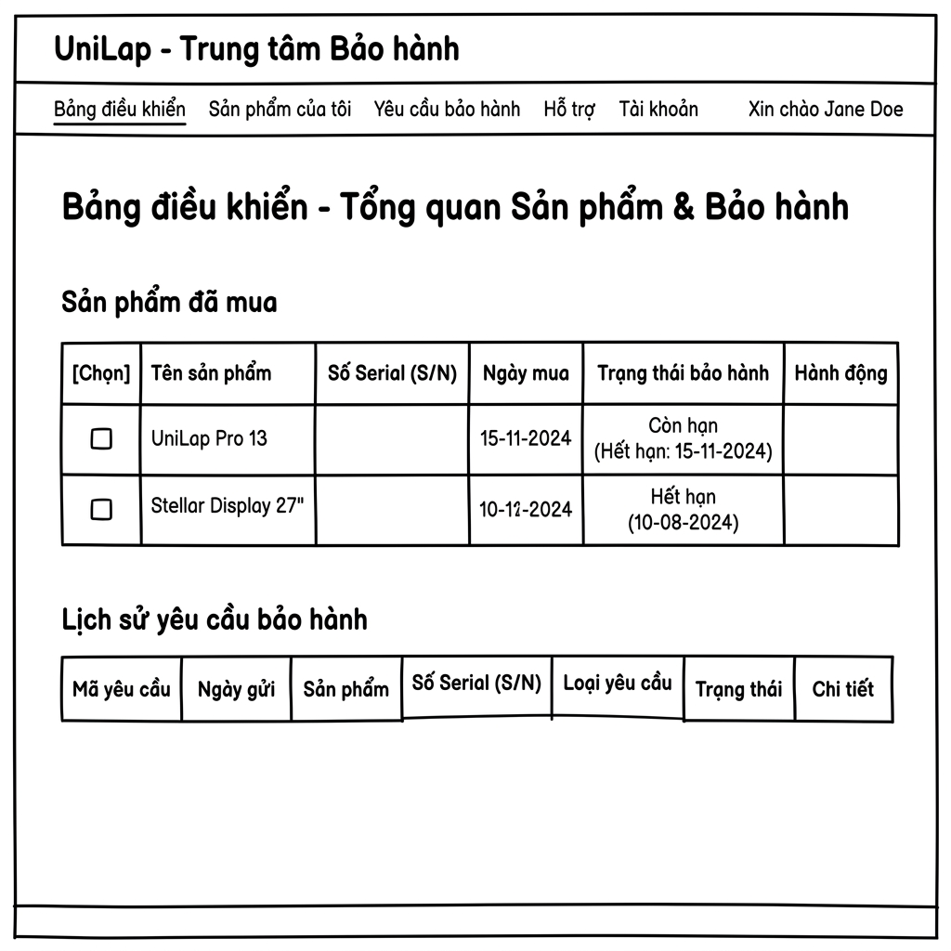
The landing portal for customer warranty actions. It contains the first step of the warranty request wizard (Product Selection), a quick tracker for claim IDs, and a history table of the customer's recent warranty requests.
Field Description
ID | Field Name (Control) | Type / Format | Required | Default Value | Description & Validation Rules
01 | Submit Warranty Request (Wizard Step 1) | Container / Form | N/A | N/A | Area allowing customers to initiate a warranty request by selecting an eligible purchased product.
02 | Product Selection Table | Grid Table | Yes | N/A | List of products from completed (COMPLETED or DELIVERED) customer orders:  - Select: Radio button to select product for warranty.  - Product: Product name + Serial Number (S/N).  - Purchase Date: Date when the order was completed.  - Warranty Status: Badge displaying remaining duration or warranty status (e.g. Under Warranty - green, or Expired - gray).
03 | Next Button (Wizard) | Action Button | N/A | Disabled | Proceed to Step 2 (Warranty Status). Enabled only when a product from the list is selected.
04 | Track Warranty Claim | Container / Form | N/A | N/A | Area allowing customers to quickly track the status of a specific claim ID.
05 | Claim ID Input | TextInput | Yes | Empty | Enter the claim ID (e.g., 42).  - Constraint: Must be a positive integer > 0.
06 | Track Button | Action Button | N/A | N/A | Validates claim ID format. If valid, redirects to the claim details page). If not found or not owned by the active account, displays an error message.
07 | Recent Warranty Activity | Grid Table | No | N/A | Table listing recent warranty requests created by this account:  - Claim ID / Created Date: Clickable claim ID link (e.g. #28) and its creation date.  - Product: Product name + Serial Number.  - Defect Title: Summary of the defect submitted by customer.  - Status: Colored badge (Pending-Yellow, Processing-Blue, Approved-Dark Blue, Completed-Green, Rejected-Red, Cancelled-Gray).  - Actions: Details / Cancel links.
08 | Cancel Action Link (Table) | Action Link | No | N/A | Visibility condition: Only visible when claim status is PENDING (rule BR-19).  Behavior: Prompts customer to confirm cancellation. If confirmed, updates status to CANCELLED, records in history log, and reloads list.
09 | Pagination Controls | Navigation | No | Page 1 | Pagination controls for "Recent Warranty Activity" grid (displays max 5 or 10 records per page).

Submit Warranty Request - Step 2: Warranty Status

Screen displaying policy and warranty duration details of the selected product for verification before writing the defect description.
Field Description
Field Name (Control) | Type / Format | Description & Validation Rules
Product Information | Text Display | Displays full name and code of selected product (default: selected product name).
Serial Number (S/N) | Text Display | Serial number of the device (default: product S/N).
Warranty Policy Name | Text Display | Warranty policy applied, fetched from database (e.g. ASUS Gaming Laptop Policy or Standard Warranty); default: active policy name.
Warranty Expiry Date | Text Display | Warranty expiration date (format DD/MM/YYYY). Formula: completed_at + WarrantyMonths (rule UC48.2).
Back Button | Button | Go back to Step 1 (Product Selection).
Next Button | Button (Blue) | Proceed to Step 3 (Defect Description).

Submit Warranty Request - Step 3: Defect Details
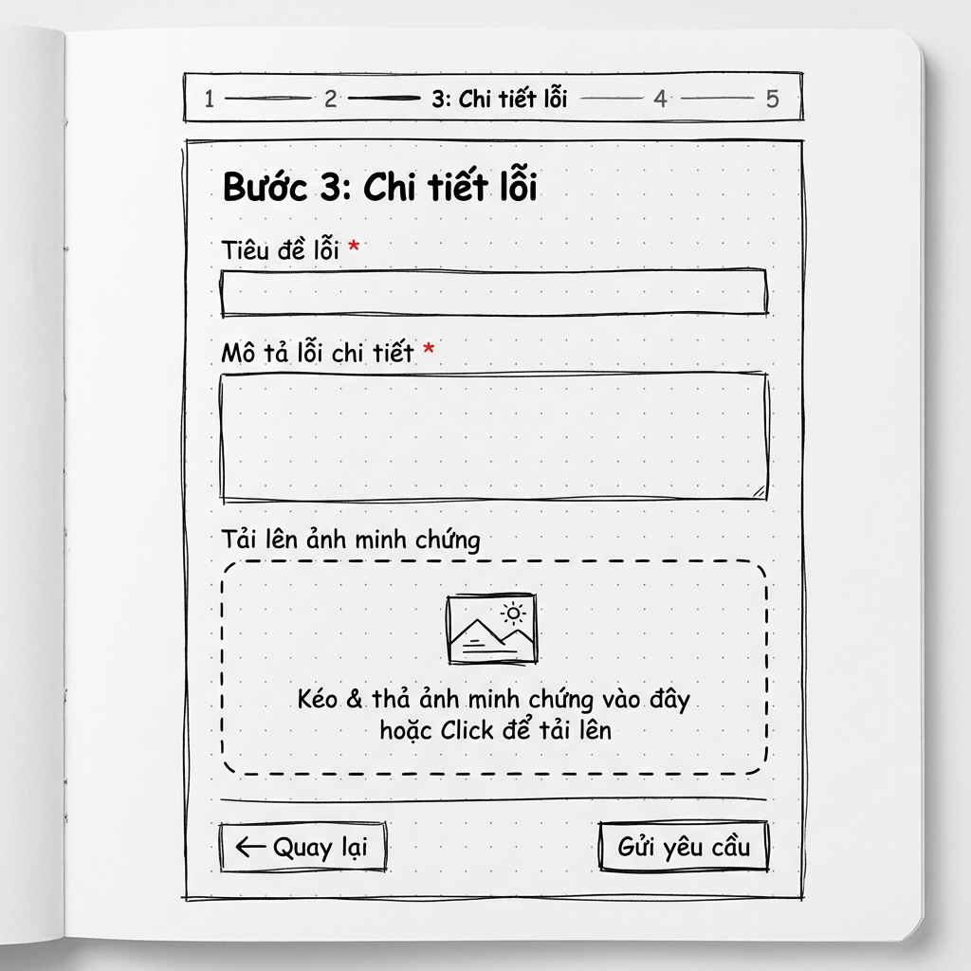
Form to input defect details and upload proof files.
Field Description
ID | Field Name (Control) | Type / Format | Required | Default Value | Description & Validation Rules
- | Defect Title * | TextInput | Yes | Empty | Defect title summary (e.g. Screen horizontal lines).  - Constraint: Max 200 characters (BR-Length).
- | Detailed Defect Description * | TextArea | Yes | Empty | Detailed defect description, circumstances of issue.  - Constraint: Max 2000 characters (BR-Length).
- | Attachment Images | File Input | No | Empty | Upload images showing product defects.  - Constraint (BR-Images): Max 5 images; formats .jpg, .jpeg, .png, .webp; max 5MB per file.
- | Back Button | Button | N/A | N/A | Return to Step 2.
- | Submit Request Button | Button (Green) | N/A | N/A | Validates inputs. If valid, creates a new warranty claim in database with status PENDING (BR-16), logs to WarrantyHistory (BR-17), saves uploaded images, and moves to Step 4.

Submit Warranty Request - Step 4: Completion
Confirmation view shown upon successful submission.Field Description
Field Name (Control) | Type / Format | Description & Validation Rules
Success Message | Text Alert | Displays green success alert banner.
Created Claim ID | Text Display | Displays auto-incremented database claim ID (e.g., #28).
Track Request Button | Button | Redirects to claim details page to track progress.
Home Button | Button | Redirects to UniLap home page.

Warranty Claim Detail Screen

Details page for a single warranty claim from the c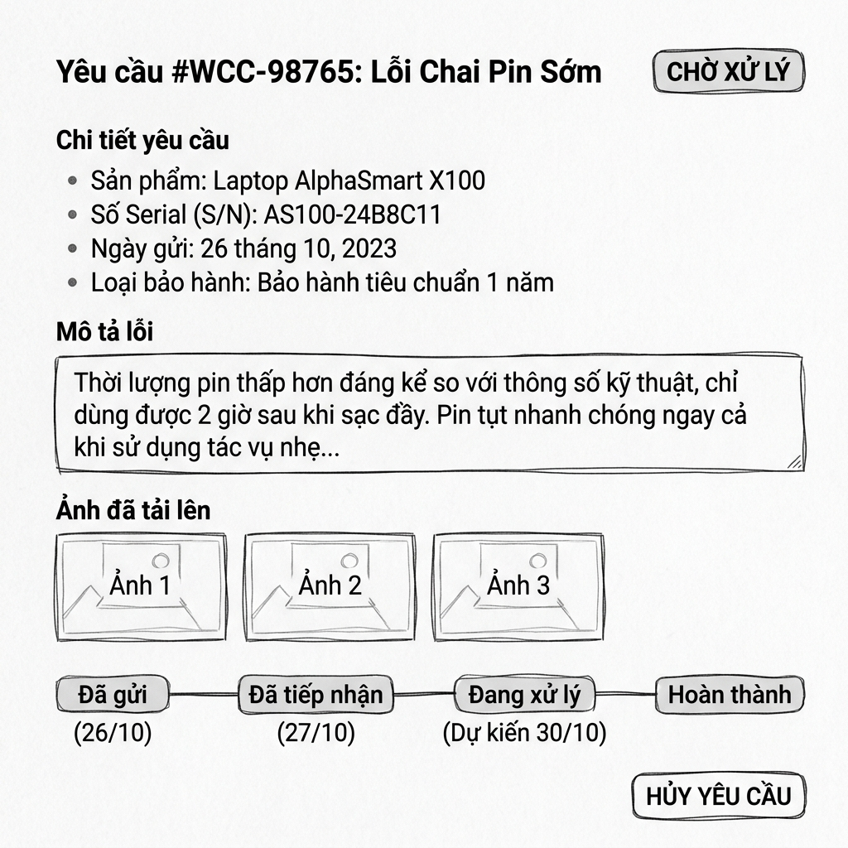Customer's viewpoint. It displays complete metadata of the claim, uploaded evidence pictures, a visual status track line, and the full timeline history including staff notes.
Field Description
ID | Field Name (Control) | Type / Format | Required | Default Value | Description & Validation Rules
01 | Claim Header Title | Text Title | N/A | Defect Title | Defect title + Claim ID (e.g. abc (Claim #25)).
02 | Status badge | Status Badge | N/A | Based on data | Visual status badge (PENDING, PROCESSING, APPROVED, REJECTED, COMPLETED, CANCELLED).
03 | Serial Number | Text Display | N/A | Device S/N | Serial number of the device.
04 | Product | Text Display | N/A | Product Name | Name of the product variant.
05 | Order ID | Text Display | N/A | Order ID | ID of the order containing this product (clickable link to view receipt).
06 | Submitted Date | Text / Date | N/A | Creation Date | Claim submission datetime: HH:mm, DD/MM/YYYY.
07 | Updated Date | Text / Date | N/A | Update Date | Most recent status update datetime.
08 | Completed Date | Text / Date | N/A | Empty or Date | Expiry/completion datetime (only shown if status is COMPLETED).
09 | Defect Description | Text Display | N/A | Description Content | Customer's defect description text.
10 | Attached Evidence | Image Thumbnails | No | N/A | Lists evidence images uploaded by customer.  Behavior: Clicking thumbnail opens full-screen lightbox preview.
11 | Processing Timeline | Visual Steps Chart | N/A | N/A | Vertical visual steps indicator:  1. Request Submitted (Active on creation)  2. Processing (Active on staff assignment)  3. Approved (Active on staff decision)  4. Completed (Active on device handover).
12 | Audit History Logs | Timeline List | Yes | N/A | Detailed history log of status changes: status state reached, transition timestamp, and Staff Note (remarks or rejection reasons from staff, e.g. "Warranty completed. Device returned to customer").
13 | Back to List Button | Navigation Button | N/A | N/A | Return to Warranty Center dashboard.
14 | Cancel Request Button | Action Button (Red) | N/A | N/A | Visibility condition: Only visible when claim status is PENDING (BR-19).  Behavior: Displays confirmation dialog. If customer accepts, updates status to CANCELLED, logs audit event, and reloads detail view (hides cancel button).

3.1.2 Warranty Console (Admin / Staff)

Warranty Console Screen - Admin/Staff
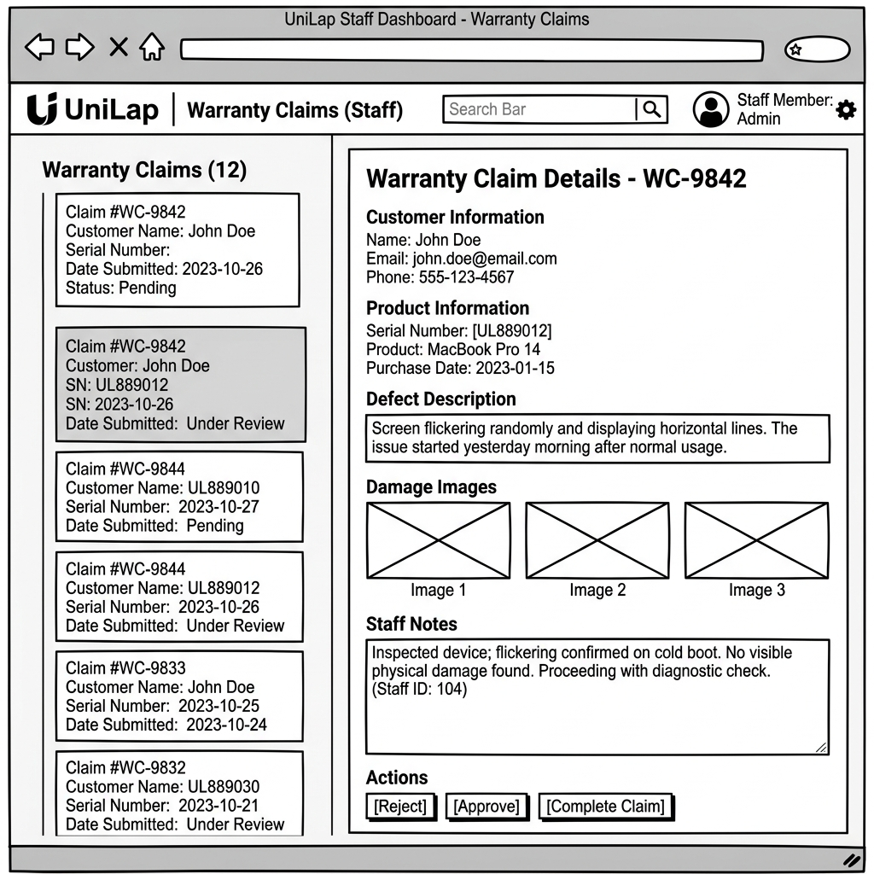
The internal dashboard layout for support staff and administrators to process claims. It features a searchable/filterable queue of active claims on the left and a detailed work panel on the right for processing actions and entering resolution logs.
Field Description
ID | Field Name (Control) | Type / Format | Required | Default Value | Description & Validation Rules
01 | Search Claims Box | TextInput | No | Empty | Enter keyword (customer name, product, claim ID, or serial) to search claims queue.
02 | Status Filter | Dropdown | Yes | All Statuses | Filter claims by status (All Statuses, Pending, Processing, Approved, Rejected, Completed, Cancelled).
03 | Reset Button | Button | N/A | N/A | Clear search terms and revert status filters to default.
04 | Claims Queue Table | Grid Table | Yes | N/A | Table listing requests matching filter:  - CLAIM ID: Claim ID (e.g. #28).  - CUSTOMER: Customer name.  - PRODUCT: Product name + S/N.  - STATUS: Status colored badge.  - DATE: Submission date.  - DETAIL: "Open ->" link to sidebar details.
05 | Claim Detail Panel (Right) | Sidebar Container | N/A | N/A | Displays details of selected claim.
06 | Evidence Images (Right) | Image Grid | No | N/A | Displays proof images (or "No images uploaded").
07 | Timeline History (Right) | List | Yes | N/A | Log list of historical transitions with staff notes.
08 | Staff Note Input | TextArea | Yes* | Empty | Textarea to input resolution remarks or transition notes.  - Constraint: Required when performing Accept, Approve, Reject, Complete, or Cancel actions (BR-21). Max 1000 characters.
09 | Accept Button | Action Button (Blue) | N/A | N/A | Visibility condition: Only shown when claim status is PENDING.  Behavior: Transitions claim status to PROCESSING (BR-20), assigns claim to active staff member (staff_id), and logs audit entry with text from Staff Note Input.
10 | Approve Button | Action Button (Green) | N/A | N/A | Visibility condition: Only shown when claim status is PROCESSING.  Behavior: Transitions status to APPROVED, logs audit entry with text from Staff Note Input.
11 | Reject Button | Action Button (Red) | N/A | N/A | Visibility condition: Only shown when claim status is PROCESSING.  Behavior: Transitions status to REJECTED. Staff must enter rejection reason in Staff Note Input to notify the customer.
12 | Complete Button | Action Button (Blue) | N/A | N/A | Visibility condition: Only shown when claim status is APPROVED.  Behavior: Transitions status to COMPLETED, records completion datetime (completed_at), and closes the warranty lifecycle for the item.
13 | Cancel Claim Button | Action Button (Red Outline) | N/A | N/A | Visibility condition: Only shown when status is PENDING or PROCESSING.  Behavior: Allows staff to cancel request (after client consultation). Transitions status to CANCELLED. Rejection/cancellation reason must be entered in Staff Note Input.

3.2 Admin Dashboard & Advanced Analytics

3.2.1 Overview Dashboard Screen
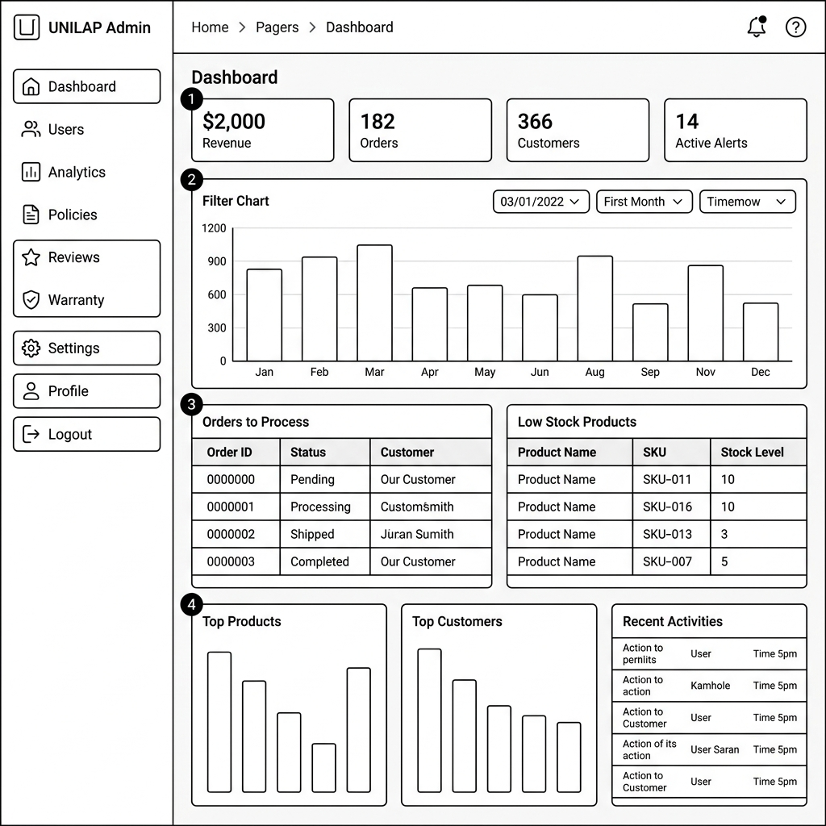
The default landing screen after an Administrator/Staff successfully logs into the admin console. It provides quick summary cards, a pending order status matrix, low stock alerts, and a recent activities log. Maps to UC50 - View System Dashboard.
Field Description
ID | Field Name (Control) | Type / Format | Required | Default Value | Description & Validation Rules
01 | Sidebar Navigation | Navigation Menu | N/A | Dashboard (Active) | Admin navigation sidebar:  - Click Dashboard -> Redirect to current page.  - Click Users -> Redirect to user management page.  - Click Analytics -> Redirect to advanced analytics page.  - Click Policies -> Redirect to warranty policy page).  - Click Warranty -> Redirect to claims processing page.
02 | Revenue This Month | KPI Card & Select | No | Current Month Revenue / "This Month" | Displays total revenue of the current month with growth percentage compared to the previous month. Dropdown allows selecting other timeframes (Today, This Week, This Month, This Year).
03 | Orders Today | KPI Card & Select | No | Current Day Orders / "Today" | Displays the count of orders created today along with the growth rate compared to yesterday. Dropdown allows changing the filter timeframe.
04 | New Customers | KPI Card & Select | No | 0 / "This Month" | Displays the total number of newly registered customer accounts within the selected timeframe.
05 | Active Alerts | KPI Card & Badge | No | 5 / "Needs attention" | Displays the count of urgent warnings needing processing (Low stock, pending claims, tickets). Clicking the card redirects to the respective detail view.
06 | Revenue Analytics Bar Chart | Interactive Chart | No | Monthly Data | Bar chart showing revenue variations over time. Hover over columns to view details.
07 | Orders Needing Process | Grid Table | No | N/A | Table summarizing order counts by status (Pending, Processing, Shipped, Cancelled) split by timeframe (Today, This Week, This Month, All). Users can click numbers (if > 0) to navigate to the order grid pre-filtered by selected criteria.
08 | Low Stock Products | Grid Table | No | N/A | Lists products with stock quantities (QTY) under the warning threshold (<=10). Columns: Product, Category, Qty.
09 | Top Products / Customers | Horizontal Bar Chart | No | Top 10 | Ranking lists:  - Top Products: Filter best sellers by quantity sold or revenue.  - Top Customers: Filter highest spending customers.
10 | Recent Activities | Log List | No | N/A | Live feed displaying system events (Delivered orders, newly submitted claims, approved/rejected claims) with relative timestamps.
11 | Logout Button | Action Button | N/A | N/A | Click to terminate current session and redirect to login page.

3.2.2 Advanced Business Analytics Screen
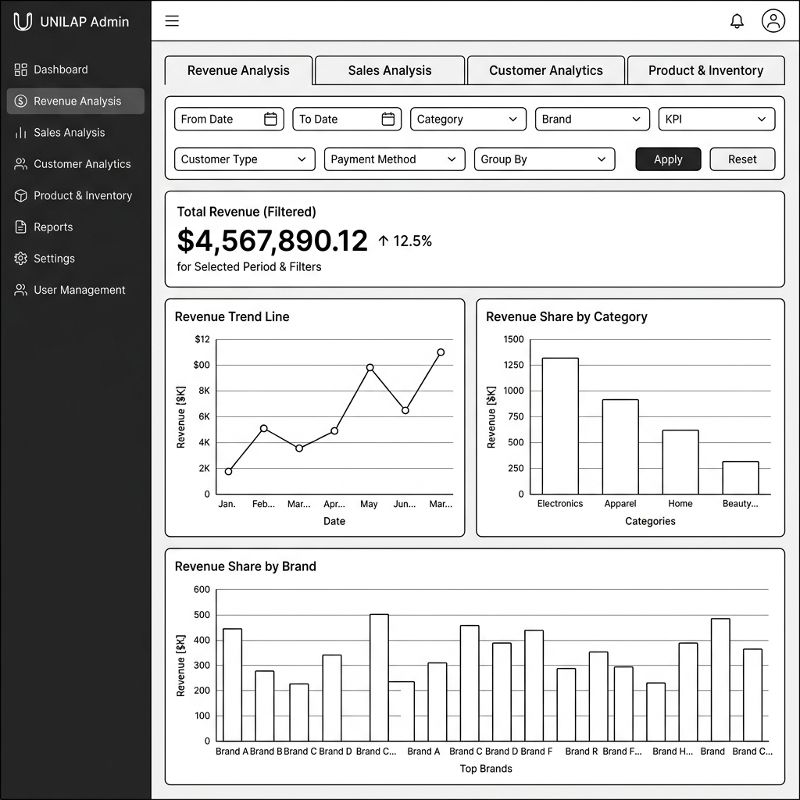
An advanced business reporting screen providing granular analytical breakdowns of revenue, sales trends, customer acquisition rates, and product stock turnover ratios. Maps to UC49 - View Advanced Analytics.

Common Filters
Shared filters placed at the top of the analytics pane, applying to all 4 tabs.
Field Name (Control) | Type / Format | Description & Validation Rules
From Date | Date (MM/DD/YYYY) | Required, default 01/01/2025. Filter from date; must be <= To Date.
To Date | Date (MM/DD/YYYY) | Required, default 12/31/2026. Filter to date; must be >= From Date.
Category | Dropdown (Select) | Optional, default "-- All Categories --". Filter by product category (Laptop, Headphone, Speaker, Keyboard).
Brand | Dropdown (Select) | Optional, default "-- All Brands --". Filter by manufacturer (Apple, ASUS, HP, Dell, Lenovo, Acer, MSI...).
Customer Type | Dropdown (Select) | Optional, default "-- All Types --". Filter by customer cohort (New, Returning).
Payment Method | Dropdown (Select) | Optional, default "-- All Methods --". Filter by payment method (bank_transfer, momo, credit_card, cod).
Group By | Dropdown (Select) | Required, default Month. Time aggregation frequency (Day, Week, Month, Year).
Apply Button | Action Button | Validates inputs. Reloads all charts and tables in the active tab.
Reset Button | Action Button | Reverts filter fields to initial default values.

Revenue Analysis Tab

Deep dive into company revenue trends, category share, and brand contributions.
Field Name (Control) | Type / Format | Description & Validation Rules
Total Revenue (Filtered) | Indicator Card | Net cumulative revenue of sold products matching filter criteria (prominently displayed as a large number).
Revenue Trend Line | Line Chart | X-axis shows time period (Group By), Y-axis shows amount. Helps track whether revenue is trending up or down.
Revenue Share by Category | Bar Chart | Represents total revenue generated from each product category.
Revenue Share by Brand | Bar Chart | Vertical bar chart classifying revenue by brand in descending order.

Sales Analysis Tab

Focuses on transaction quantities, average order sizes, and payment behaviors.
Field Name (Control) | Type / Format | Description & Validation Rules
Total Orders | Indicator Card | Total count of successful orders within query period.
Average Order Value (AOV) | Indicator Card | Average order value. Formula: Total Revenue / Total Orders.
Orders Volume Trend | Area Chart | Area chart plotting changes in order volume over time.
Share by Payment Method | Colored Bar Chart | Represents order count corresponding to each payment gateway to audit customer payment behaviors.

Customer Analytics Tab

Analyzes new user acquisition, customer retention, and ranks high-value VIP buyers.
Field Name (Control) | Type / Format | Description & Validation Rules
Top Customers N | TextInput (Integer) | Enter number of VIP customers to rank (Default: 10). Constraint: Must be a positive integer >= 1.
Cohort Customer Acquisition | Line Chart | Tracks count of newly created accounts over time.
New vs Returning Customers | Donut Chart | Donut chart showing percentage split between New Customers (first purchase) and Returning Customers.
Top Spending Customers Table | Data Table (Grid) | Table listing VIP buyer details: Rank, Customer Name, Email Address, Distinct Orders, Total Spending (VND).

Product & Inventory Tab

Controls cost of goods, stock value, turnover efficiency, and monitors hot/cold products.
Field Name (Control) | Type / Format | Description & Validation Rules
Rank Limit (N) | TextInput (Integer) | Enter count of best/worst sellers to display. Default: 10. Constraint: Integer >= 1.
Rank By | Dropdown (Select) | Criteria for ranking products (Quantity Sold or Revenue).
Cost of Goods Sold (COGS) | Indicator Card | Cost of goods sold. Formula: Sum (Product Cost Price * Quantity Sold).
Average Inventory Value | Indicator Card | Average inventory value calculated as the average of start-of-period and end-of-period inventory values.
Inventory Turnover Ratio | Indicator Card | Inventory turnover ratio. Formula: COGS / Average Inventory Value. Higher ratio indicates faster, more efficient sales.
Best Selling Products Table | Data Table (Grid) | List of top 10 best-selling products: Rank, Product/Variant, Qty Sold, Revenue.
Worst Selling Products Table | Data Table (Grid) | List of top 10 worst-selling products for markdown or inventory clearance planning.

3.3 Store Policies Management
Screen that manages store terms, privacy docs, and product warranty policies. Divided into two main sub-tabs: Warranty Policies and Footer Policies.

3.3.1 Warranty Policies Tab
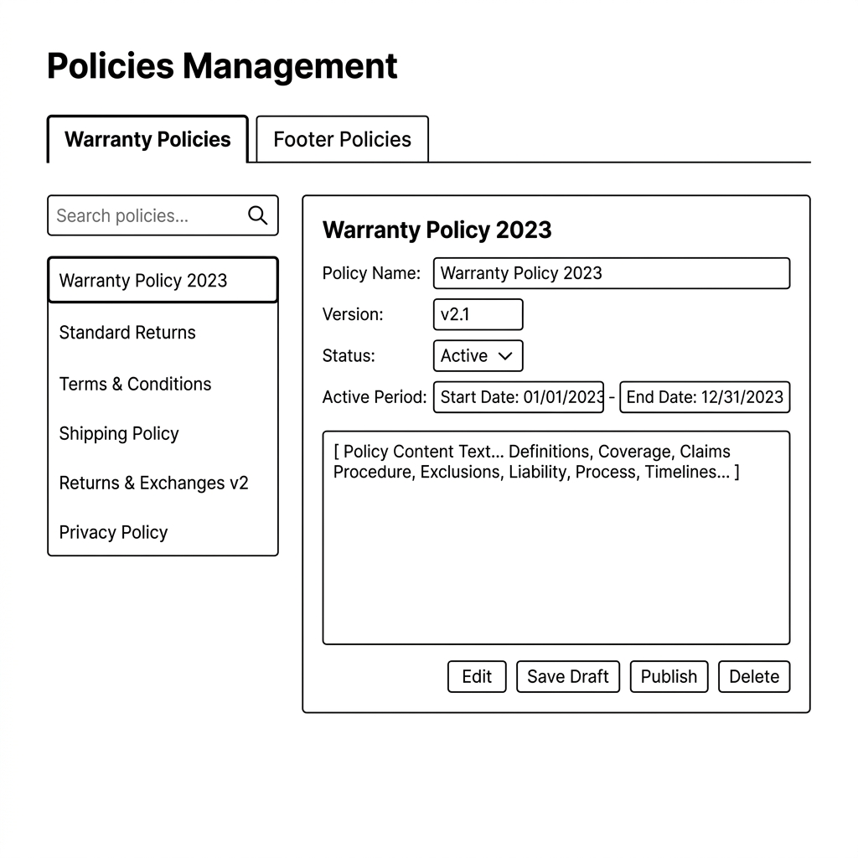
Screen displaying the list and details of product warranty policies. Maps to UC48.1-UC48.6.
Field Description
Field Name (Control) | Type / Format | Description & Validation Rules
Warranty Policies Tab Link | Tab Select | Required, default Active. Clicking loads warranty policy management sub-system.
Search Box | TextInput | Optional, default Empty. Enter keyword to search warranty policies by name.
Go Button | Button | Execute search and filter list below.
Active Documents List | Sidebar List | Required. List of existing warranty policies in the system, showing policy name, status (DRAFT, LIVE, DISABLED), and last updated date.
+ New Policy Button | Action Button | Click to open modal popup to create a new warranty policy.
Version History Button | Action Button | View modification history of selected policy.
Status Dropdown | Dropdown | Required, default based on document. Change active policy status (Draft, Live, Disabled).
Delete Button | Action Button (Red) | Delete selected warranty policy. Displays confirmation prompt before deletion.
Edit Policy Button | Action Button | Allows editing details of the active policy
Save Draft Button | Action Button | Save changes as DRAFT without publishing.
Publish Button | Action Button (Blue) | Change status to LIVE and apply it to product groups (validates business rule BR-24).

3.3.2 Create New Warranty Policy Modal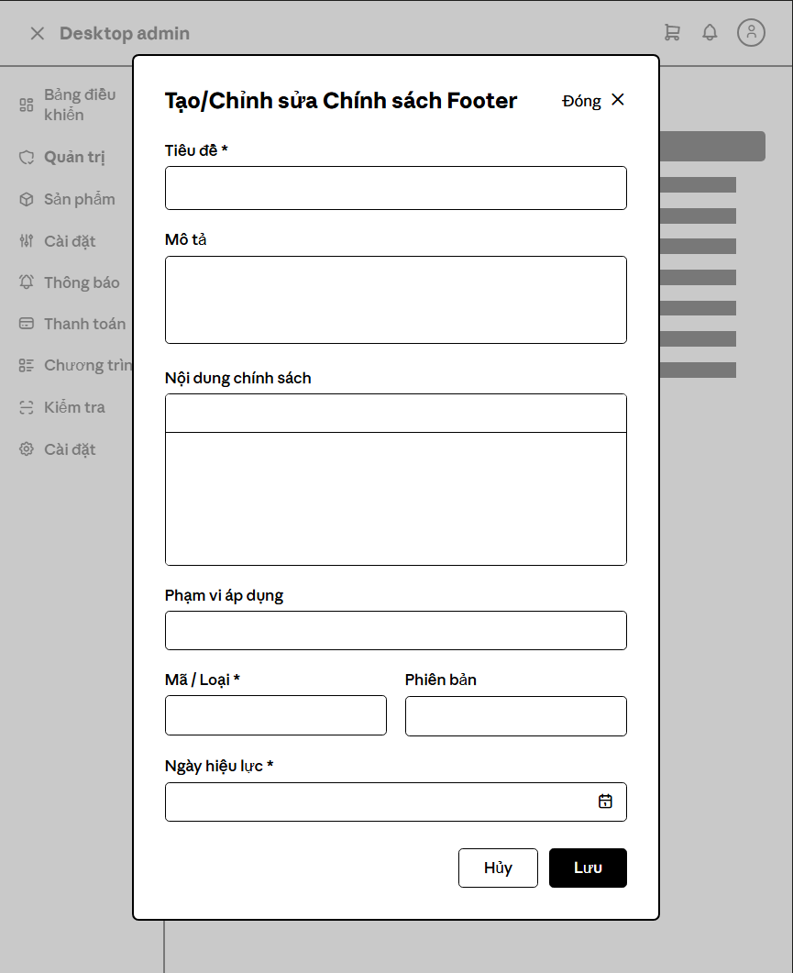

Popup modal shown when clicking the + New Policy button..
Field Description
ID | Field Name (Control) | Type / Format | Required | Default Value | Description & Validation Rules
1 | Policy Name * | TextInput | Yes | Empty | Name of the new warranty policy.  - Constraint: Must not contain purely numbers, maximum 150 characters, must be unique (otherwise errors with MSG02 - "Policy name has already existed").
2 | Description | TextArea | No | Empty | Brief description of the policy's purpose.
3 | Policy Content | RichText Editor | Yes | Empty | RichText editor containing detailed terms. Cannot be empty when publishing as LIVE (BR-24).
4 | Applicable Regions | TextInput | No | Empty | Geographic regions (separated by commas, e.g. NA, EU, VN).
5 | Warranty Months | TextInput (Number) | Yes | Empty | Warranty duration in months.  - Constraint: Positive integer > 0.
6 | Version | TextInput | Yes | v1.0 | Policy version code (format e.g. v1.0, v2.0).
7 | Effective Date | DatePicker | Yes | Current Date | Date when the policy goes into effect.
8 | Cancel Button | Button | N/A | N/A | Close modal and discard unsaved input.
9 | Create Policy Button | Button (Blue) | N/A | N/A | Validate inputs. If valid, save to database as DRAFT and close modal.

3.3.3 Edit Warranty Policy Modal

Popup modal shown when selecting a policy and clicking Edit Policy.
Field Description
ID | Field Name (Control) | Type / Format | Required | Default Value | Description & Validation Rules
1 | Policy Name * | TextInput | Yes | Old Value | Name of policy to edit. Name uniqueness rule does not check against itself. Max 150 characters.
2 | Description | TextArea | No | Old Value | Update brief description of the policy.
3 | Policy Content | RichText Editor | Yes | Old Value | Update policy terms details via the editor.
4 | Applicable Regions | TextInput | No | Old Value | Geographic regions applicable.
5 | Warranty Months | TextInput (Number) | Yes | Old Value | Warranty duration in months.  - Constraint: Positive integer > 0.
6 | Version | TextInput | Yes | Old Value | Policy version code.
7 | Effective Date | DatePicker | Yes | Old Value | Effective date.
8 | Status | Dropdown | Yes | Old Value | Edit active status directly (Draft, Live, Disabled). Selecting Live validates that content is not empty (BR-24).
9 | Cancel Button | Button | N/A | N/A | Discard changes and close modal.
10 | Save Changes Button | Button (Blue) | N/A | N/A | Commit updates to database, record "UPDATED" status history, and close modal

3.3.4 Footer Policies Tab

Screen that manages store terms, privacy docs, and other static articles displayed in the website footer. Maps to UC52.1 and related sub-use-cases.
Field Description
Field Name (Control) | Type / Format | Description & Validation Rules
Footer Policies Tab Link | Tab Select | Required, default Active. Loads footer policy management data
+ New Footer Policy Button | Action Button | Click to open modal to create a new footer policy
Footer Documents List | Sidebar List | Required. List of existing footer policies (Return policy, shipping, privacy, terms...).
Hien thi o Footer (Show in Footer) | Checkbox | Required, default Checked. Toggle to decide if this policy is shown in footer
Thu tu hien thi (Display Order) | TextInput (Number) | Required, default 0. Display order sorting value under footer; smaller numbers display first. Constraint: Integer >= 0.
Save Settings Button | Action Button | Save footer display settings and order sequence.
Content Preview | RichText Panel | Optional. Shows read-only preview of selected policy
Delete Button | Action Button (Red) | Delete selected footer policy
Edit Content Button | Action Button (Blue) | Open modal to edit selected footer policy title and content

3.3.5 Create / Edit Footer Policy Modals

Create New Footer Policy Modal
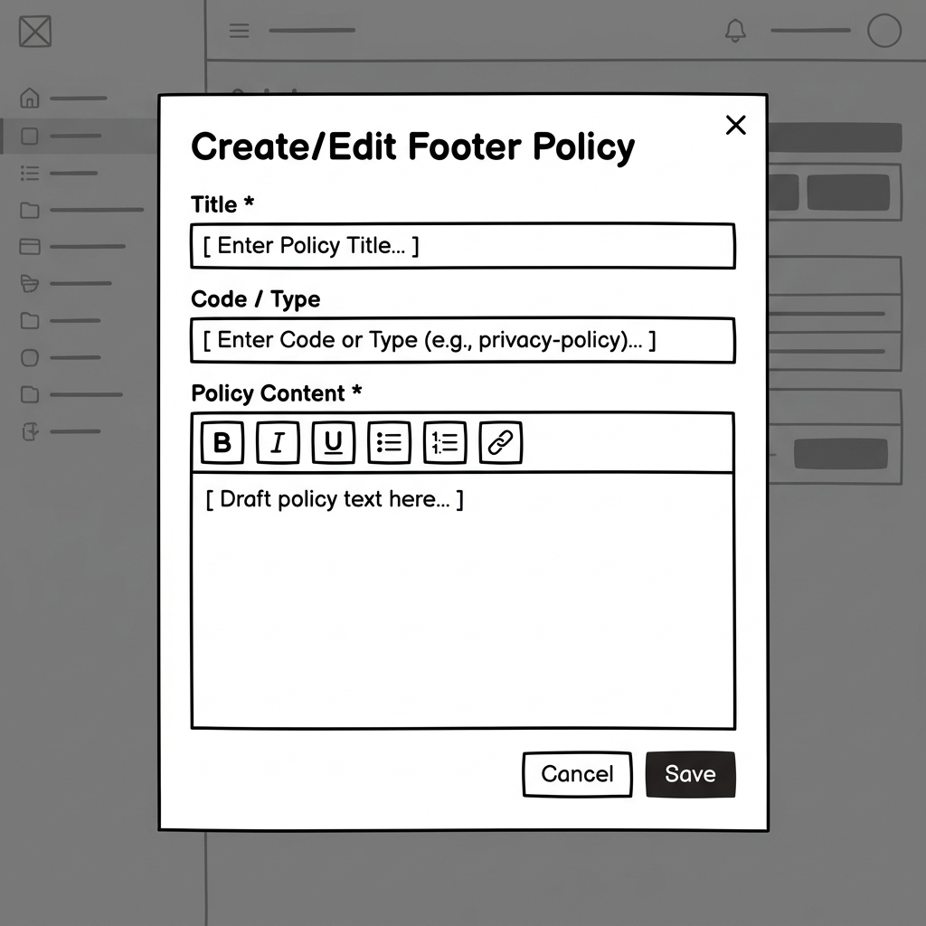
Popup modal for creating footer policy content. Maps to UC52.3.
Field Description
Field Name (Control) | Type / Format | Description & Validation Rules
Tieu de * (Title) | TextInput | Required, default Empty. Title of the new footer policy (e.g. Shipping Policy). Constraint: Maximum 100 characters.
Ma chinh sach (Code) | TextInput | Optional, default Empty. Unique identifier code (e.g., SHIPPING_POLICY). Constraint: Uppercase alphabetic string, no spaces, no accents; used for backend routing.
Noi dung chinh sach * (Content) | RichText Editor | Required, default Empty. RichText content of the detailed terms.
Create Policy Button | Button (Blue) | Submit request to save the new policy.

Edit Footer Policy Content Modal
Popup modal for editing footer policy content
Field Description
Field Name (Control) | Type / Format | Description & Validation Rules
Tieu de * (Title) | TextInput | Required, default Old Value. Edit selected footer policy title.
Noi dung chinh sach * (Content) | RichText Editor | Required, default Old Value. Update policy terms details.
Save Changes Button | Button (Blue) | Submit update request and close modal.

3.4 Authentication &Account Management
3.4.1 Guest

3.4.1.1 Register Account Screen
The registration screen allows unregistered guests to create a new UNILAP account. Users fill in their full name, email, phone number, and password with confirmation. The form includes client-side validation for phone format and password length. Upon successful registration, the user is redirected to the Login screen with a success message. Maps to UC01 (Register Account).
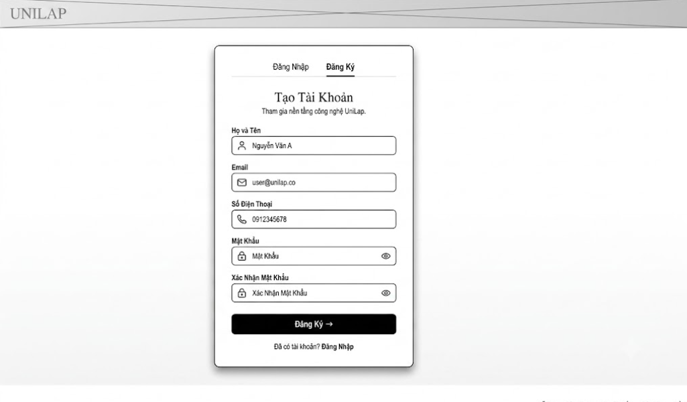

Field Name (Control) | Type / Format | Description & Validation Rules
Tab Navigation | Navigation tab | Toggle between Login and Register screens. Default: Đăng Ký (active).
Họ Và Tên | Text Input | Required, default Empty. User's full name. Cannot be blank.
Email | Text Input | Required, default Empty. Must be valid email format. Must be unique in system (server-side check). Used as login identifier.
Số điện thoại | Text Input | Required, default Empty. Vietnamese phone number. Constraint: pattern ^0[35789]\d{8}$ (10 digits, starts with 03/05/07/08/09). Max length: 10.
Mật khẩu | password | Required, default Empty. Minimum 6 characters, maximum 32 characters. Masked input.
Xác nhận mật khẩu | password | Required, default Empty. Must exactly match Password field. Min 6, max 32 characters.
Đăng ký button | Action button | Submits form via POST. On success → redirects to Login with ?success=1. On failure → re-displays form with error message, preserves entered data.
Đã có tài khoản? | Hyperlink | Navigates to the Login screen.

3.4.2 All Registered Users

3.4.2.1 Login Screen
The login screen allows registered users to authenticate into the UNILAP system. Users can log in using email and password, with an option to remember credentials via browser cookies. A "Quên mật khẩu?" link provides access to the password recovery flow. The screen also supports Google OAuth 2.0 as an alternative authentication method. Upon successful login, users are redirected to the appropriate dashboard based on their assigned role. Maps to UC02 (Login).
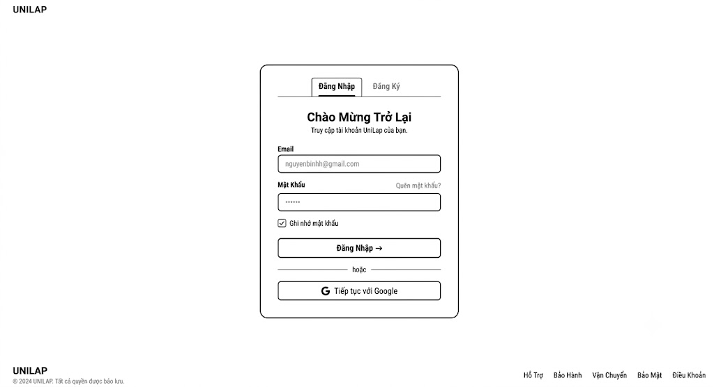

Field Name (Control) | Type / Format | Description & Validation Rules
Tab Navigation | Navigation tab | Toggle between "Đăng Nhập" (active) and "Đăng Ký" screens.
Email | Text Input | Required, default: cookie value (if remembered) or Empty. Email used as login identifier. Pre-filled from c_email cookie if "Remember me" was previously checked.
Mật khẩu | password | Required, default: cookie value (if remembered) or Empty. Masked input. Pre-filled from c_password cookie if remembered.
Quên mật khẩu | password | Navigates to the Forgot Password screen (3.4.2.2) to initiate password recovery.
Ghi nhớ mật khẩu | Checkbox | Optional, default Unchecked. When checked, stores email/password in browser cookies for auto pre-fill on next visit.
Đăng nhâp button | Action Button | Submits credentials via POST. On success → redirects by role: Admin → Admin Dashboard, Staff → Inventory, Customer/Student → Home. On failure → displays error message.
Tiếp tục với Google | OAuth LInk | Redirects to Google OAuth 2.0 consent screen. Returns auth code to /login-google. If email exists → logs in; otherwise → creates new account automatically.
Success Message | Alert Banner | Hidden by default. Displays contextual message: "Đăng ký thành công!" (from registration ?success=1) or "Đặt lại mật khẩu thành công!" (from password reset ?success=2).

3.4.2.2 Reset Password Screen
The reset password flow consists of two sub-screens: (a) Forgot Password – where users enter their registered email to receive a password reset link via email, and (b) Reset Password – where users create a new password using a secure token embedded in the email link. The token is validated server-side to prevent unauthorized password changes. Maps to UC03 (Reset Password).
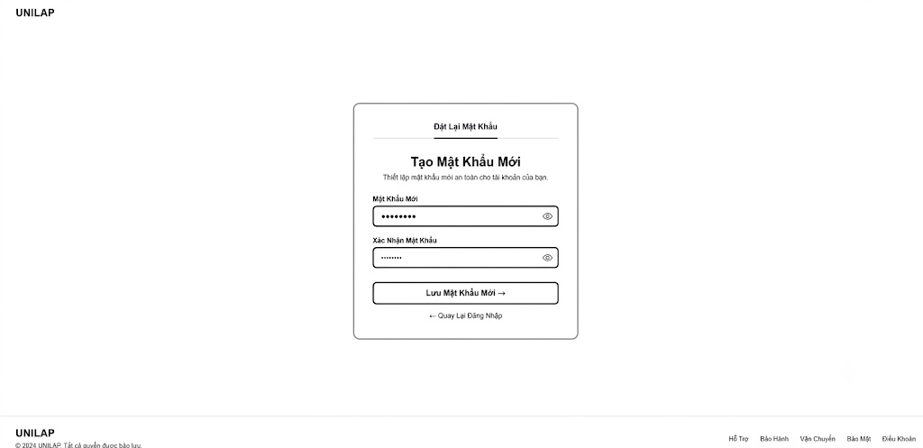

Field Name (Control) | Type / Format | Description & Validation Rules
Mật khẩu mới | password | Required, default Empty. Minimum 6 characters. Includes eye toggle button for show/hide. Client-side validation checks length before submission.
Xác nhận mật khẩu mới | password | Required, default Empty. Must exactly match New Password field. Includes eye toggle button. Client-side JavaScript validates match before form submission.
Lưu mật khẩu mới | Action Button | Runs validateForm() on submit. Checks: password ≥ 6 chars, password matches confirm. On success → POST with token, redirects to Login with ?success=2. On failure → displays client-side or server-side error.
Quay lại đăng nhập | Hyperlink | Navigate back to login screen

3.4.2.3 Personal Profile Screen
The profile management screen is accessible to all authenticated users. It uses a sidebar-content layout. The left sidebar displays the user's avatar, full name, email, role badge, and navigation menu for switching between tabs. The main content area shows the profile editing form where users can update their full name, phone number, and avatar image. The email field is displayed as read-only since it serves as the account identifier. Quick link cards at the bottom provide shortcuts to other tabs. Maps to UC04 (View/Edit Profile).
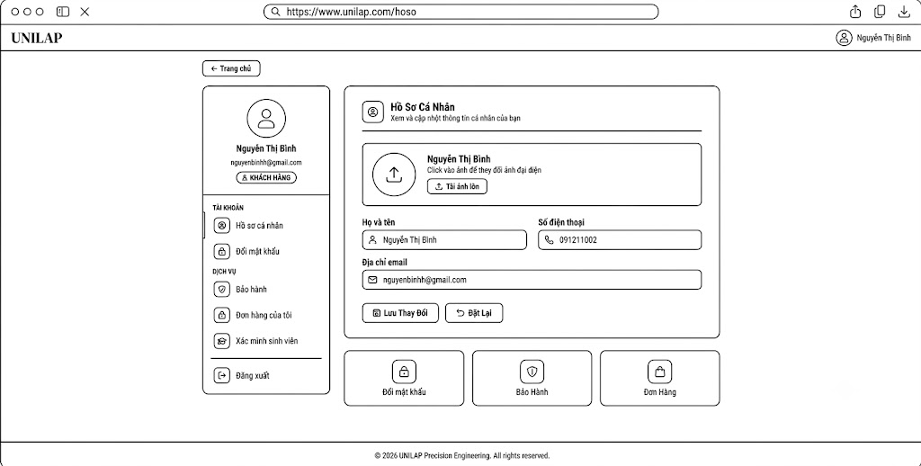

Field Name (Control) | Type / Format | Description & Validation Rules
Side Bar Navigation | Navigation Menu | Grouped into sections — Tài khoản: "Hồ sơ cá nhân" (active), "Đổi mật khẩu". Dịch vụ (Customer/Student only): "Bảo hành", "Đơn hàng của tôi", "Xác minh sinh viên". Bottom: "Đăng xuất" (red). Active tab highlighted with blue left border.
Avatar Upload | File Upload | Optional, default: current avatar or placeholder icon. Click on avatar circle or "Tải ảnh lên" button to select image file. Accepts image/* format. Preview updates immediately on selection. Submitted with profile form via multipart/form-data.
Họ và tên | Text input | Required, default: current user name. Editable text field with user icon. Updates userName in database on save.
Số điện thoại | Text input | Optional, default: current phone number. Editable text field with phone icon. Updates phone in database on save.
Lưu thay đổi Button | Action Button | Submits profile form via POST with multipart/form-data encoding. Updates user name, phone, and avatar in database. Displays success or error alert message.
Đặt lại Button | Reset Button | Resets all form fields to their last saved values (original state before editing).
Quick Card(Đổi mk, bảo hành, đơn hàng) | Card Links | Shortcut cards displayed below the form. Clicking switches to the corresponding tab panel. "Bảo Hành" and "Đơn Hàng" cards only visible for Customer/Student roles.

3.4.2.4 Change Password Screen
The change password panel is a tab within the Personal Profile page, accessible to all authenticated users. It allows users to securely update their account password by verifying the current password first. The form includes a real-time password strength indicator bar and validation rule checklist. A "Mẹo bảo mật" (Security Tips) card is displayed below the form to guide users on creating strong passwords.
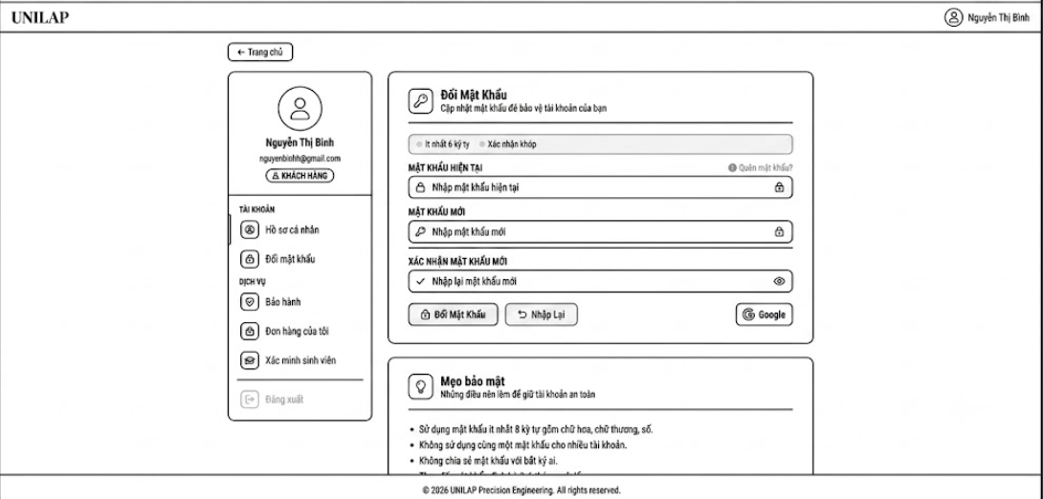

Field Name (Control) | Type / Format | Description & Validation Rules
Password Rule CheckList | Info List | Displays two real-time validation rules at the top: "Ít nhất 6 ký tự" (minimum 6 characters) and "Xác nhận khớp" (confirmation matches). Each rule shows a green check (✓) icon when satisfied, gray circle (○) when not yet met. Updated live via JavaScript.
Mật khẩu hiện tại | password | Required, default Empty. User's existing password. Verified server-side against the stored BCrypt hash. Includes eye toggle button (👁) for show/hide. A "Quên mật khẩu?" link is positioned to the right, redirecting to the Forgot Password screen (3.4.2.2).
Mật khẩu mới | password | Required, default Empty. Minimum 6 characters. Includes eye toggle button. A color-coded strength indicator bar below provides real-time visual feedback (weak → red, medium → amber, strong → green) via JavaScript checkPwStrength().
Xác nhận mật khẩu | password | Required, default Empty. Must exactly match the New Password field. Includes eye toggle button. Validated in real-time — the "Xác nhận khớp" rule in the checklist updates as the user types.
Đổi mật khẩu Button | Action Button | Submits form via POST to /profile. Server verifies current password against BCrypt hash, checks new password ≥ 6 chars, confirms passwords match, then updates the password hash in database. Displays success or error alert.
Nhập lại Button | Reset Button | Clears all three password fields and resets the strength bar and validation rule indicators to default state.
Google Button | OAuth Link | Optional action to link or manage Google account authentication.

3.4.3 Admin-Account Management Console

3.4.3.1 Manager Account Screen
The admin user management console provides a comprehensive dashboard for system administrators to monitor, search, filter, and manage all registered user accounts. Administrators can view detailed profiles in a pop-up modal, change roles using inline dropdowns, and activate or deactivate accounts with the lock/unlock actions. Maps to UC06a (View User List), UC06b (Change User Role), and UC06c
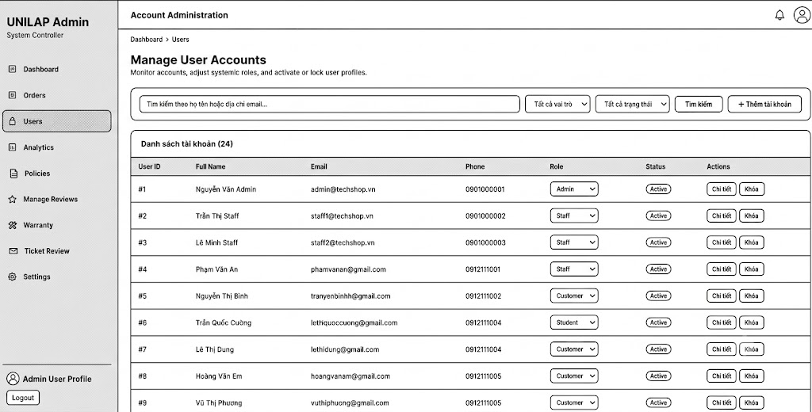

Field Name (Control) | Type / Format | Description & Validation Rules
Sidebar Navigation | Navigation Menu | Left side navigation. Links: Dashboard, Orders, Users (active), Analytics, Policies, Manage Reviews, Warranty, Ticket Review, Settings. Bottom: Profile shortcut and Logout button.
Search Input (Tìm kiếm theo...) | TextInput | Optional, default Empty. Searches users by matching keywords in their full name or email address.
Role Filter (Tất cả vai trò) | Dropdown | Optional, default "Tất cả vai trò". Options: Admin, Staff, Customer, Student. Auto-submits search form on value change.
Status Filter (Tất cả trạng thái) | Dropdown | Optional, default "Tất cả trạng thái". Options: Active, Inactive. Auto-submits search form on value change.
Tìm kiếm Button | Action Button | Submits the search input and selected filters via GET to refresh the account list.
+ Thêm tài khoản Button | Action Button | Green button. Clicking opens the Add New User Account Modal (3.4.3.2).
Users Table | Grid Table | Lists matching user accounts. Columns: User ID, Full Name, Email, Phone, Role, Status, Actions. Shows total count in header: "Danh sách tài khoản (N)".
Role Selection (inline) | Dropdown | In-table dropdown to update a user's role. Options: Admin, Staff, Customer, Student, B2B. Disabled for the logged-in admin's own row. Triggering changes opens a confirmation dialog before submitting POST.
Status Badge | Badge | Visual indicator displaying "Active" (green) or "Inactive" (red) status.
Chi tiết Button | Action Button | Opens the account details modal displaying avatar, full metadata, registration timestamp, and last login.
Khóa / Mở khóa Button | Action Button | Toggle action based on current status. "Khóa" (red border) deactivates an active user; "Mở khóa" (green border) reactivates a locked account. Disabled for the logged-in admin. Prompts confirmation dialog.

3.4.3.2 Add New User Account Modal
The Add New User Account modal is an overlay triggered from the user administration console. It allows system administrators to manually create user accounts for different roles (Admin, Staff, Customer, Student, B2B). The form includes client-side inputs for basic profile details, an initialization password, and role selection. Maps to UC06d (Create User Account).
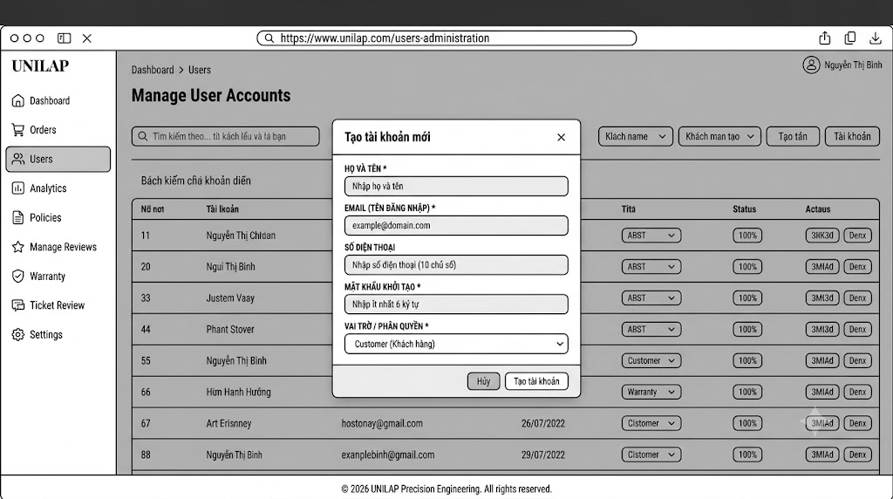

Field Name (Control) | Type / Format | Description & Validation Rules
Họ và tên * | TextInput | Required, default Empty. Full name of the user being created. Cannot be blank.
Email (Tên đăng nhập) * | TextInput (email) | Required, default Empty. Must be a valid email address. Uniqueness is checked on the server-side to prevent duplicate registration.
Mật khẩu khởi tạo * | Password | Required, default Empty. The temporary password for account creation. Must be at least 6 characters in length. Hashed with BCrypt in the backend.
Vai trò / Phân quyền * | Dropdown | Required, default "Customer (Khách hàng)". Options: Admin, Staff, Customer, Student, B2B. Configures systemic permissions for the account.
Hủy Button | Action Button | Closes the modal dialog and resets all input fields without saving changes.
Tạo tài khoản Button | Action Button | Runs JavaScript validations on input constraints. On success, submits data via POST (action=create) to update user table. On failure, returns server-side errors (e.g., Email already exists).

3.4.4 Student Verification
3.4.4.1 Submit Verification Screen
The Student Verification Submit screen is a dedicated tab panel inside the Personal Profile section, visible only to users with the Customer or Student role. It enables customers to submit verification requests by uploading an image of their student ID card to unlock student discounts. The screen dynamically adapts its interface based on the state of the verification: displaying the file upload form, a pending notification, or a verified status banner. Maps to UC07a (Submit Student Verification).
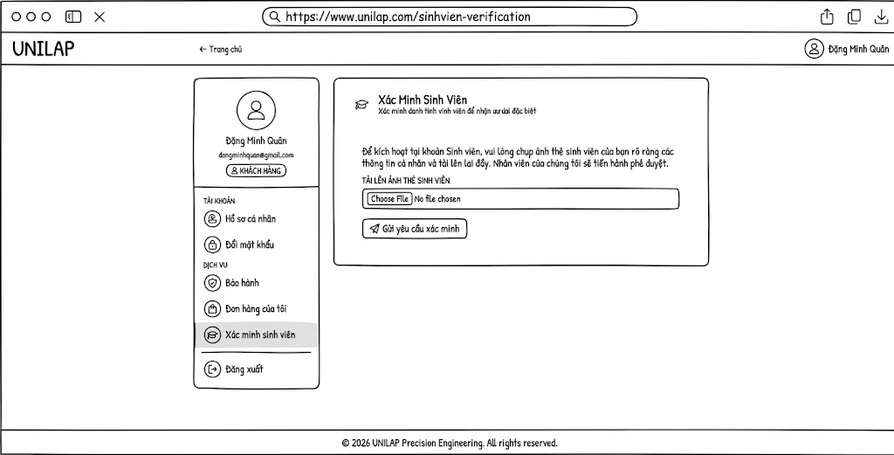

Field Name (Control) | Type / Format | Description & Validation Rules
Sidebar Tab (Xác minh sinh viên) | Navigation Tab | Menu link in the profile sidebar. Only visible to Customer (roleId = 3) and Student (roleId = 4) accounts. Active tab is highlighted.
Tải lên ảnh thẻ sinh viên (Choose File) | File Upload (image) | Required, default Empty. Accepts standard image files (image/*). The user must upload a clear photograph of their physical student ID card showing readable details.
Gửi yêu cầu xác minh Button | Action Button | Submits the form data via POST with multipart/form-data encoding to /profile/student-verify. On success, records request in database under "pending" status.
Verification Status Display | Status Banner | Displays dynamically based on DB state: (1) Pending (warns user card is under review, shows uploaded photo), (2) Approved (displays green verified badge, shows photo), (3) Rejected (shows red alert with feedback note, displays file upload input to retry).

Verify Student Console
The Verify Student Console is a staff-facing management dashboard where customer service or system staff review and approve/reject pending student role upgrade requests. Staff can toggle between active pending requests presented in an inspection card grid layout, and the historical records table. Actions performed here instantly change user permissions in the system database. Maps to UC07b (Review Student Verification).
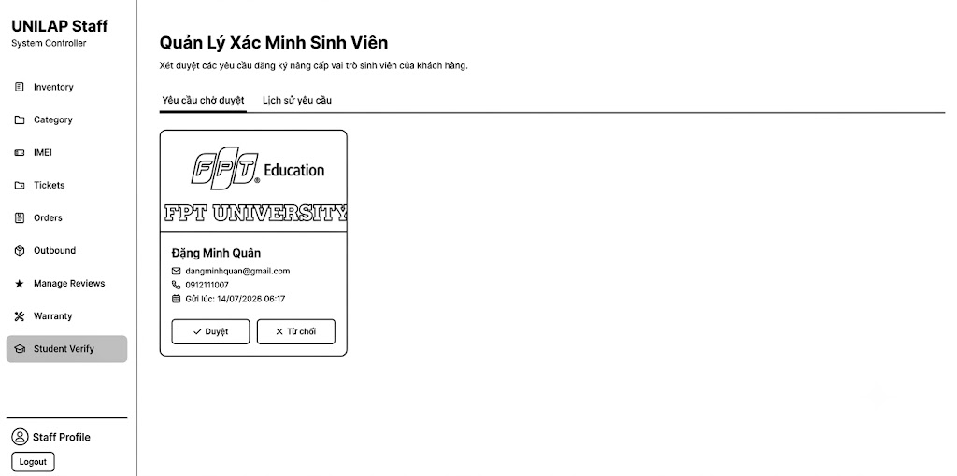

Field Name (Control) | Type / Format | Description & Validation Rules
Sidebar Navigation | Navigation Menu | Staff navigation menu. Links: Inventory, Category, IMEI, Tickets, Orders, Outbound, Manage Reviews, Warranty, Student Verify (active). Bottom: Profile link and Logout button.
Tab Navigation | Tab Buttons | Toggle buttons to switch content views. Tabs: "Yêu cầu chờ duyệt" (default, pending cards grid) and "Lịch sử yêu cầu" (data table of processed requests).
Student Card Image Preview | Image / Lightbox | Image display showing the uploaded student ID card. Hovering displays zoom instructions. Clicking triggers full-page lightbox zoom modal.
Duyệt Button (Approve) | Action Button | Green border button with checkmark. Prompts a confirmation pop-up. Confirming submits POST action=approve to upgrade user to Student role (roleId = 4) and set request status to "approved".
Từ chối Button (Reject) | Action Button | Red border button with X mark. Opens the Rejection Modal popup overlay to input reason note.
Rejection Modal | Modal Dialog | Modal overlay with a required text area for feedback note (staffNote). Action buttons: "Hủy" (close modal) and "Xác nhận từ chối" (submits POST action=reject with reason to user).
History Table | Grid Table | Visible on history tab. Columns: Họ Tên, Email, Ảnh Thẻ, Ngày Gửi, Trạng Thái (green Approved or red Rejected badge), Ngày Xử Lý, Phản Hồi.

3.5 Product Catalog Management

3.5.1. Product List Screen
The main dashboard for managing the store's product catalog. Staff can view all available products and variants, filter by categories or stock level, search by text, and access edit or deactivation actions. Maps to UC31b (View Product Variant List) and UC31d (Deactivate Product).
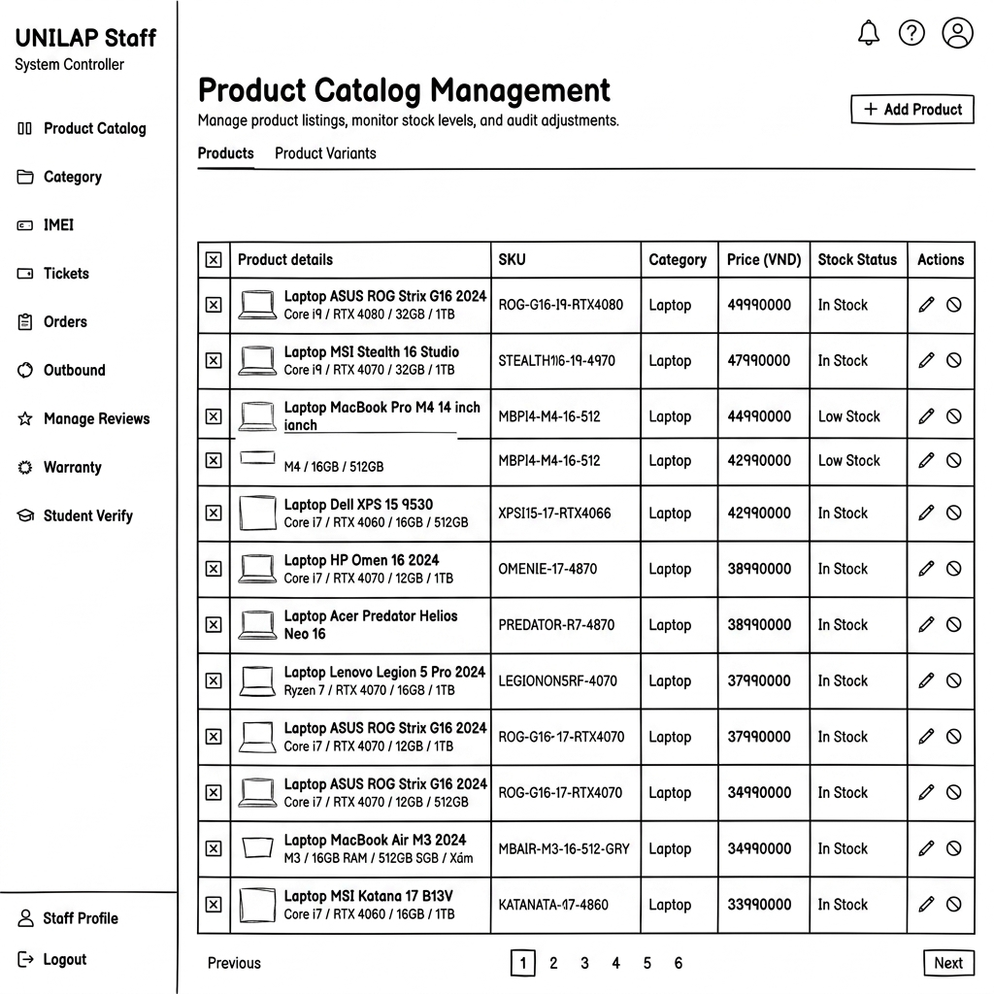

ID | Field Name | Type/Format | Required | Default Value | Description and Validation Rule
01 | Tab Navigation | Navigation Tab | N/A | Product Variants | Toggle between Products (base model views) and Product Variants (specific configurations).
02 | Search Input | TextInput | No | Empty | Searches the catalog by product name, SKU, or category.
03 | Category Filter | Dropdown | No | All Categories | Filters the list by selecting a product category (fetched from database).
04 | Stock Status Filter | Dropdown | No | All | Filters variants by stock state: In Stock, Low Stock, or Out of Stock
05 | Sort By | Dropdown | No | All | Sorts the table by Retail Price: High to Low, or Low to High.
06 | Product Variants Table | Grid Table | N/A | N/A | Table displaying the current variant list: Product Name & SKU, Retail Price (Format #,### đ), Stock Level, Category and Status (Active/Inactive badge).
07 | Edit Action Button | Action Link | No | N/A | Clickable edit icon next to each row. Redirects to Edit Product Screen.
08 | Deactivate Action Button | Action Button | No | N/A | Toggle switch or button to activate/deactivate the product. Prompts a confirmation dialog. If confirmed, toggles database status

3.5.2. Add Product Variant Screen
Form screen allowing Staff to register and configure a new product variant in the catalog

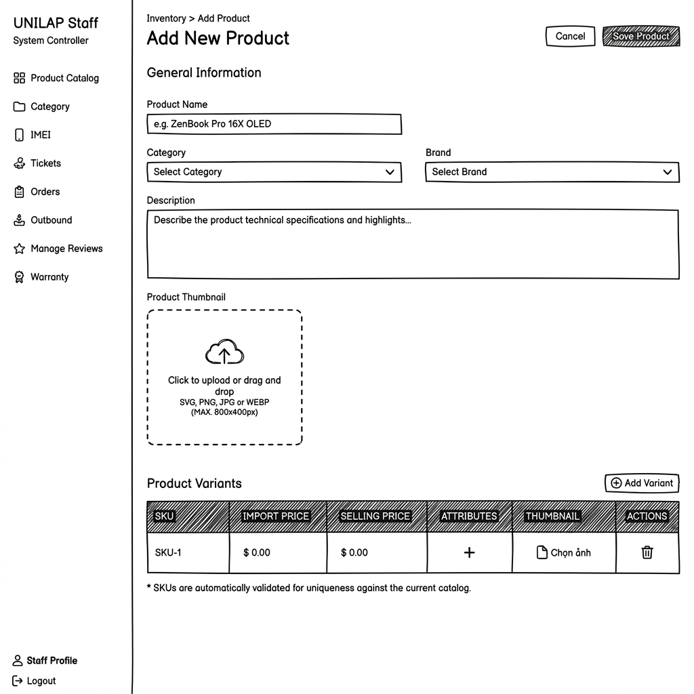

ID | Field Name | Type/Format | Required | Default Value | Description and Validation Rule
01 | Parent Product | Dropdown | Yes | Select  Product | Selects the base product model this variant belongs to.
02 | Variant Name | TextInput | Yes | Empty | Specific name for this variant configuration (e.g. 16GB/512GB Black). Max 100 characters.
03 | SKU Code | TextInput | Yes | Empty | Unique Stock Keeping Unit code. Constraint: Must be unique in database, alphanumeric, max 50 chars
04 | Retail Price | NumberInput | Yes | Empty | Price displayed to customers. Must be a positive integer >= 1,000.
05 | Product Images | File Input | No | Empty | Upload variant images. Max 3 files, formats .jpg, .png, max 3MB per file.
06 | Submit Button | Button (Blue | N/A | N/A | Validates inputs. If valid, inserts variant to database and redirects to Product List.
07 | Edit Action Button | Action Link | No | N/A | Clickable edit icon next to each row. Redirects to Edit Product Screen.

3.5.3. Edit Product Information Screen
Form screen pre-populated with existing details allowing Staff to edit and update variant configurations
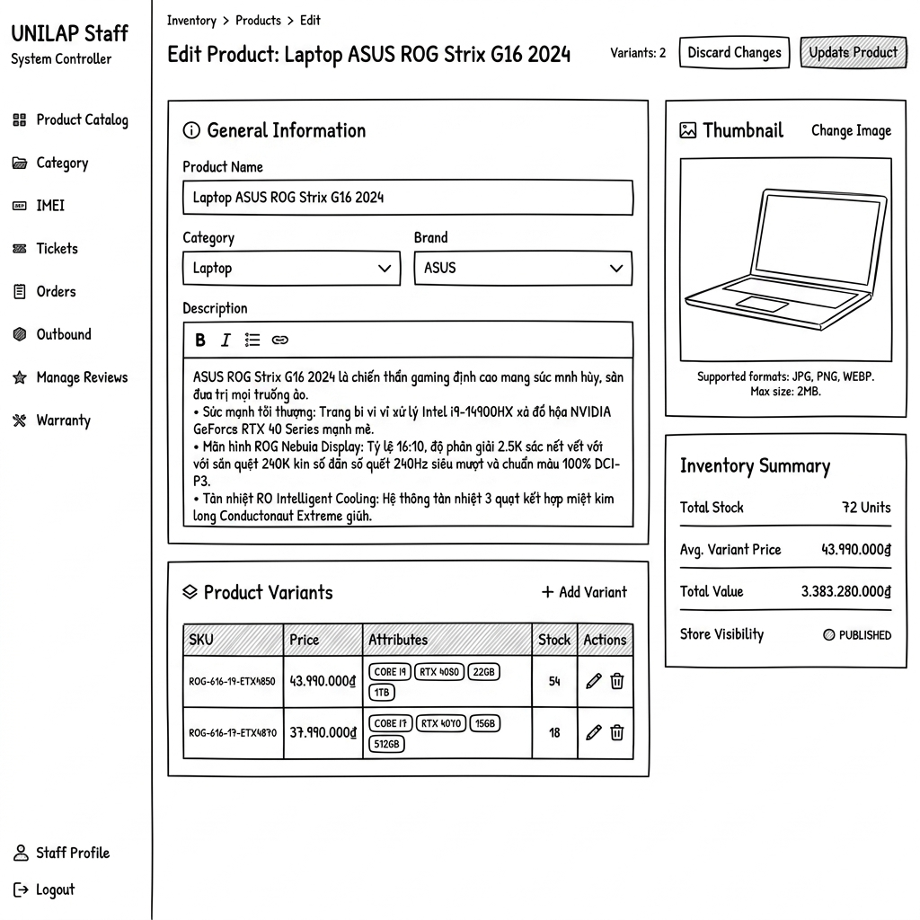

ID | Field Name | Type/Format | Required | Default Value | Description and Validation Rule
01 | Variant Name | TextInput | Yes | Prefilled | Editable name of the variant. Max 100 characters.
02 | SKU Code | TextInput | Yes | Prefilled | SKU code of the product. Non-editable (read-only) once created.
03 | Retail Price | NumberInput | Yes | Prefilled | Update variant price. Must be a positive integer
04 | Save Changes Button | Button (Green) | N/A | N/A | Validates inputs, saves updates to SQL database, and redirects back to Product List.

3.5.4. Category Management Screen
Dashboard for managing product categories. Allows Staff to add, edit, and delete category labels
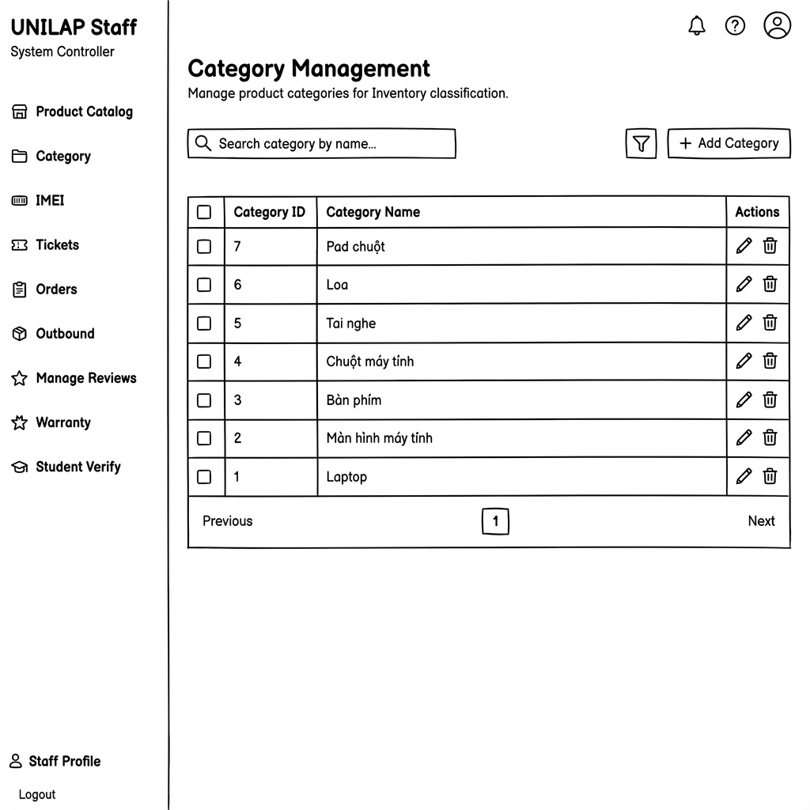

ID | Field Name | Type/Format | Required | Default Value | Description and Validation Rule
01 | New Category Input | TextInput | Yes | Empty | Field to input new category label name. Max 50 chars.
02 | Add Category Button | Button (Blue) | N/A | N/A | Adds category name to database and refreshes list.

3.6. Inbound Management

3.6.1. Inbound Ticket List Screen
Dashboard displaying all inbound procurement requests
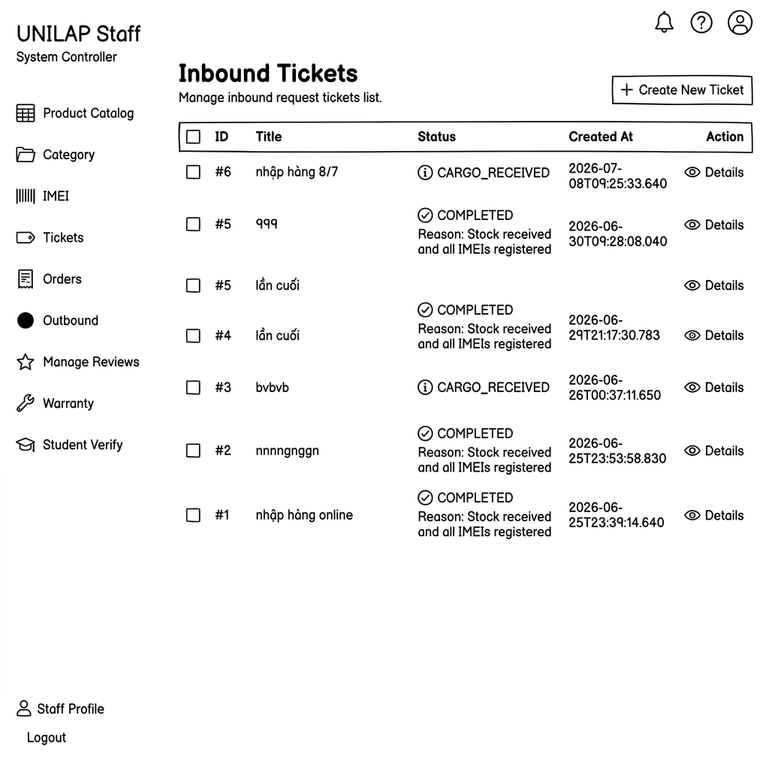

ID | Field Name (Control) | Type / Format | Required | Default Value | Description & Validation Rules
01 | Create Ticket Button | Button (Blue) | N/A | N/A | Redirects to Create Inbound Ticket page.

3.6.2. Create Inbound Ticket Screen
Form screen allowing Admin to draft and submit a new inbound inventory request
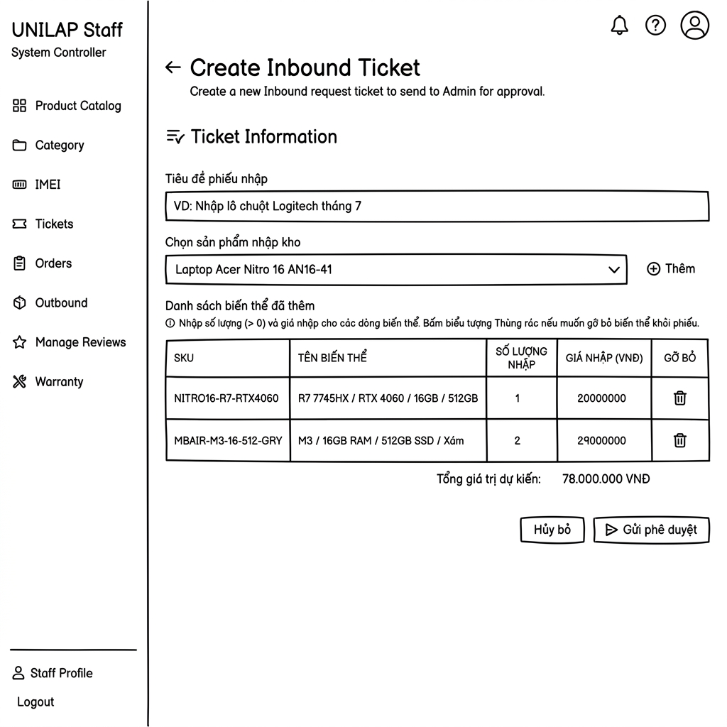

ID | Field Name (Control) | Type / Format | Required | Default Value | Description & Validation Rules
01 | Ticket Title | TextInput | Yes | Empty | Descriptive title for the ticket. Max 150 chars.

3.6.3. Inbound Ticket Detail Screen
Detailed ticket view showing items, expected quantities, imported quantities, status workflow, and action buttons.
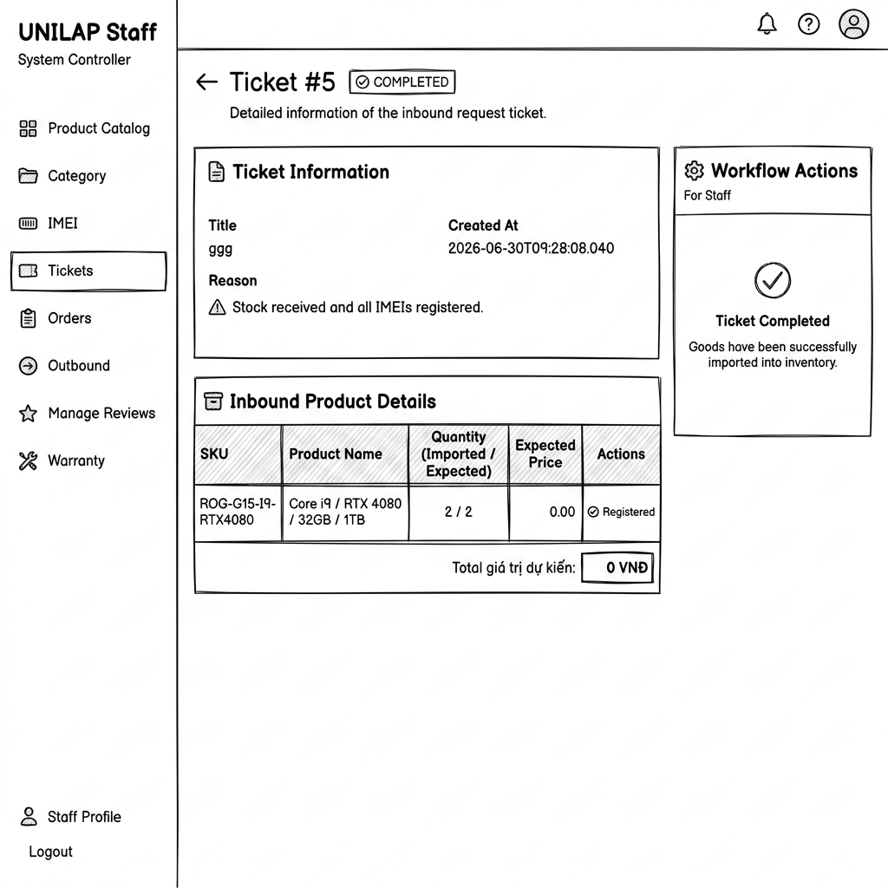

ID | Field Name (Control) | Type / Format | Required | Default Value | Description & Validation Rules
01 | Ticket Status Badge | Status Badge | N/A | PENDING | Displays state: PENDING, APPROVED_EXECUTION, CARGO_RECEIVED, COMPLETED, CANCELLED.
02 | Register IMEI Button | Action Link | No | N/A | Visible only when status is CARGO_RECEIVED and imported < expected. Redirects to Register IMEI screen.

3.6.4. Register Product IMEI/Serial Screen
Fulfillment page where Staff registers the exact Serial, IMEI, and Barcode numbers of physical units arriving at the warehouse.
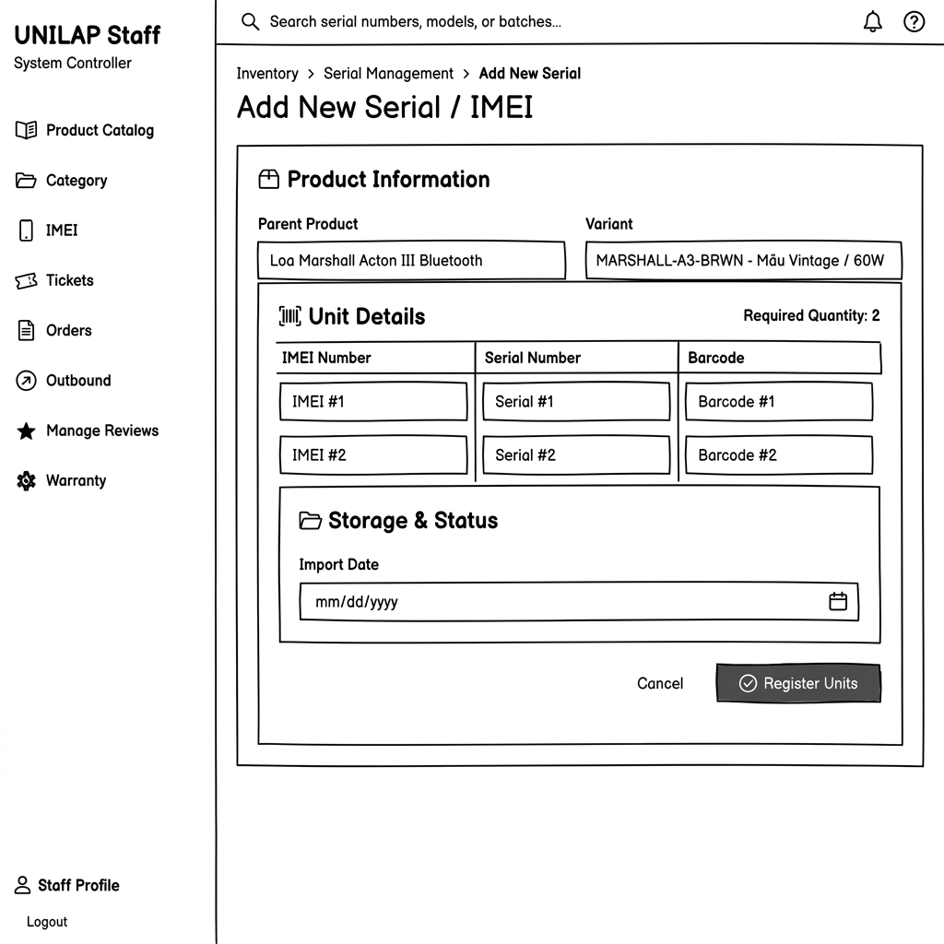

ID | Field Name (Control) | Type / Format | Required | Default Value | Description & Validation Rules
01 | Variant Display | Text Display | N/A | Selected Name | Displays the name and SKU of the variant currently being registered.

3.6.5. IMEI Management Screen
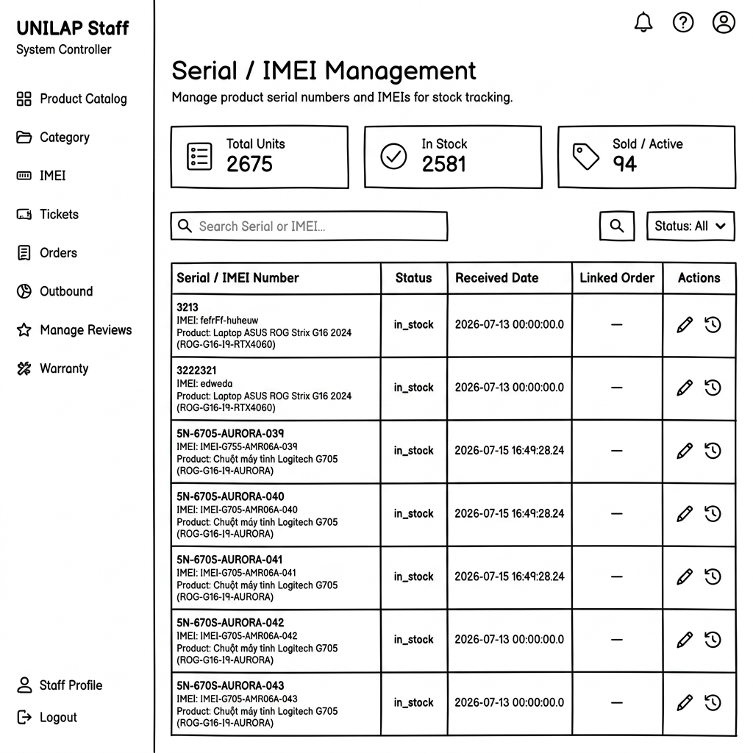

ID | Field Name (Control) | Type / Format | Required | Default Value | Description & Validation Rules
01 | Total Units Card | Stat Card | N/A | N/A | Displays total count of registered serial/IMEI records.
02 | In Stock Card | Stat Card | N/A | N/A | Displays total count of units currently in stock.
03 | Sold / Active Card | Stat Card | N/A | N/A | Displays total count of units sold or activated.
04 | Search Input | Text Box | No | Empty | Filters table. Allows alphanumeric search on Serial, IMEI, or Product name.
05 | Status Filter | Dropdown | Yes | All | Filters rows. Options: All, in_stock, sold, out_of_stock.
06 | Edit Action | Button (Icon) | No | N/A | Opens edit pop-up to modify Serial/IMEI details.
07 | History Action | Button (Icon) | No | N/A | Opens status change log history popup for the row.

3.6.6. Inbound Ticket Management Screen(Admin)
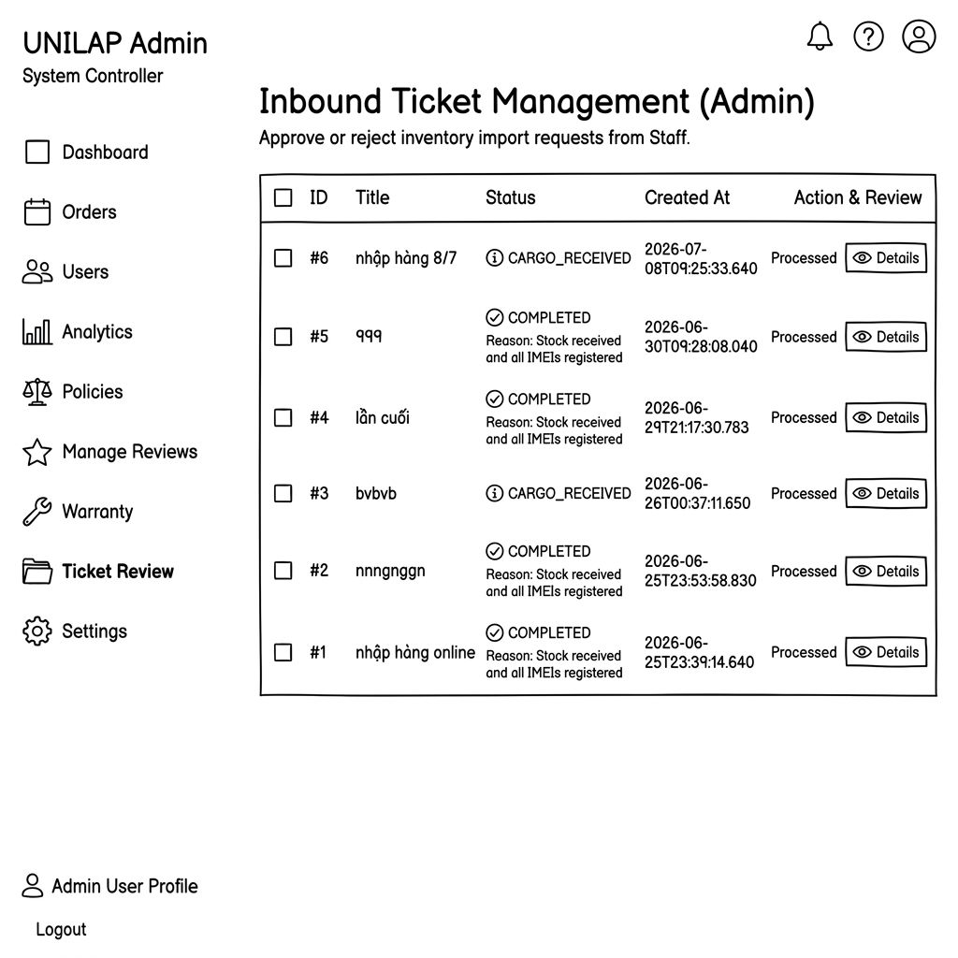
ID | Field Name (Control) | Type / Format | Required | Default Value | Description & Validation Rules
01 | Bulk Selector | Checkbox | No | Unchecked | Header checkbox to select all visible rows for bulk operations.
02 | Ticket ID | Label | N/A | N/A | Displays unique Inbound ticket ID prefixed with #.
03 | Ticket Title | Label | N/A | N/A | Short description or purpose of the import request.
04 | Status Badge | Status Badge | N/A | N/A | Shows states: PENDING, CARGO_RECEIVED, COMPLETED, CANCELLED.
05 | Completion Note | Text Label | N/A | N/A | Displays resolution reasons below status (e.g., "Reason: Stock received...").
06 | Created At | Date/Time | N/A | N/A | Creation timestamp. Format: YYYY-MM-DD HH:mm:ss.SSS.
07 | Processing State | Label | N/A | N/A | Shows processing phase: Processed or Pending Review.
08 | Details Button | Button | Yes | N/A | Redirects Admin to the ticket approval/rejection decision screen.

3.7. Outbound Management

3.7.1. Pending Orders & Screen
Queue display of customer orders that are paid and ready for Serial/IMEI assignment and shipping
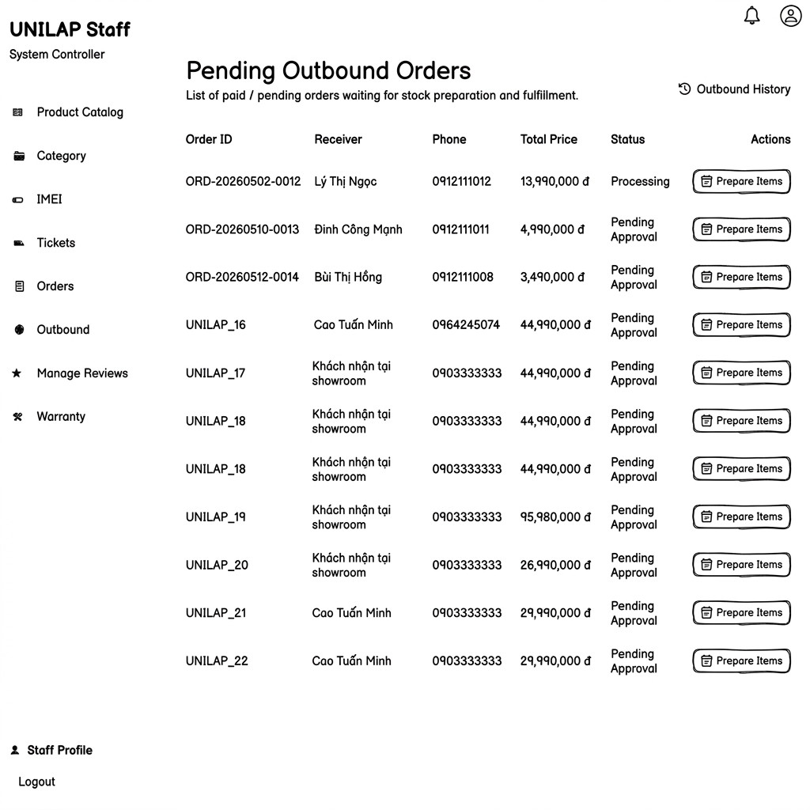

ID | Field Name (Control) | Type / Format | Required | Default Value | Description & Validation Rules
01 | Search Bar | TextInput | No | Empty | Searches orders by customer name, phone number, or Order Code.

3.7.2. Order Fulfillment Screen (IMEI Selection)
Processing screen where Staff matches physical packages with the order by selecting specific Serial/IMEI numbers
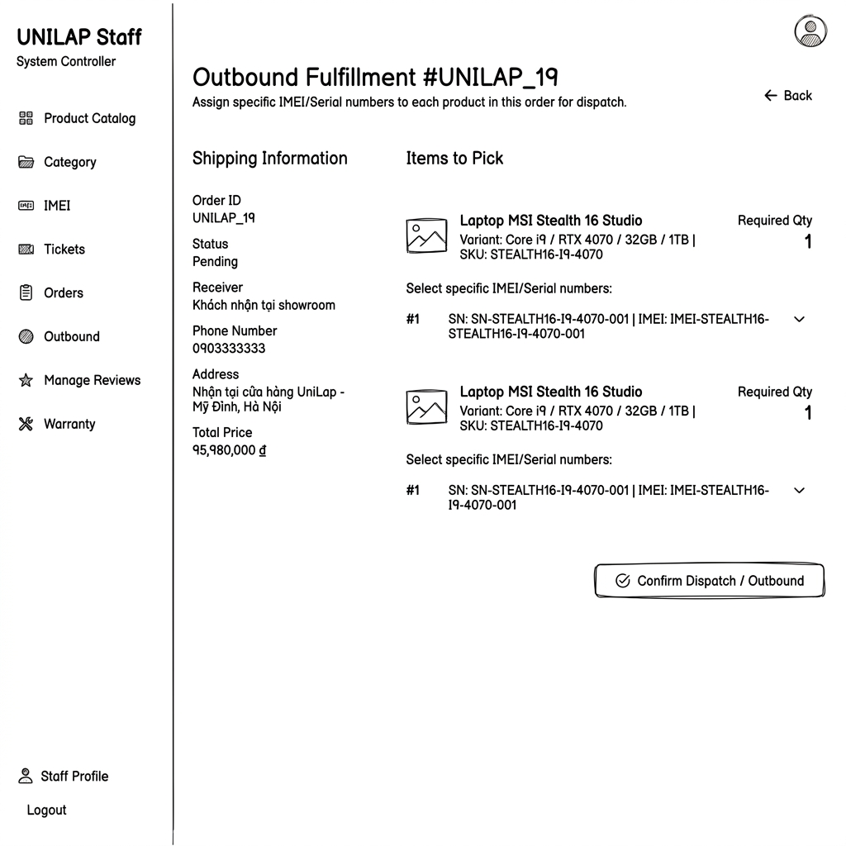

ID | Field Name (Control) | Type / Format | Required | Default Value | Description & Validation Rules
01 | Order Info Summary | Container | N/A | N/A | Displays Order Code, Receiver Name, Phone, and Shipping Address.

3.7.3. Outbound Invoice Slip Screen (Print Preview)
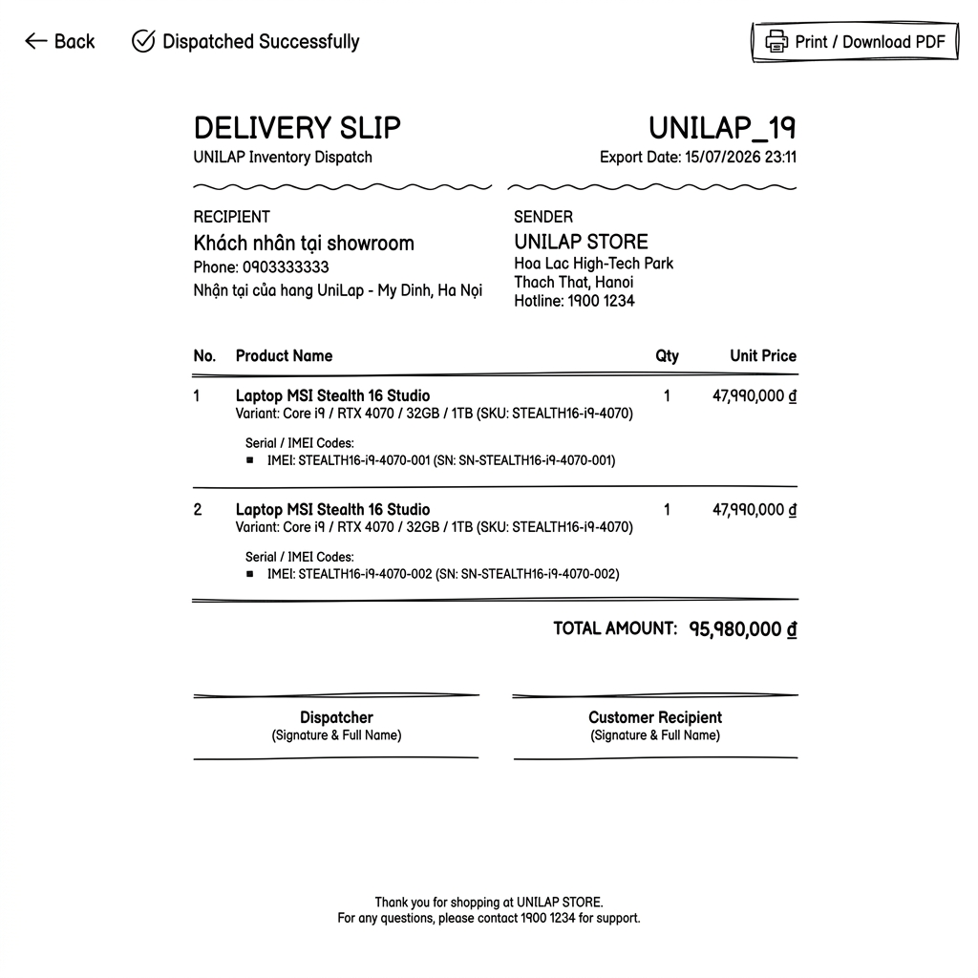

ID | Field Name (Control) | Type / Format | Required | Default Value | Description & Validation Rules
01 | Return Button | Action Link | N/A | N/A | Closes tab or redirects back to Outbound History list.

3.7.4. Outbound History Screen
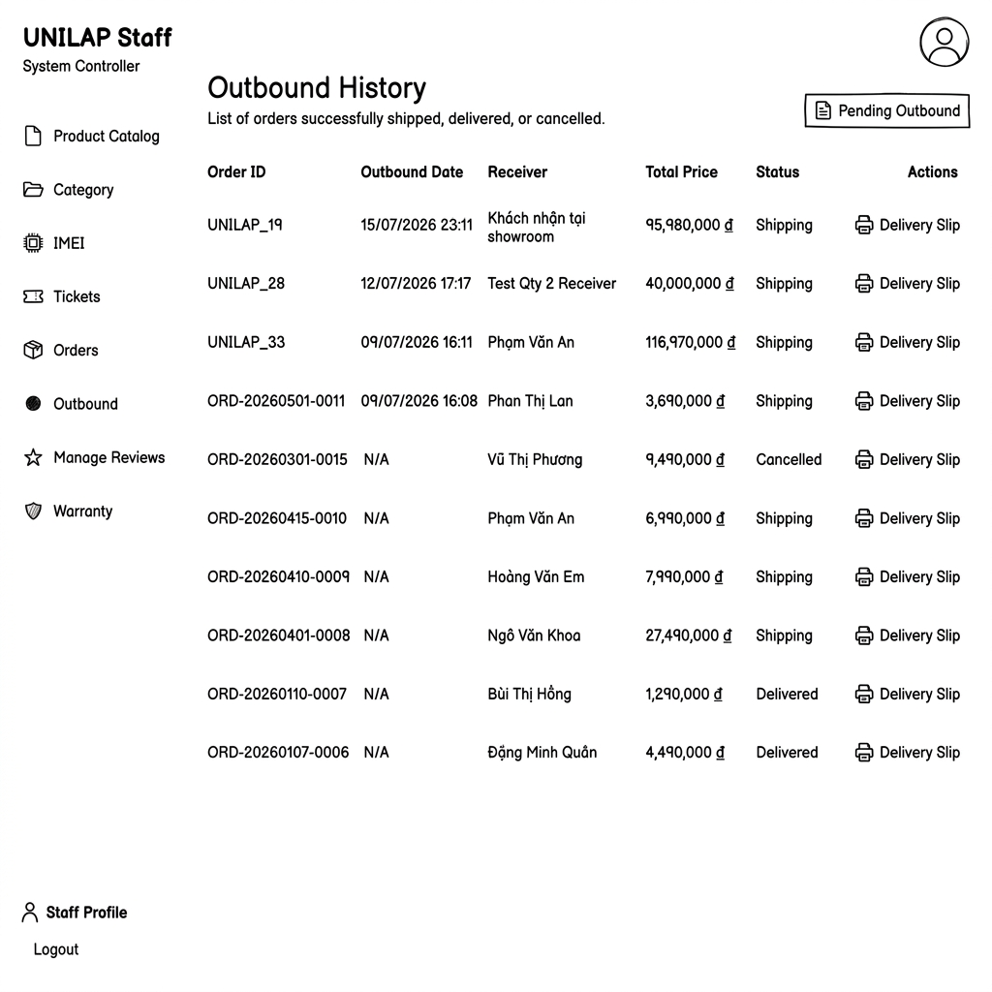

ID | Field Name (Control) | Type / Format | Required | Default Value | Description & Validation Rules
01 | History Search | TextInput | No | Empty | Searches history by customer name or Order Code.
02 | History List Table | Grid Table | N/A | N/A | Lists records: Order Code, Customer Name, Outbound Date, Total Value, and Status.
03 | Action Icon (Table) | Action Icon | No | N/A | Print icon that redirects Staff to the Outbound Invoice Slip Screen (UC52) to reprint.

3.8 Online Shopping & Order Processing

3.8.1 Browse Home Products & Search Products
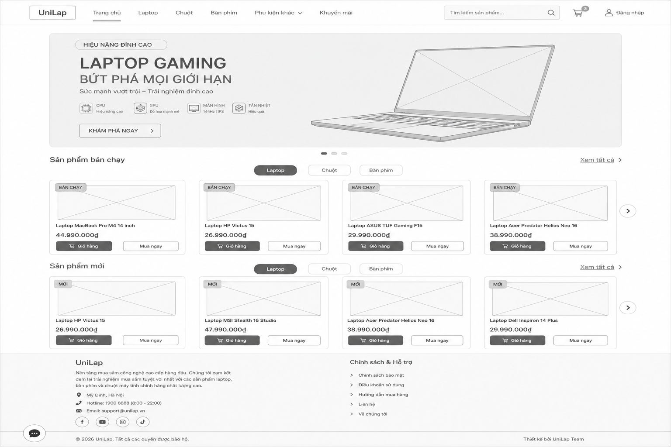

ID | Field Name (Control) | Type / Format | Required | Default Value | Description & Validation Rules
01 | Search Box | Text Input | No | Empty | Search products by name or brand.
02 | Hero Banner | Carousel | N/A | First Banner | Display promotional banners.
03 | Best-selling Products | Product Grid | N/A | Laptop | Display top-selling products by category.
04 | New Products | Product Grid | N/A | Laptop | Display newly added products by category.
05 | Category Tabs | Tab | No | Laptop | Switch displayed product category.
06 | Footer | Information Panel | N/A | Static | Display company and support information.

3.8.2 Browse & Search Product Catalog
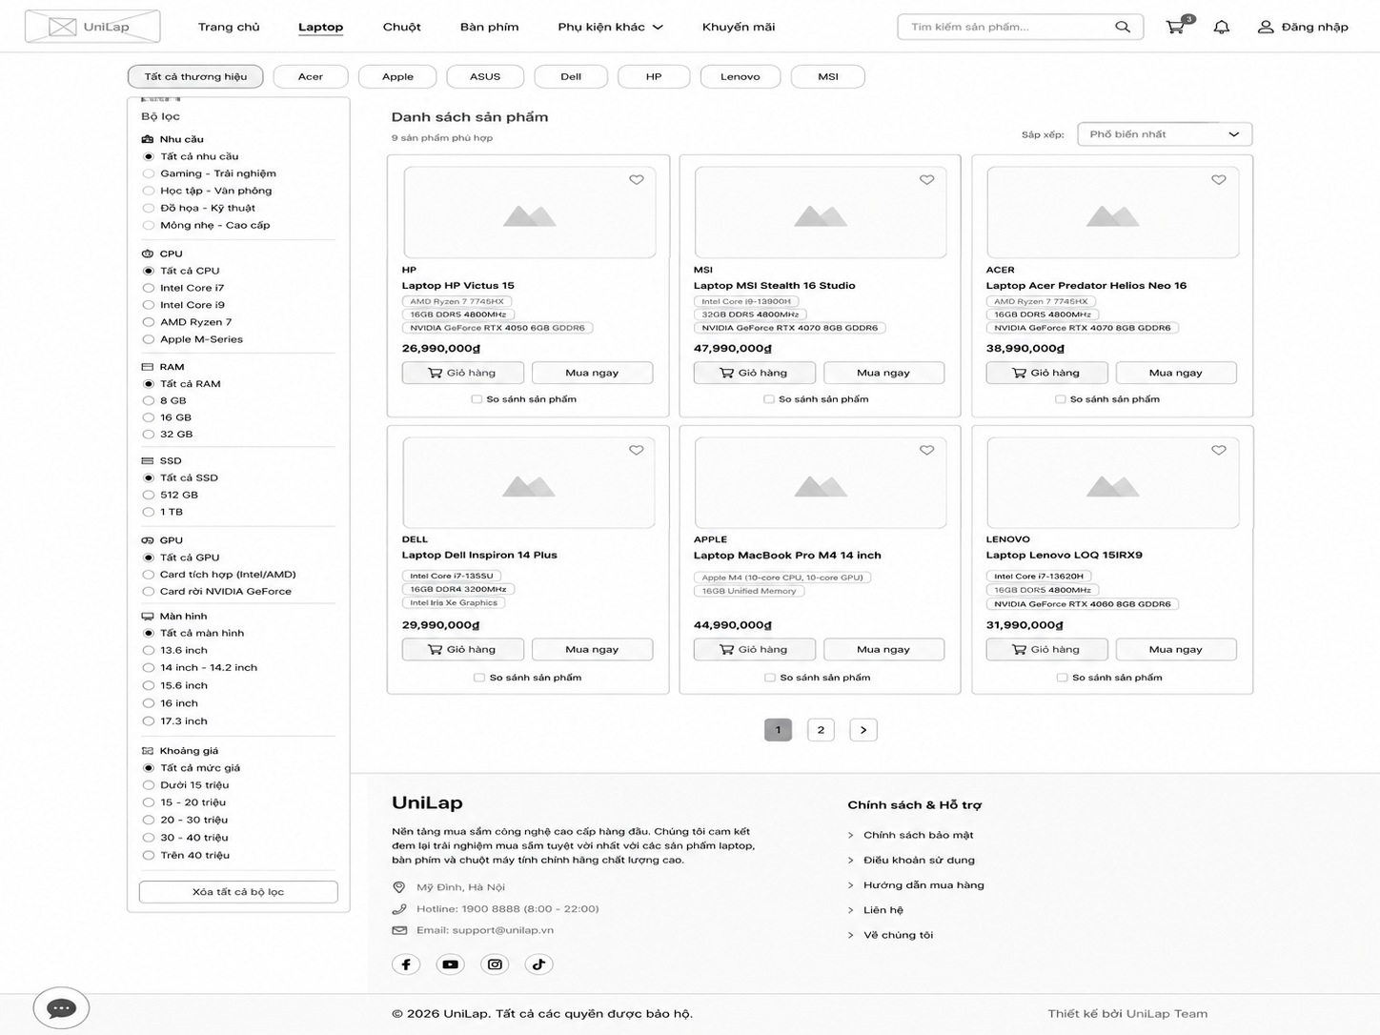

ID | Field Name (Control) | Type / Format | Required | Default Value | Description & Validation Rules
01 | Brand Tabs | Tab | No | All Brands | Filter products by brand.
02 | Filter Panel | Checkbox / Radio | No | All | Filter products by specifications.
03 | Sort Dropdown | Dropdown | No | Most Popular | Sort product list.
04 | Product List | Product Grid | N/A | N/A | Display matching products.
05 | Product Card | Card | N/A | N/A | Display product image, name, specs and price.
06 | Pagination | Pagination | No | Page 1 | Navigate between pages.

3.8.3 View Product Detail
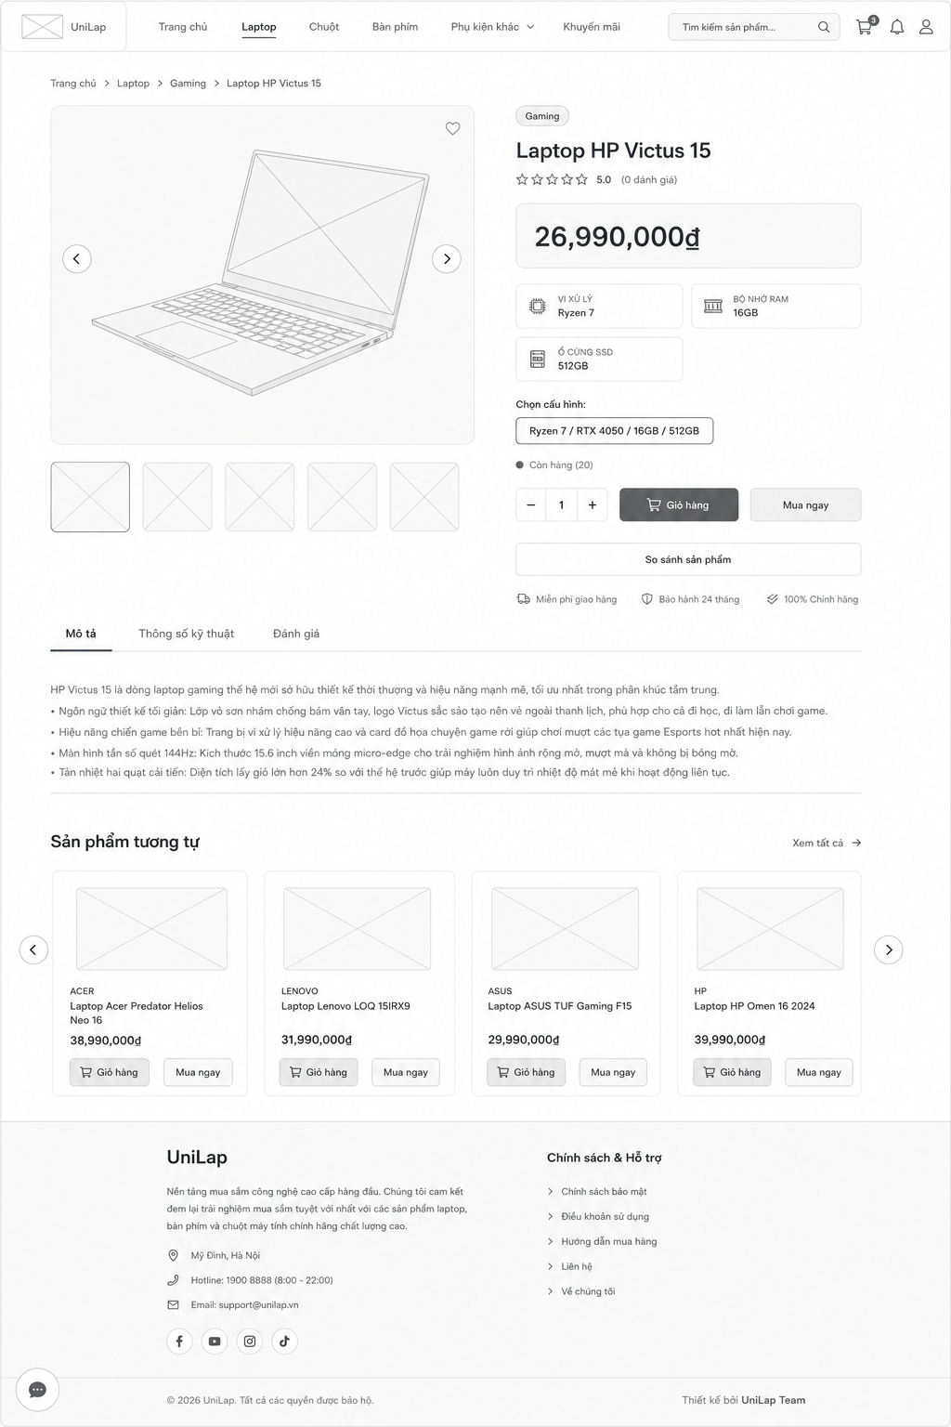

ID | Field Name (Control) | Type / Format | Required | Default Value | Description & Validation Rules
01 | Product Images | Image Gallery | N/A | Main Image | Display product images and thumbnails.
02 | Product Information | Information Panel | N/A | N/A | Display product name, price, rating and key specifications.
03 | Configuration | Dropdown / Option | Yes | First Variant | Select product variant.
04 | Quantity | Number Input | Yes | 1 | Select purchase quantity.
05 | Action Buttons | Button Group | No | Enabled | Add to Cart, Buy Now and Compare Product.
06 | Product Description | Tab Panel | N/A | Description | Display description, specifications and reviews.
07 | Related Products | Product Grid | N/A | N/A | Display similar products.

3.8.4 View &Update Shopping Cart
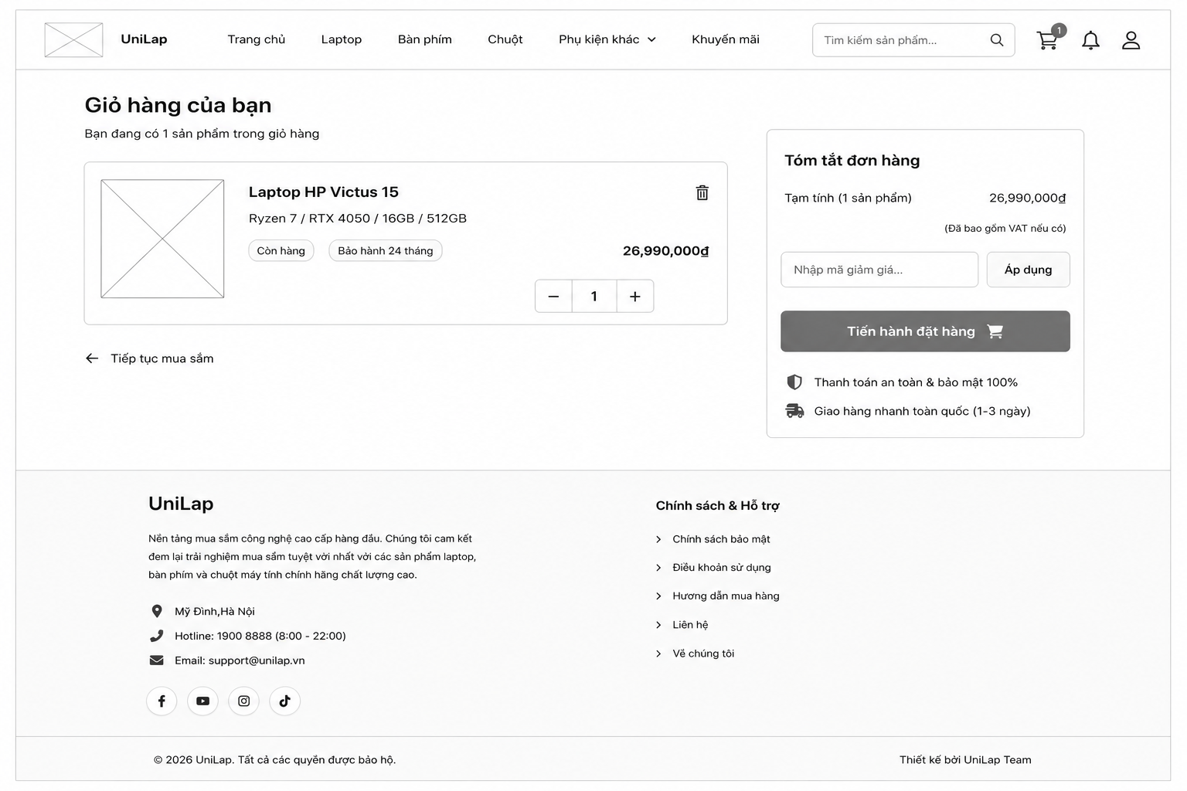

ID | Field Name (Control) | Type / Format | Required | Default Value | Description & Validation Rules
01 | Cart Item List | Product List | N/A | N/A | Display products added to the cart.
02 | Quantity Control | Number Input | Yes | 1 | Update product quantity.
03 | Order Summary | Information Panel | N/A | N/A | Display subtotal and total amount.
04 | Discount Code | Text Input | No | Empty | Enter voucher code.
05 | Checkout Button | Button | Yes | Enabled | Proceed to Checkout page.
06 | Continue Shopping | Link | No | Enabled | Return to Product Catalog.

3.8.5 Check out
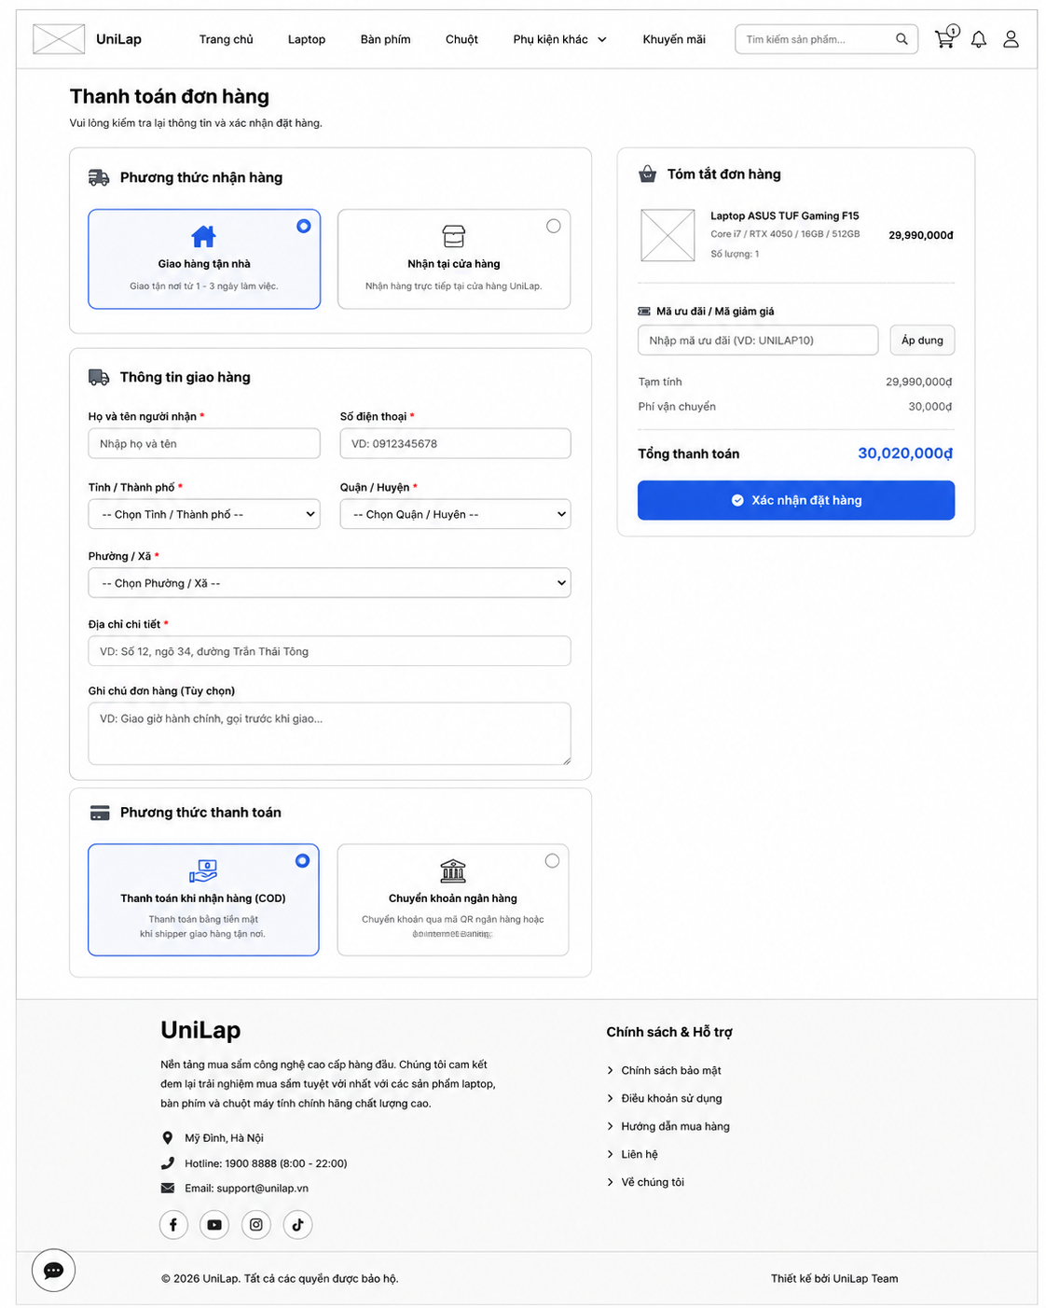

ID | Field Name (Control) | Type / Format | Required | Default Value | Description & Validation Rules
01 | Delivery Method | Radio Button | Yes | Home Delivery | Select delivery method.
02 | Shipping Information | Form | Yes | Empty | Enter recipient and delivery address.
03 | Payment Method | Radio Button | Yes | COD | Select payment method.
04 | Order Summary | Information Panel | N/A | N/A | Display order details and total amount.
05 | Discount Code | Text Input | No | Empty | Enter and apply voucher code.
06 | Confirm Order | Button | Yes | Enabled | Submit order for processing.

3.8.6 Track order
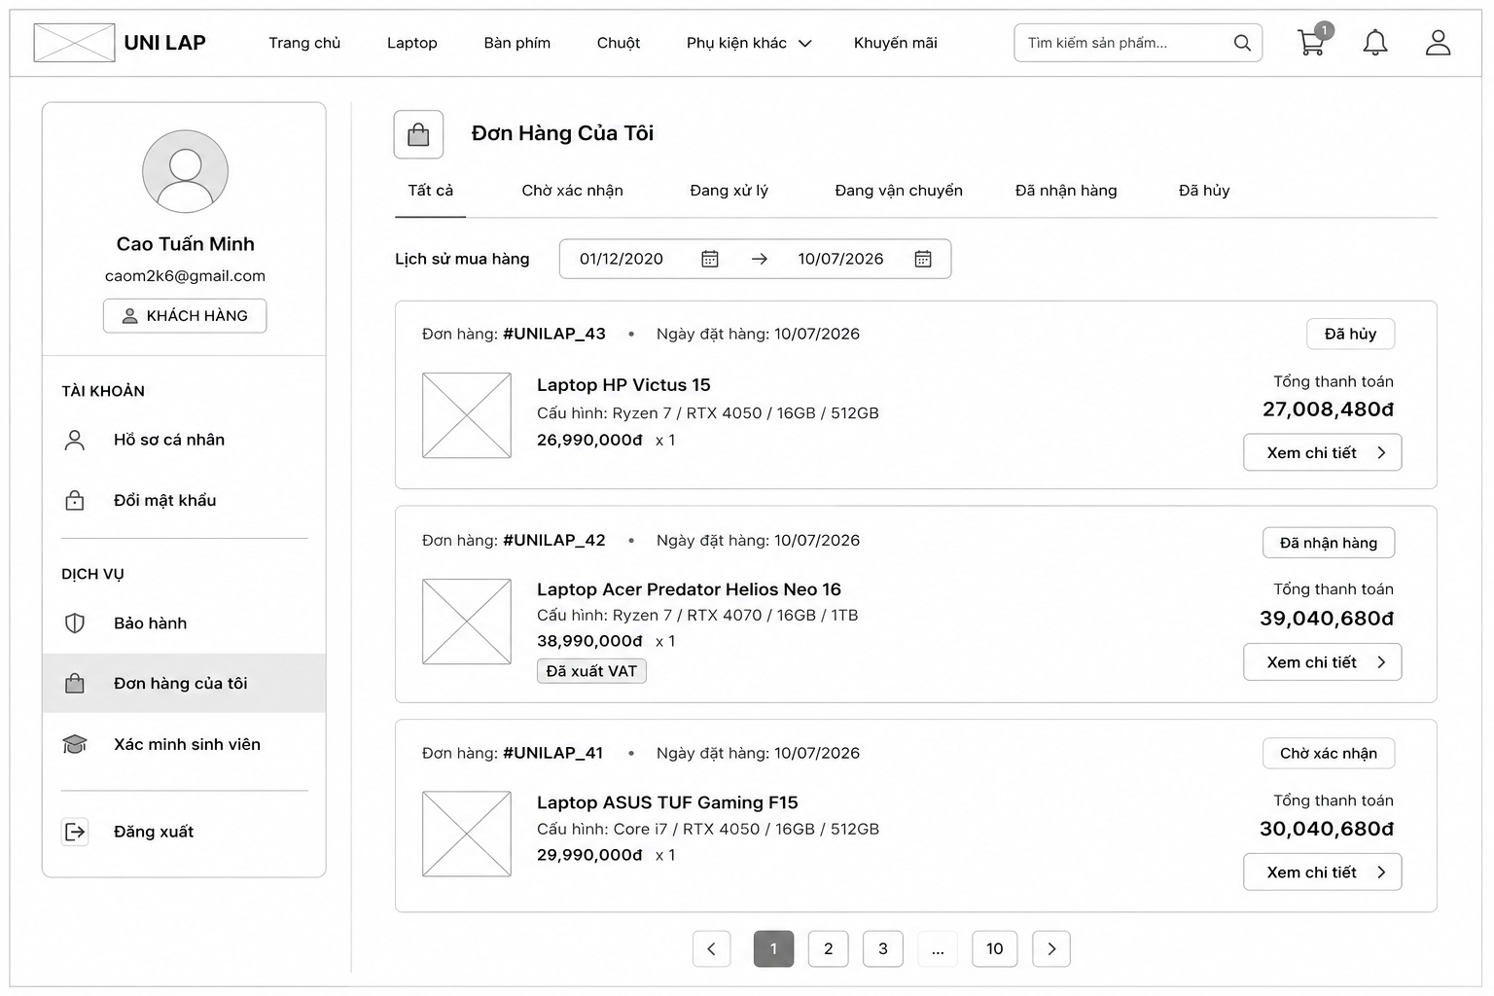

ID | Field Name (Control) | Type / Format | Required | Default Value | Description & Validation Rules
01 | Order Status Tabs | Tab | No | All | Filter orders by status.
02 | Purchase Date Filter | Date Picker | No | Empty | Filter orders by purchase date.
03 | Order List | List | N/A | N/A | Display customer orders.
04 | Order Card | Card | N/A | N/A | Display order information and total amount.
05 | View Details | Button | No | Enabled | View order details.
06 | Navigation Menu | Sidebar | N/A | My Orders | Navigate account pages.

3.8.7Manage order

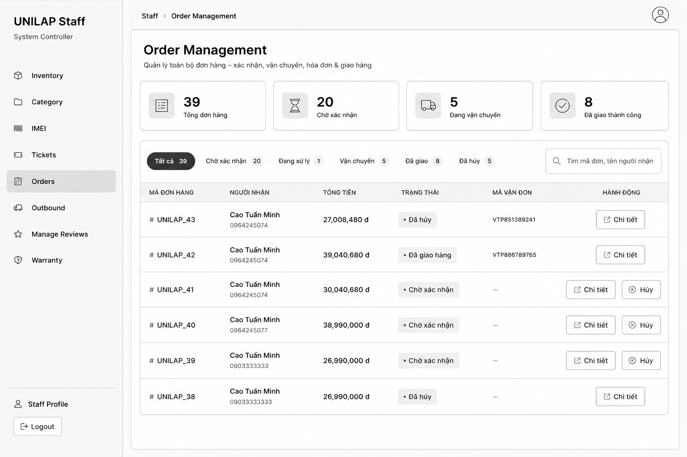

ID | Field Name (Control) | Type / Format | Required | Default Value | Description & Validation Rules
01 | Order Statistics | Information Panel | N/A | N/A | Display order statistics by status.
02 | Status Tabs | Tab | No | All | Filter orders by status.
03 | Search Box | Text Input | No | Empty | Search by order code or customer name.
04 | Order List | Grid Table | N/A | N/A | Display order information.
05 | Order Status | Label | N/A | Depends | Display current order status.
06 | Action Button | Button | No | Enabled | View order details or cancel eligible orders.

4. Non-Functional Requirements

4.1 External Interfaces

4.1.1 User Interface
The system provides a responsive web interface that supports desktop and laptop devices.
The user interface shall:
- Support Google Chrome, Mozilla Firefox, and Microsoft Edge browsers
- Maintain a consistent layout and navigation structure
- Provide user-friendly interactions and clear feedback messages
- Allow users to easily search, compare products, and place orders
- Display responsive layouts for different screen resolutions

4.1.2 Hardware Interface
The system requires:
- Web application server
- Database server
- Stable internet connection
The application server communicates with the database server to store and retrieve system data.

4.1.3. Software Interface
External System | Description
Email Service API | Send account verification and order confirmation emails
Payment Gateway API | Process online payment transactions
Chatbot Recommendation Service | Provide product recommendations based on customer preferences

4.2 Quality Attributes

4.2.1 Usability

Requirement | Description
User Learning Time | New users complete ordering process within 5 minutes
Navigation Efficiency | Users can access main functions within 3 clicks
Error Visibility | Validation and error messages displayed clearly

4.2.2 Performance

Requirement | Description
Homepage loading time | < 3 seconds
Search response time | < 2 seconds
Order processing time | < 5 seconds
Concurrent users | ≥ 100 users

4.2.3 Security

Requirement | Description
Password encryption | BCrypt hashing
Data transmission | TLS 1.3
Authorization | Role-Based Access Control (RBAC)
Login protection | Lock account after 5 failed attempts
Session management | Automatic logout after inactivity

4.2.4 Reliability

Requirement | Description
Data consistency | No order data loss
Transaction integrity | Payment and order information remain synchronized
Backup recovery | System backup available daily

4.2.5 Availability

Requirement | Description
System uptime | ≥ 99%
Service availability | System accessible 24/7 except maintenance periods

4.2.5 Scalability

Requirement | Description
Product expansion | Support unlimited categories and products
User scalability | Support increasing numbers of users
Database scalability | Allow future database growth

4.2.7 Maintainability

Requirement | Description
Architecture | MVC or 3-Layer Architecture
Source code | Modular and reusable
Documentation | Technical documentation maintained

4.2.7 Compatibility

Requirement | Description
Browser support | Chrome, Firefox, Edge
Device support | Desktop and laptop
Screen compatibility | Responsive UI for common resolutions

5. Requirement Appendix

5.1 Business Rules

ID | Rule Definition
BR-01 | Customers are only allowed to select a minimum of 2 and a maximum of 4 products simultaneously to use the configuration and price comparison feature.
BR-02 | Product inventory quantity shall be automatically updated and deducted when an order reaches the confirmed status.
BR-03 | The system only accepts payments via the following methods: Cash on Delivery (COD), Bank Transfer
BR-04 | Invoice must be automatically generated and sent via email to the customer immediately after a successful payment transaction.
BR-05 | Customers are only allowed to cancel a warranty request when the request is still in an unprocessed state by the staff.
BR-06 | Customers are only allowed to cancel an order if the order is still within the allowable cancellation period.
BR-07 | Customers are only allowed to leave a review (5-star system) and personal comments for products they have successfully purchased.
BR-08 | All online warranty requests submitted by customers must include valid evidence (images, videos, or documents).
BR-09 | The management and tracking of product quantity and status (from the warehouse to the customer), as well as warranties, must be identified via Serial/IMEI codes.
BR-10 | High-impact discount campaigns (Voucher Campaigns) created by staff must be approved by the Administrator (Admin) before being applied to the system.
BR-11 | The application of discount codes (Vouchers/Coupons) must satisfy binding conditions including: expiration date, spending limit, usage limit, and application scope or bundle purchase conditions.
BR-12 | Users who abuse the AI (spam, prompt injection, unsafe usage patterns) will be detected by the system, and the Admin has the right to disable (Block) that account's AI access.
BR-13 | Passwords of all users in the system must be encrypted using the MD5 standard before being stored in the database to ensure security.
BR-14 | Only the Administrator (Admin) has the authority to assign, change roles, deactivate, or reactivate user accounts (Customer, Staff, Accounter).
BR-15 | A customer can submit a warranty request only for a product that belongs to their completed order, is linked to an active Warranty Policy, and is still within its warranty period.
BR-16 | Every newly submitted warranty request shall be created with the initial status PENDING.
BR-17 | Every warranty request creation, cancellation, and status transition shall be recorded in the Warranty History log together with theeeeeeeeeeeeeeeeee action performed, and timestamp.
BR-18 | A customer may view the complete information and processing history of their own warranty requests only.
BR-19 | A customer may cancel a warranty request only while its status is PENDING. Once cancelled, the request cannot be restored.
BR-20 | Warranty request status transitions shall strictly follow the workflow: PENDING → PROCESSING → APPROVED → COMPLETED, or PENDING → PROCESSING → REJECTED. Direct transitions to any other state are not permitted.
BR-21 | Staff shall provide processing remarks when approving or rejecting a warranty request. These remarks become visible to the customer after the processing result is finalized
BR-22 | Only authorized Staff members are allowed to process warranty requests and update their processing status.
BR-23 | A warranty request cannot be processed simultaneously by multiple Staff members. The system shall ensure that only one Staff member can process a request at a time.
BR-24 | A Warranty Policy must define at minimum: policy name, at least one applicable product category, warranty duration in months, and terms and conditions text.
BR-25 | Disabling a Warranty Policy does not retroactively invalidate active customer warranties; existing warranties remain valid until their individually computed expiry dates.
BR-26 | Revenue and Orders KPIs are computed from confirmed and completed orders only; cancelled and refunded orders are excluded from revenue totals.
BR-27 | Conversion Rate is calculated using the total number of unique user sessions in the selected period as the denominator.
BR-28 | An Inventory Alert is triggered when a product’s stock quantity falls below the defined low-stock threshold.
BR-29 | Only approved product reviews are displayed on the public product detail page; pending, hidden, rejected, or deleted reviews must not be visible to public users.
BR-30 | Product average rating and total review count must be calculated from approved reviews only.
BR-31 | A customer can submit only one review for the same product in the same completed order.
BR-32 | Product review moderation actions such as approve, hide, or delete can only be performed by Staff or Admin accounts with review management permission.
BR-33 | Every product review moderation status change should be recorded with actor identity, action type, and timestamp.
BR-34 | Voucher code must be unique when a campaign uses a promo code.
BR-35 | Campaign start date and end date must form a valid time range, where the end date is later than the start date.
BR-36 | Discount value must be valid according to discount type: percentage discount must be greater than 0 and not exceed 100, while fixed amount discount must be greater than 0.
BR-37 | Deactivated voucher campaigns must not be applied to new checkout orders and must not modify completed historical orders.
BR-38 | Only Admin accounts with voucher campaign management permission can create, edit, view, or forcefully deactivate voucher campaigns.
BR-39 | Deleting a Warranty Policy permanently removes it along with its full change history; this action cannot be undone.
BR-40 | A footer policy's title must not be left empty when updating its content.
BR-41 | Deleting a footer policy is permanent and immediately removes it from the public site footer; this action cannot be undone.
BR-42 | Warranty request images: up to 5 files may be attached, in JPEG, PNG, JPG, or WEBP format, maximum 5MB per file.
BR-43 | Warranty request field lengths: serial number ≤ 100 characters, title ≤ 200 characters, defect description ≤ 2000 characters.
BR-44 | The warranty policy list is paginated at 5 records per page, ordered by creation time descending.
BR-45 | Footer policies are displayed in ascending display order; policies sharing the same order are shown alphabetically by title.
BR-46 | The footer policy management list is ordered by display order ascending, then by creation order
BR-47 | If a footer policy's code is left blank, the system automatically generates one from the title (uppercase, spaces replaced with underscores, non-alphanumeric characters removed).
BR-48 | Changes to a footer policy's display settings take effect immediately on the public-facing site footer.
BR-49 | Each homepage section (Best-selling / New) displays a fixed number of products plus a “View all” button.
BR-50 | Search matches by product name and brand, case-insensitive.
BR-51 | Filters, brand tabs, and sorting work simultaneously and jointly update the “... matching products” count.
BR-52 | Only products with ACTIVE status are displayed.
BR- 53 | The price shown on a card is the Flash Sale price if still valid, otherwise the regular selling price.
BR-54 | Only logged-in customers may place orders.
BR-55 | Creating the order and deducting stock must occur within a single transaction (both succeed together or roll back).
BR-56 | Delivery fields (name, phone, address) are required and must be validated on both the client and server before the order is created.
BR-57 | The phone number must be in the correct format (e.g. 10 digits, numeric only) and the address must meet a minimum length.
BR-58 | A payment method must be selected; for online/bank-transfer payment, the order is only created/confirmed once the payment result is valid, while COD is accepted immediately.
BR-59 | A discount code / voucher only applies when valid (still active, eligible, correct type); a voucher may reduce the product amount or waive/reduce the shipping fee.
BR- 60 | Only users with staff rights can access the order-management page.
BR- 61 | Filtering, searching, sorting, and pagination operate simultaneously on the same set of orders.
BR-62 | Each row in the list correctly reflects the current [Order].status.

5.2 System Messages

# | Message Code | Message Type | Context | Content
1 | MSG01 | In line | Search empty | No products found.
2 | MSG02 | In red, under the text box | Required field | This field is required.
3 | MSG03 | Toast message | Login success | Login successfully.
4 | MSG04 | Toast message | Order success | Order placed successfully.
5 | MSG05 | Toast message | Registration success | Account created successfully.
6 | MSG06 | In red, under the text box | Max length | Exceed maximum length of  {max_length}.
7 | MSG07 | In red, under the text box | Out of stock | Product is out of stock.
8 | MSG08 | In red, under the text box | Payment failed | Payment failed. Please try again.
9 | MSG09 | In red, under the text box | Invalid login | Incorrect email or password.
10 | MSG10 | In red, under the text box | Invalid email | Invalid email format.
11 | MSG11 | In red, under the text box | Email not verified | Email has not been verified.
12 | MSG12 | In red, under the text box | Account blocked | Account has been blocked.
13 | MSG13 | In red, under the text box | Account locked | Account locked for 30 minutes.
14 | MSG14 | In red, under the text box | Duplicate email | Email already exists.
15 | MSG15 | In red, under the text box | Password mismatch | Password confirmation does not match.
16 | MSG16 | In red, under the text box | Invalid quantity | Product quantity exceeds stock.
17 | MSG17 | Toast message | Profile updated | Profile updated successfully.
18 | MSG18 | In red, under the text box | Validation error | Please check highlighted fields.
19 | MSG19 | In red, under the text box | Invalid voucher | Voucher code is invalid or expired.
20 | MSG20 | In red, under the text box | AI service unavailable | AI service is temporarily unavailable.

5.3 Validation Rule

ID | Rule Definition
VR-01 | Email must follow valid email format
VR-02 | Password minimum 8 characters
VR-03 | Password must contain uppercase, lowercase, and number
VR-04 | Product quantity cannot exceed inventory quantity
VR-05 | Cart quantity cannot be less than 1
VR-06 | Compare function accepts only 2–4 products
VR-07 | Phone number must contain 10 digits
VR-08 | Required fields cannot be empty

